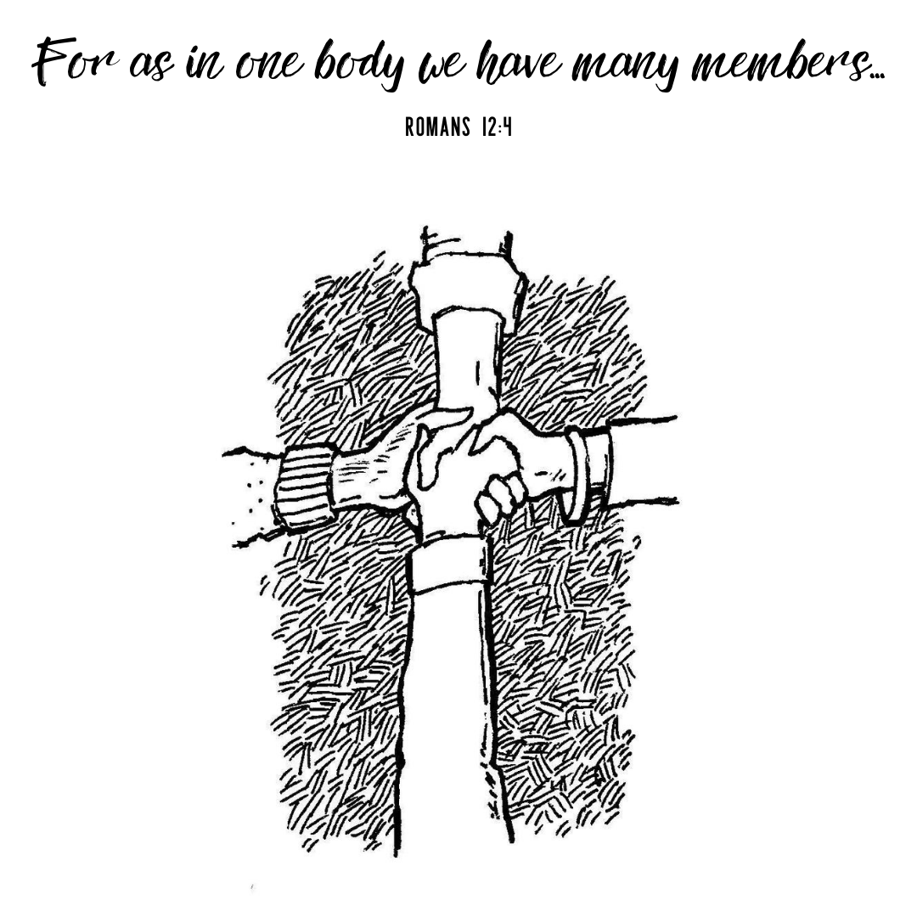

Twelfth Sunday After Pentecost
August 23, 2020
8:00 AM, 9:15 AM, & 10:30 AM

Christ Lutheran Church
3509 SW Burlingame Rd.
Topeka, KS 66611
785-266-6263
www.christlcms.org

Rev. Ben Micheel, Pastor

Amanda Adams, DCE

Chris Francik, TLS Principal

Welcome and Opening Prayer

784 Take My Life and Let It Be LSB 784
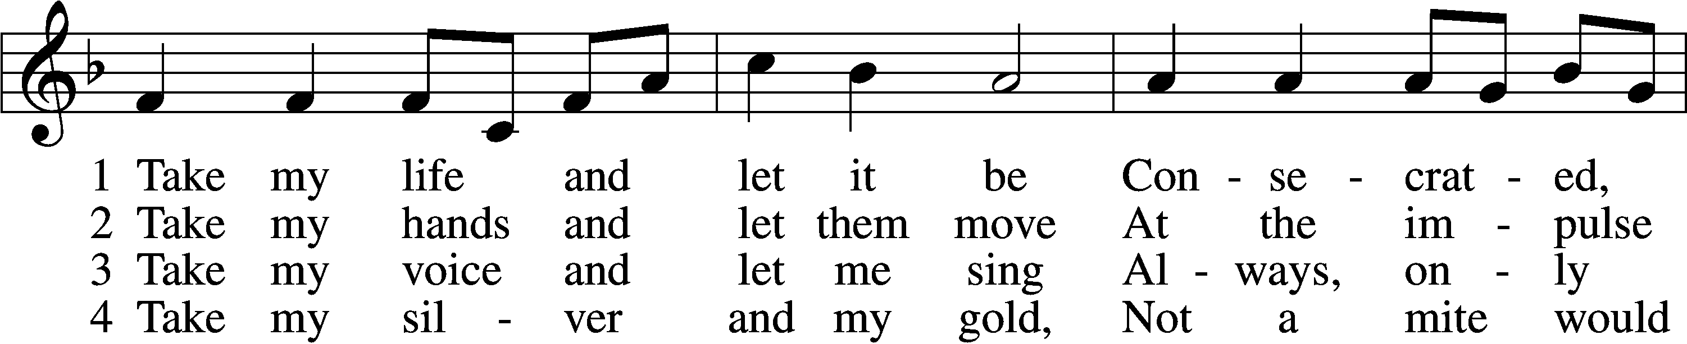
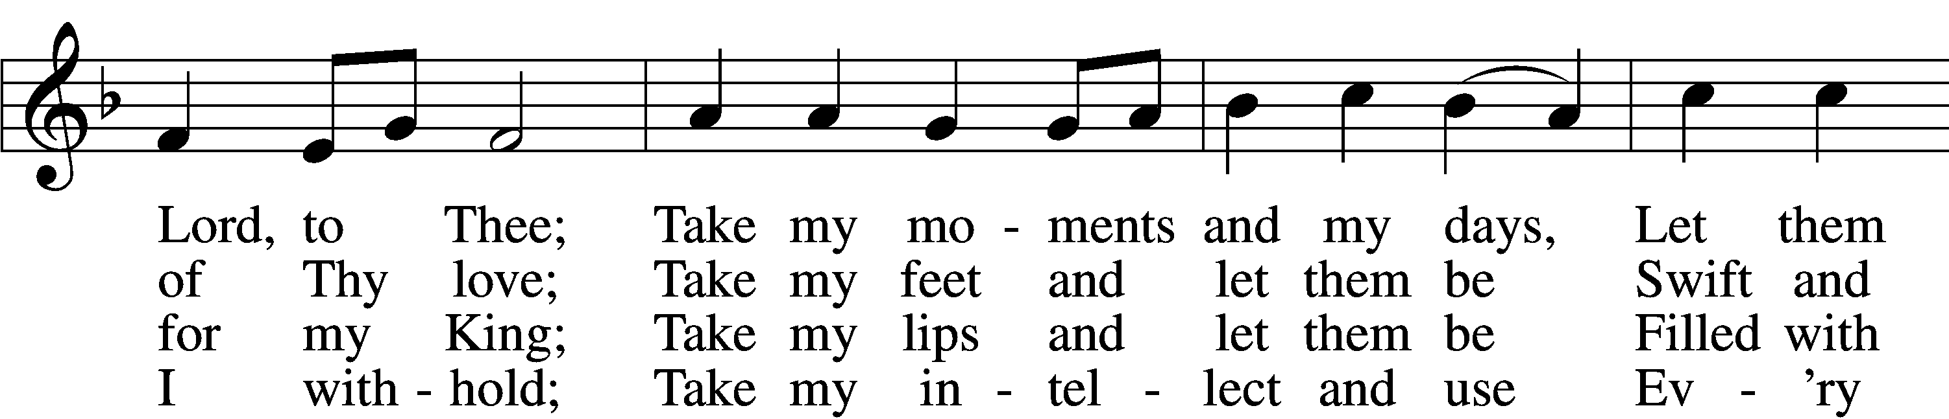
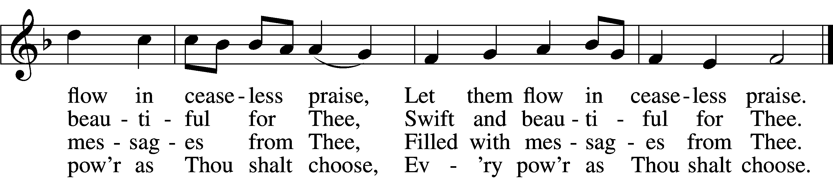

5 Take my will and make it Thine,
It shall be no longer mine;
Take my heart, it is Thine own,
It shall be Thy royal throne,
It shall be Thy royal throne.
6 Take my love, my Lord, I pour
At Thy feet its treasure store;
Take myself, and I will be
Ever, only, all for Thee,
Ever, only, all for Thee.

Tune and text: Public domain

Stand
Divine Service Setting One, page 151
T Confession and Absolution T
Confession, to confess to God our sins and sinful nature. Absolution, “To absolve of sin and wrongdoing,” more specifically, to affirm God’s forgiveness to all who sincerely confess their sins to Him.

The sign of the cross may be made by all in remembrance of their Baptism.

Invocation Matthew 28:19b; 18:20
P In the name of the Father and of the T Son and of the Holy Spirit.
C Amen.

Exhortation 1 John 1:8–9 LSB 151
P If we say we have no sin, we deceive ourselves, and the truth is not in us.
C But if we confess our sins, God, who is faithful and just, will forgive our sins and cleanse us from all unrighteousness.

Silence for reflection on God’s Word and for self-examination. Consider: Have you loved God with all your heart, all your soul, and all your strength? Have you loved your neighbor as yourself?

Confession of Sins LSB 151
P Let us then confess our sins to God our Father.
C Most merciful God, we confess that we are by nature sinful and unclean. We have sinned against You in thought, word, and deed, by what we have done and by what we have left undone. We have not loved You with our whole heart; we have not loved our neighbors as ourselves. We justly deserve Your present and eternal punishment. For the sake of Your Son, Jesus Christ, have mercy on us. Forgive us, renew us, and lead us, so that we may delight in Your will and walk in Your ways to the glory of Your holy name. Amen.

Absolution [John 20:19–23] LSB 151
P Almighty God in His mercy has given His Son to die for you and for His sake forgives you all your sins. As a called and ordained servant of Christ, and by His authority, I therefore forgive you all your sins in the name of the Father and of the T Son and of the Holy Spirit.
C Amen.

Sit

Service of the Word

Introit Psalm 2:6–7; 117; antiphon: Psalm 115:18
P But we will bless the Lord
C from this time forth and forevermore. Praise the Lord!
P As for me, I have set my King
C on Zion, my holy hill.
P I will tell of the decree:
C The Lord said to me, “You are my Son; today I have begotten you.”
P Praise the Lord, all nations!
C Extol him, all peoples!
P For great is his steadfast love toward us,
C and the faithfulness of the Lord endures forever. Praise the Lord! Glory be to the Father and to the Son and to the Holy Spirit; as it was in the beginning, is now, and will be forever. Amen.
P But we will bless the Lord
C from this time forth and forevermore. Praise the Lord!

Kyrie Mark 10:47 LSB 152
A Greek phrase meaning, “Lord, have mercy!” A brief prayer not only imploring God’s mercy but rejoicing in it through Jesus Christ.

P In peace let us pray to the Lord.
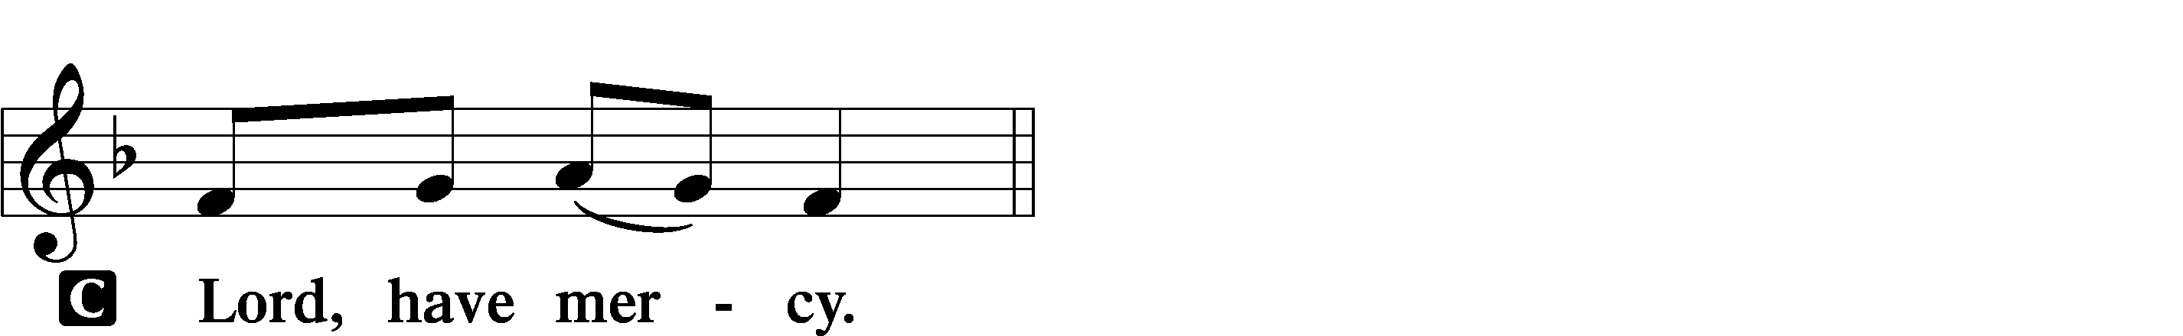

P For the peace from above and for our salvation let us pray to the Lord.
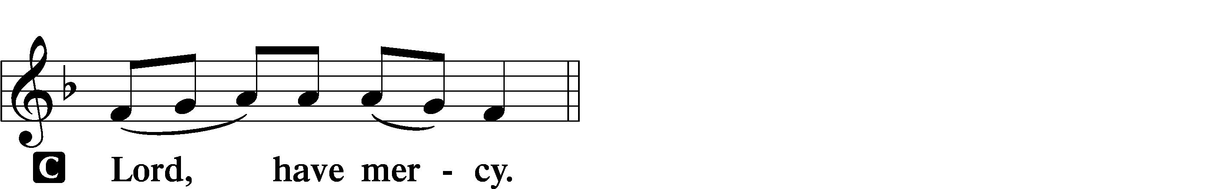

P For the peace of the whole world, for the well-being of the Church of God, and for the unity of all let us pray to the Lord.
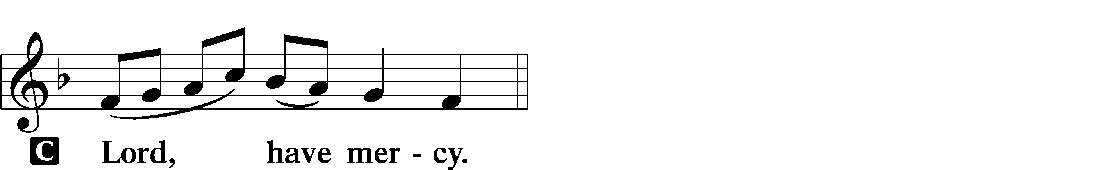

P For this holy house and for all who offer here their worship and praise let us pray to the Lord.
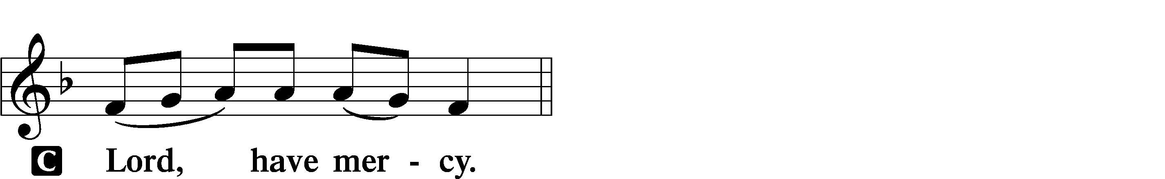

P Help, save, comfort, and defend us, gracious Lord.

This Is the Feast Revelation 5:12–13; 19:5–9 LSB 155
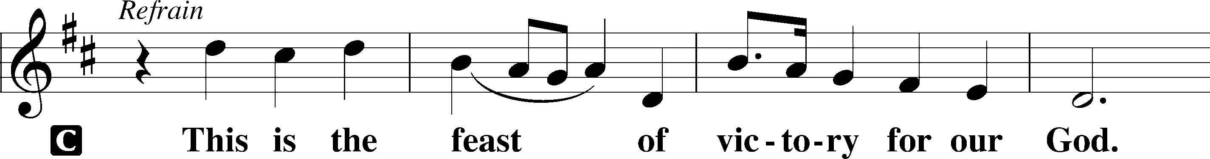
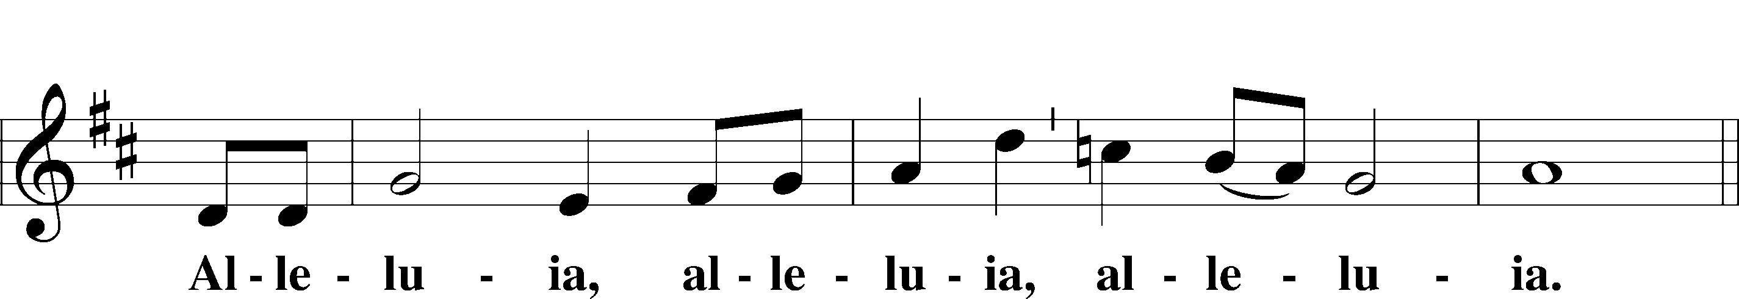
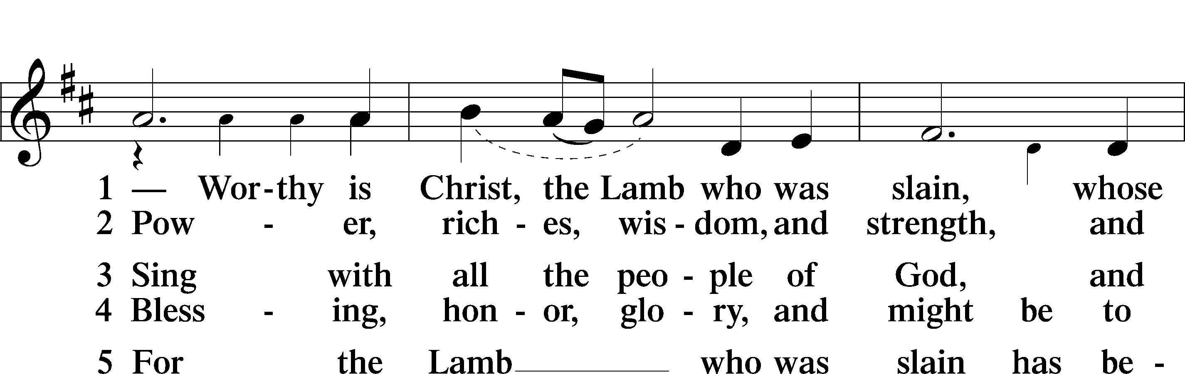
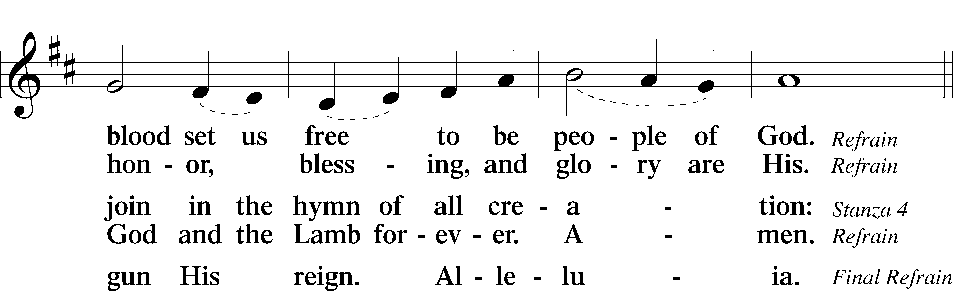
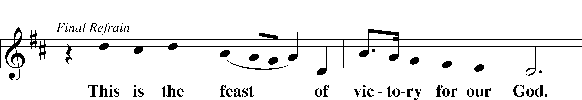
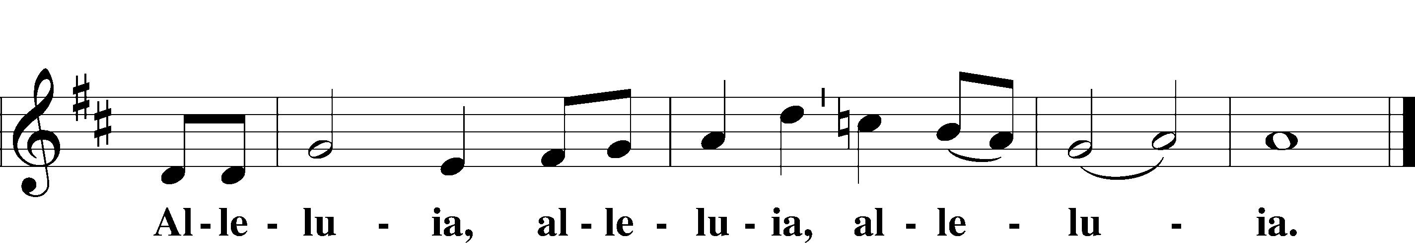

Salutation and Collect of the Day
“Salutation” is a word from Latin meaning, “to greet.” "Collect" (KAH-lekt), a brief structured prayer, usually consisting of five parts: address to God, basis for the prayer, petition, desired benefit or result, and trinitarian conclusion. The Collect of the Day also "collects" the message of the day's Gospel reading.

P The Lord be with you.
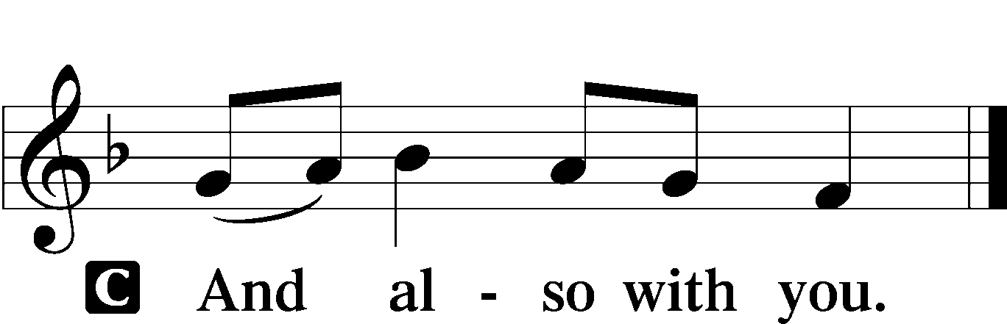

P Let us pray.
Almighty God, whom to know is everlasting life, grant us to know Your Son, Jesus, to be the way, the truth, and the life that we may boldly confess Him to be the Christ and steadfastly walk in the way that leads to life eternal; through the same Jesus Christ, our Lord, who lives and reigns with You and the Holy Spirit, one God, now and forever.

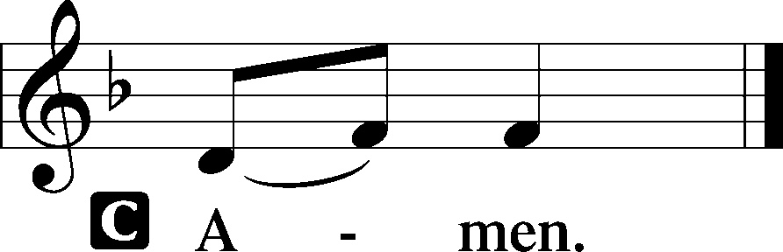

Old Testament Reading Isaiah 51:1–6
A The Old Testament Reading is from Isaiah, chapter 51.

1“Listen to me, you who pursue righteousness,
you who seek the Lord:
look to the rock from which you were hewn,
and to the quarry from which you were dug.
2Look to Abraham your father
and to Sarah who bore you;
for he was but one when I called him,
that I might bless him and multiply him.
3For the Lord comforts Zion;
he comforts all her waste places
and makes her wilderness like Eden,
her desert like the garden of the Lord;
joy and gladness will be found in her,
thanksgiving and the voice of song.
4“Give attention to me, my people,
and give ear to me, my nation;
for a law will go out from me,
and I will set my justice for a light to the peoples.
5My righteousness draws near,
my salvation has gone out,
and my arms will judge the peoples;
the coastlands hope for me,
and for my arm they wait.
6Lift up your eyes to the heavens,
and look at the earth beneath;
for the heavens vanish like smoke,
the earth will wear out like a garment,
and they who dwell in it will die in like manner;
but my salvation will be forever,
and my righteousness will never be dismayed.”

A This is the Word of the Lord.
C Thanks be to God.

Epistle Romans 11:33—12:8
A The Epistle is from Romans, chapters 11 and 12.

33Oh, the depth of the riches and wisdom and knowledge of God! How unsearchable are his judgments and how inscrutable his ways!
34“For who has known the mind of the Lord,
or who has been his counselor?”
35“Or who has given a gift to him
that he might be repaid?”
36For from him and through him and to him are all things. To him be glory forever. Amen.
1I appeal to you therefore, brothers, by the mercies of God, to present your bodies as a living sacrifice, holy and acceptable to God, which is your spiritual worship. 2Do not be conformed to this world, but be transformed by the renewal of your mind, that by testing you may discern what is the will of God, what is good and acceptable and perfect.
3For by the grace given to me I say to everyone among you not to think of himself more highly than he ought to think, but to think with sober judgment, each according to the measure of faith that God has assigned. 4For as in one body we have many members, and the members do not all have the same function, 5so we, though many, are one body in Christ, and individually members one of another. 6Having gifts that differ according to the grace given to us, let us use them: if prophecy, in proportion to our faith; 7if service, in our serving; the one who teaches, in his teaching; 8the one who exhorts, in his exhortation; the one who contributes, in generosity; the one who leads, with zeal; the one who does acts of mercy, with cheerfulness.

A This is the Word of the Lord.
C Thanks be to God.

Stand

Alleluia and Verse LSB 156
Hebrew word meaning "praise the LORD." Also spelled "Hallelujah".
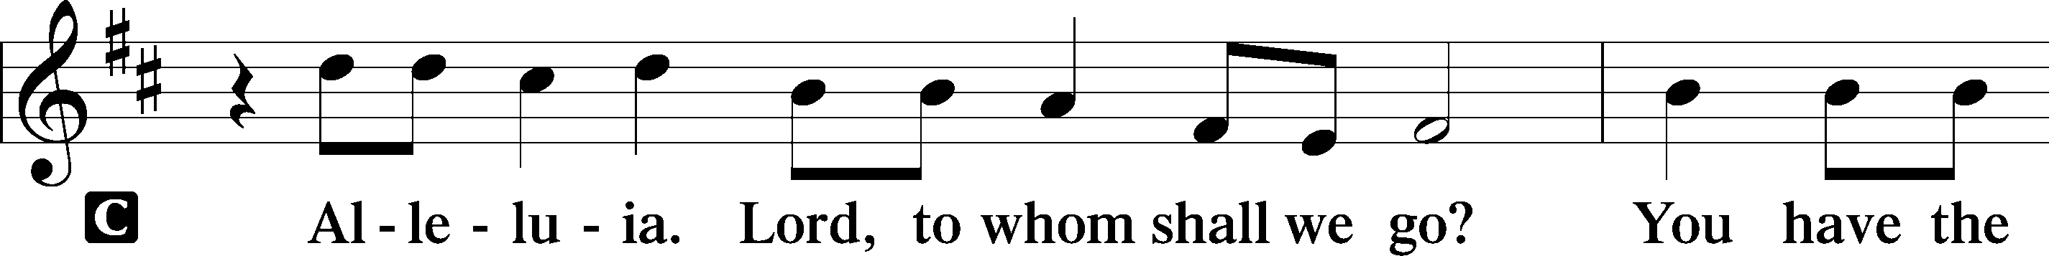
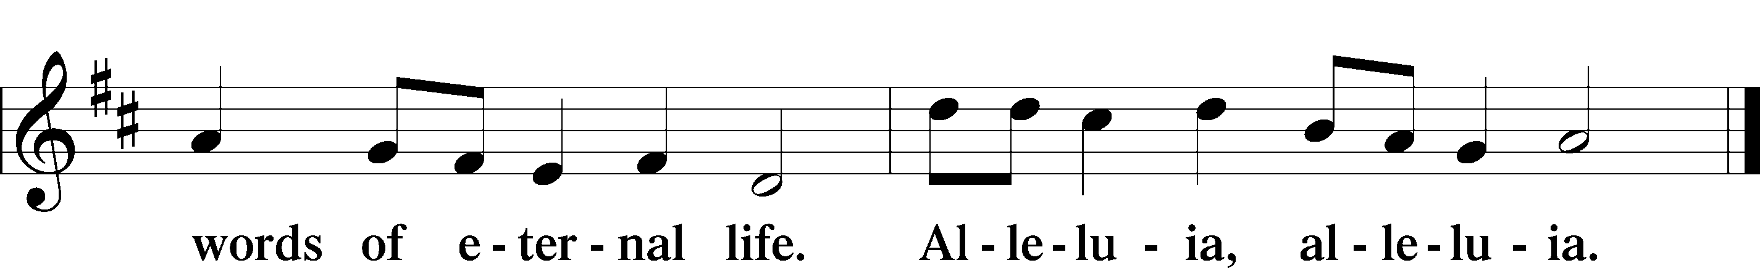

Holy Gospel Matthew 16:13–20
P The Holy Gospel according to St. Matthew, the sixteenth chapter.

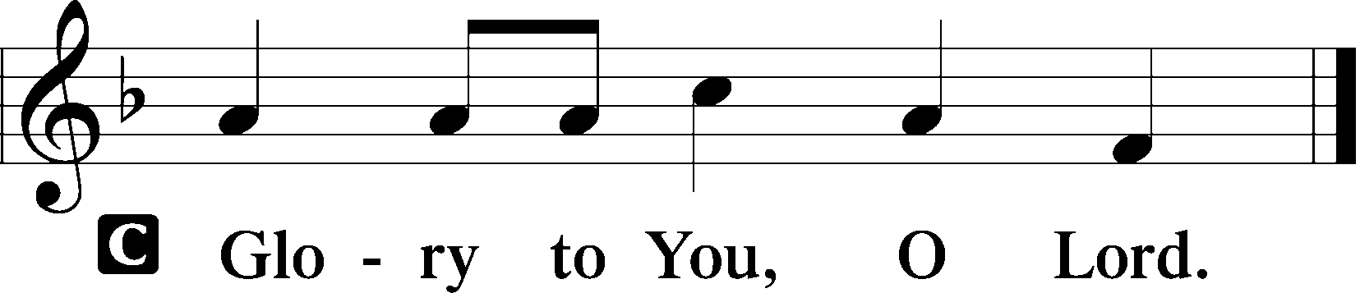

13Now when Jesus came into the district of Caesarea Philippi, he asked his disciples, “Who do people say that the Son of Man is?” 14And they said, “Some say John the Baptist, others say Elijah, and others Jeremiah or one of the prophets.” 15He said to them, “But who do you say that I am?” 16Simon Peter replied, “You are the Christ, the Son of the living God.” 17And Jesus answered him, “Blessed are you, Simon Bar-Jonah! For flesh and blood has not revealed this to you, but my Father who is in heaven. 18And I tell you, you are Peter, and on this rock I will build my church, and the gates of hell shall not prevail against it. 19I will give you the keys of the kingdom of heaven, and whatever you bind on earth shall be bound in heaven, and whatever you loose on earth shall be loosed in heaven.” 20Then he strictly charged the disciples to tell no one that he was the Christ.

P This is the Gospel of the Lord.

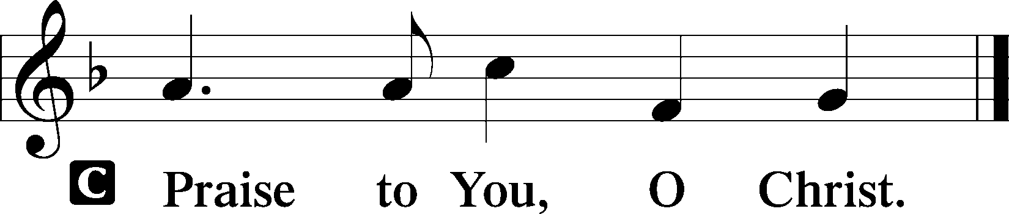

Nicene Creed
Creed comes from the Latin “credo” which means “I believe." We confess our Christian faith in one of the three creeds (short statement of belief) agreed upon by the ancient church.

C I believe in one God,
the Father Almighty,
maker of heaven and earth
and of all things visible and invisible.

And in one Lord Jesus Christ,
the only-begotten Son of God,
begotten of His Father before all worlds,
God of God, Light of Light,
very God of very God,
begotten, not made,
being of one substance with the Father,
by whom all things were made;
who for us men and for our salvation came down from heaven
and was incarnate by the Holy Spirit of the virgin Mary
and was made man;
and was crucified also for us under Pontius Pilate.
He suffered and was buried.
And the third day He rose again according to the Scriptures
and ascended into heaven
and sits at the right hand of the Father.
And He will come again with glory to judge both the living and the dead,
whose kingdom will have no end.

And I believe in the Holy Spirit,
the Lord and giver of life,
who proceeds from the Father and the Son,
who with the Father and the Son together is worshiped and glorified,
who spoke by the prophets.
And I believe in one holy Christian and apostolic Church,
I acknowledge one Baptism for the remission of sins,
and I look for the resurrection of the dead
and the life Tof the world to come. Amen.

Sit
645 Built on the Rock LSB 645
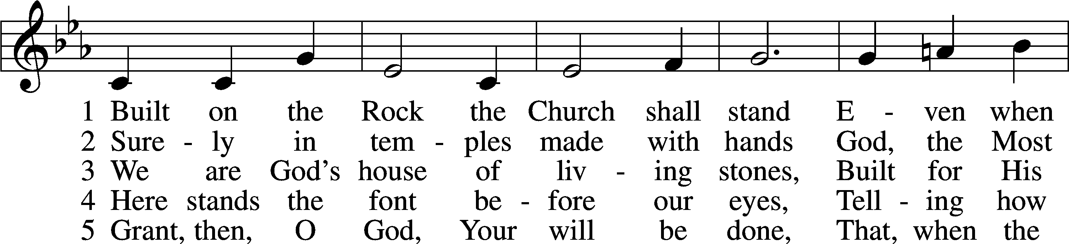
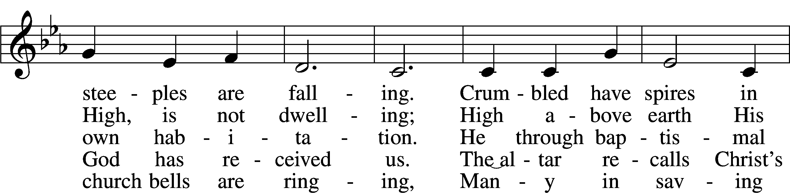
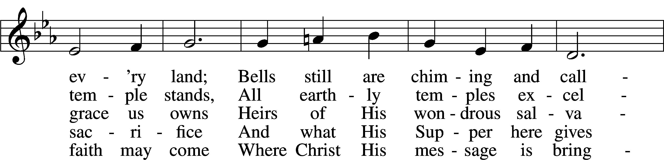
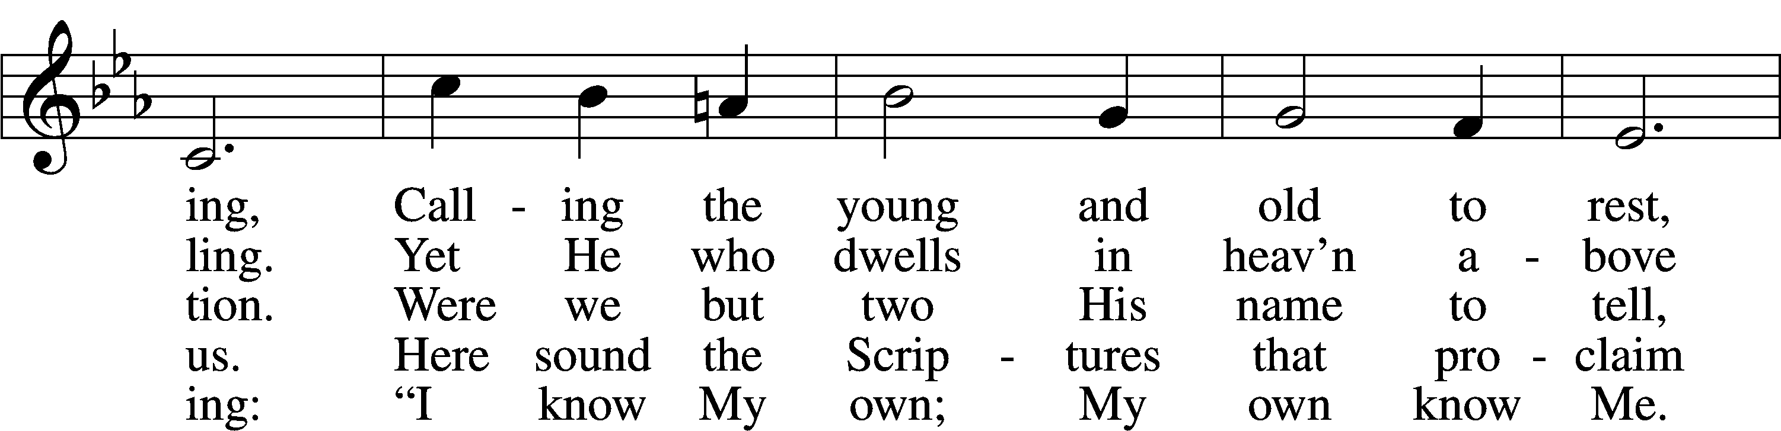
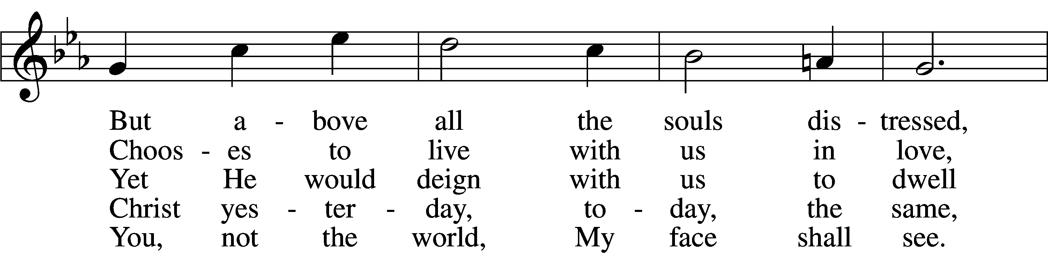
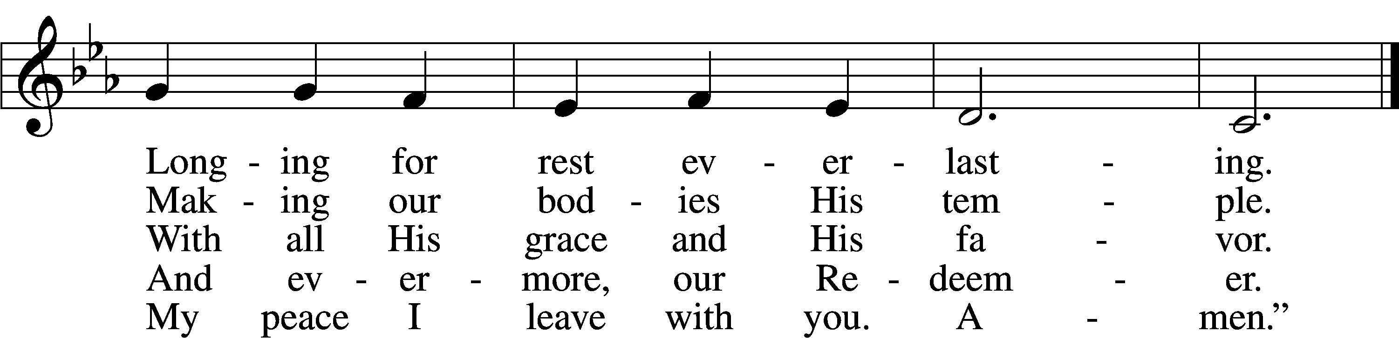
Tune and text: Public domain

Sermon

Offering
For those gathered with us in-person, an offering plate will be at the back of the room for a contactless drop-off for your gifts, tithes, and offerings as you leave today’s service.

For those still joining us remotely, we have multiple options for giving. You can text CHRISTLCMS to 77977 to give via text message, or sign up for online giving at pushpay.com/pay/christlcms for a one-time or recurring gift. Or, use the “My Church by PushPay” app, with keyword CHRISTLCMS. You may also mail your offering to the church office (3509 SW Burlingame Rd, Topeka, KS 66611).
Direct links with more information are available on the church website (christlcms.org/giving).

If you have prayer requests, please e-mail them to our church office (office@christlcms.org) or call the office at (785) 266-6263. We will include them in next week’s service, and also share them with our prayer chain if desired.

Stand

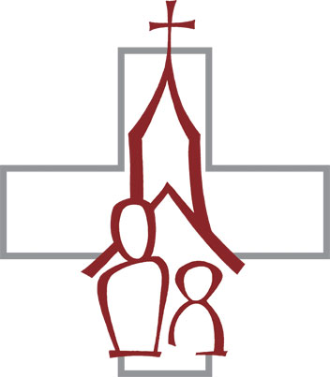
Offertory Psalm 116:12–13, 17–19 LSB 159
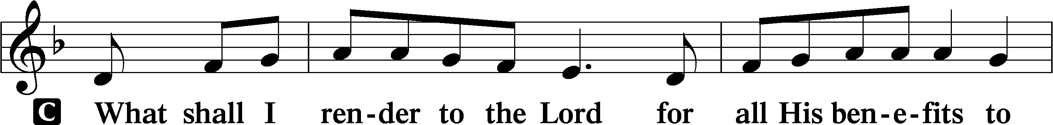
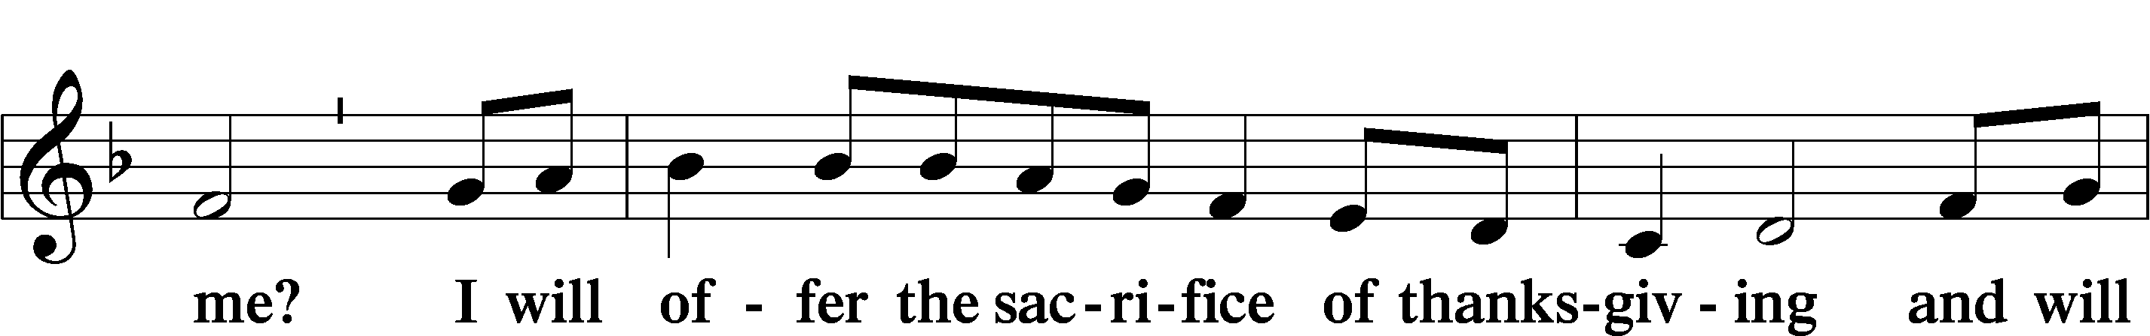
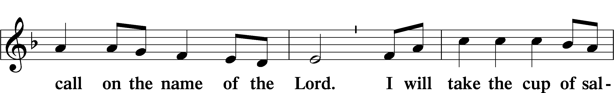
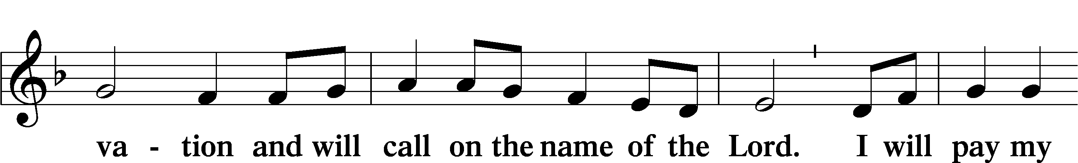
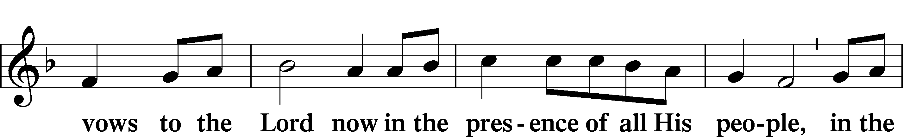
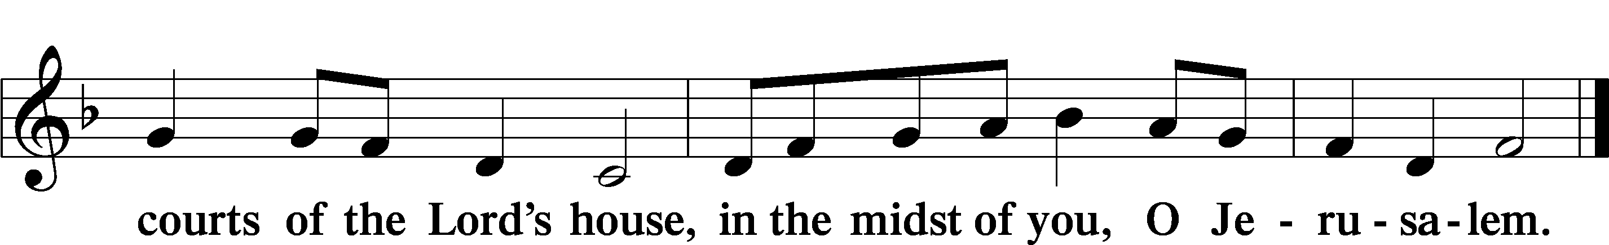

Reception of Members by Transfer (9:15 am)

Congregation Sit

P Beloved in the Lord, our Lord Jesus Christ said to His apostles: “Whoever confesses Me before men, I will also confess before My Father who is in heaven. But whoever denies Me before men, I will also deny before My Father who is in heaven.” Lift up your hearts, therefore, to the God of all grace and joyfully give answer to what I now ask you in the name of the Lord.

P Do you this day in the presence of God and of this congregation acknowledge the gifts that God gave you in your Baptism?
R Yes, I do.
P Do you renounce the devil and all his works and all his ways?
R Yes, I renounce them.

P Do you believe in God, the Father Almighty, in Jesus Christ, His only Son our Lord, and in the Holy Spirit?
R Yes, I believe in God the Father, Son, and Holy Spirit.

P Do you hold all the prophetic and apostolic Scriptures to be the inspired Word of God and the doctrine of the Evangelical Lutheran Church, drawn from them and confessed in the Small Catechism, to be faithful and true?
R I do.

P Do you intend to hear the Word of God and receive the Lord’s Supper faithfully?
R I do, by the grace of God.

P Do you intend to live according to the Word of God, and in faith, word, and deed to remain true to God, Father, Son, and Holy Spirit, even to death?
R I do, by the grace of God.

P Do you intend to continue steadfast in this confession and Church and to suffer all, even death, rather than fall away from it?
R I do, by the grace of God.

P Do you desire to become a member of this congregation?
R I do.

P Will you support the work our gracious Lord has given this congregation with your prayers and the gifts God has given you?
R I will, with the help of God.

P Upon this your confession of faith, I acknowledge publicly that you are a member of the Evangelical Lutheran Church and of this congregation. Receive the Lord’s Supper and participate with us in all the blessings of salvation that our Lord has given to His Church, in the name of the Father and of the T Son and of the Holy Spirit.
C Amen.

Stand

P Let us pray.
Lord God, heavenly Father, we thank and praise You for Your great goodness in bringing these Your sons and daughters to the knowledge of Your Son, our Savior, Jesus Christ, and enabling them both with the heart to believe and with the mouth to confess His saving name. Grant that by Your Word and Spirit they may continue steadfast in the one true faith in the fellowship of this congregation as together we await the day when all who have fought the good fight of faith shall receive the crown of righteousness; through Jesus Christ, Your Son, our Lord, who lives and reigns with You and the Holy Spirit, one God, now and forever.
C Amen.

The pastor may extend the right hand of fellowship, greeting each by name. The rite concludes with the following blessing:

P The grace of our T Lord Jesus Christ be with you.
C Amen.

The new members return to their places.

Prayer of the Church 1 Timothy 2:1-4
P Let us pray to the Lord for all that we need and on behalf of all people, that He may bestow upon us the riches of His grace and that we may receive His gifts with faith and thanksgiving in our hearts.

Brief silence

P For true unity in the faith; for the preservation of pure doctrine; for harmony in the lives of our congregation, district and Synod; and for charitable hearts that put the best construction on what we see and hear, let us pray to the Lord:
C Lord, have mercy.
P For those outside the kingdom; for missionaries near and far; for the ministries and agencies of our Church whereby the Gospel is spoken to those who have not heard; and for those who hear, that they may be brought to faith, let us pray to the Lord:
C Lord, have mercy.

P For all pastors and church workers, for those preparing for full-time church work, and for those considering church-work vocations, let us pray to the Lord:
C Lord, have mercy.

P For all families, for husbands and wives to live in faithfulness to each other, for all mothers with child, for all children, and for those who bring them to Baptism and nurture them in the faith, let us pray to the Lord:
C Lord, have mercy.

P For our president; the Congress; our governor; all elected and appointed leaders; all judges and magistrates; the members of the armed forces; and our police, firefighters and emergency medical personnel in their duties to protect and serve us, let us pray to the Lord:
C Lord, have mercy.

P For the healing of the sick, the relief of the suffering, the comfort of the grieving and the peace of the dying, [especially _____________,] and for those who care for them in their afflictions, let us pray to the Lord:
C Lord, have mercy.

P For this holy assembly and for our communion upon the Lord’s body and blood, and for us to bear in our lives the fruits of the Spirit and do the good works for which we were created, let us pray to the Lord:
C Lord, have mercy.

P For all honest work and occupations, for our good use of the fruits of our labors, for generosity for those in need, and for the tithes and offerings that accompany our sacrifice of praise and thanksgiving, let us pray to the Lord:
C Lord, have mercy.

P For our remembrance of the saints and in thanksgiving for their faithful witness, that at last we may be joined with them in Your eternal presence, let us pray to the Lord:
C Lord, have mercy.

P Lord God, giver of all that is good, mercifully hear the prayers of Your people and grant us Your grace, that we may endure the changes and chances of this mortal life and be found worthy when our Savior comes to bring to completion all things; through Jesus Christ, our Lord, who lives and reigns with You and the Holy Spirit, one God, now and forever.
C Amen.

Service of the Sacrament

Preface 2 Timothy 4:22; [Colossians 3:1]; [Psalm 136] LSB 160
P The Lord be with you.

P Lift up your hearts.

P Let us give thanks to the Lord our God.
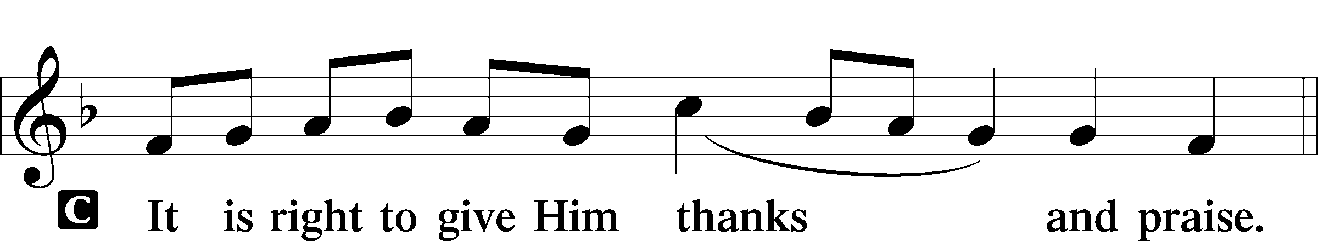

Proper Preface (Full)
P It is truly good, right, and salutary that we should at all times and in all places give thanks to You, holy Lord, almighty Father, everlasting God, through Jesus Christ, our Lord, who on this day overcame death and the grave and by His glorious resurrection opened to us the way of everlasting life. Therefore with angels and archangels and with all the company of heaven we laud and magnify Your glorious name, evermore praising You and saying:

Sanctus Isaiah 6:3; Matthew 21:9 LSB 161
(SAHNK-toose),"Sanctus" is Latin for "holy".
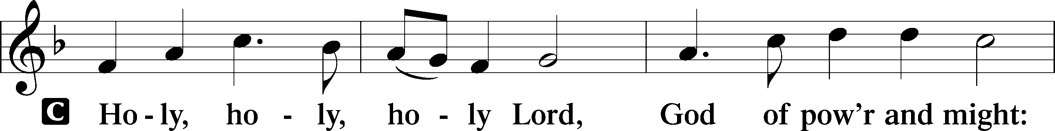
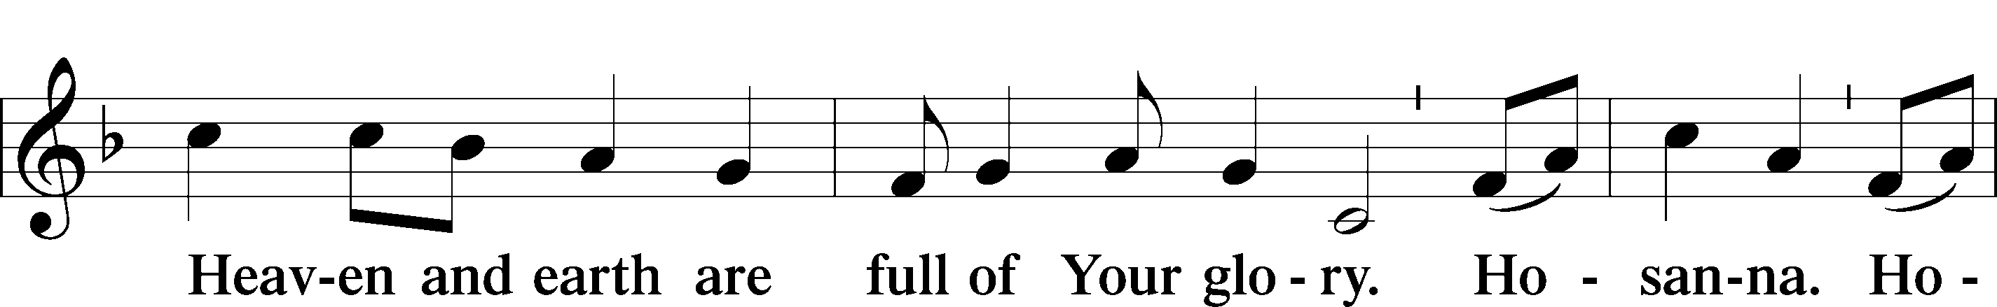
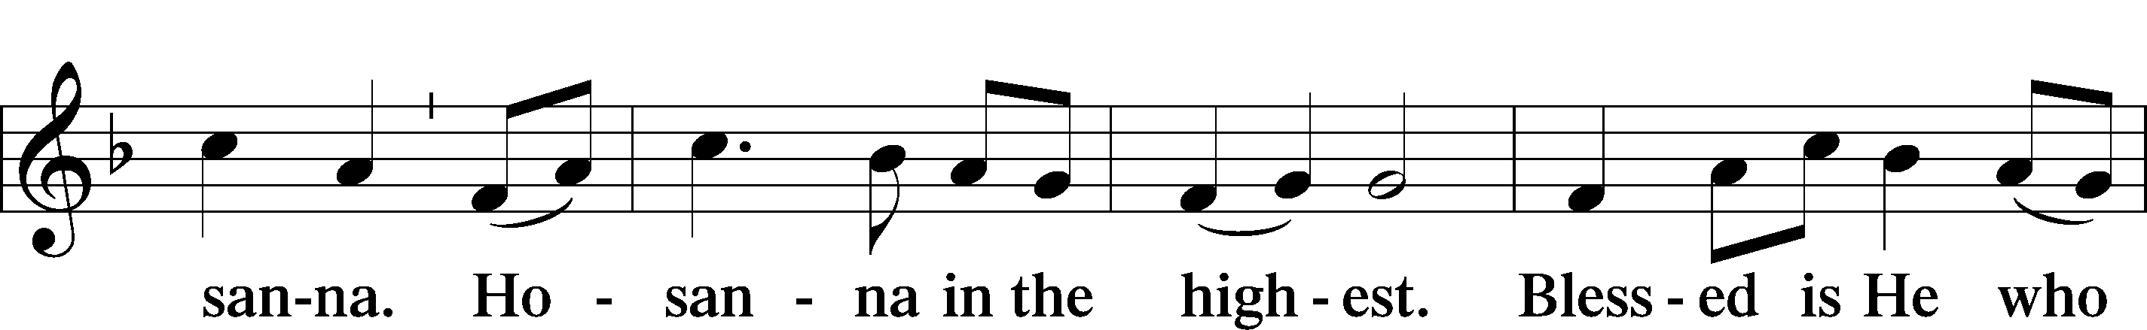
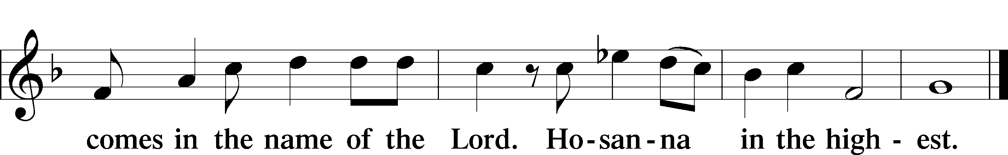

Prayer of Thanksgiving LSB 161
P Blessed are You, Lord of heaven and earth, for You have had mercy on those whom You created and sent Your only-begotten Son into our flesh to bear our sin and be our Savior. With repentant joy we receive the salvation accomplished for us by the all-availing sacrifice of His body and His blood on the cross.

Gathered in the name and the remembrance of Jesus, we beg You, O Lord, to forgive, renew, and strengthen us with Your Word and Spirit. Grant us faithfully to eat His body and drink His blood as He bids us do in His own testament. Gather us together, we pray, from the ends of the earth to celebrate with all the faithful the marriage feast of the Lamb in His kingdom, which has no end. Graciously receive our prayers; deliver and preserve us. To You alone, O Father, be all glory, honor, and worship, with the Son and the Holy Spirit, one God, now and forever.
C Amen.

Lord’s Prayer Matthew 6:9–13 LSB 162
P Lord, remember us in Your kingdom and teach us to pray:
C Our Father who art in heaven,
hallowed be Thy name,
Thy kingdom come,
Thy will be done on earth
as it is in heaven;
give us this day our daily bread;
and forgive us our trespasses
as we forgive those
who trespass against us;
and lead us not into temptation,
but deliver us from evil.
For Thine is the kingdom
and the power and the glory
forever and ever. Amen.

The Words of Our Lord
P Our Lord Jesus Christ, on the night when He was betrayed, took bread, and when He had given thanks, He broke it and gave it to the disciples and said: “Take, eat; this is My T body, which is given for you. This do in remembrance of Me.”

In the same way also He took the cup after supper, and when He had given thanks, He gave it to them, saying: “Drink of it, all of you; this cup is the new testament in My T blood, which is shed for you for the forgiveness of sins. This do, as often as you drink it, in remembrance of Me.”

Pax Domini John 20:19 LSB 163
(PAKS DOH-mee-nee), Latin for "peace of the Lord" (John 20:19).

P The peace of the Lord be with you always.

Agnus Dei John 1:29 LSB 163
(AHG-noose DAY-ee). Latin for “Lamb of God.”

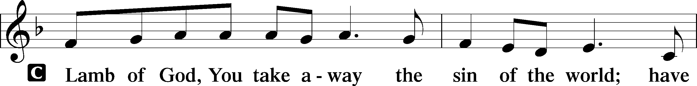
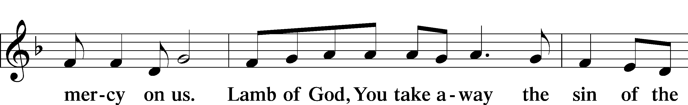
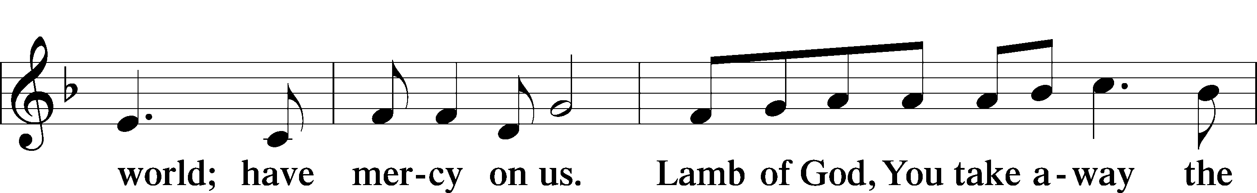
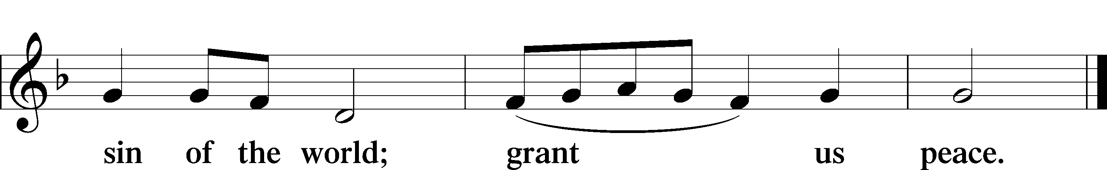

Sit

Distribution
Communion is reserved for those who are members of the Lutheran Church-Missouri Synod or members of a church body in fellowship with the LCMS unless special arrangements have been made with the pastor. The pastor and those who assist him receive the body and blood of Christ first. Then they will distribute it to those who cannot come up to the front of the sanctuary due to physical ailments. Following that the ushers will dismiss the people from their pews to proceed to the front. All are invited up to receive a blessing.

575 My Hope Is Built on Nothing Less LSB 575
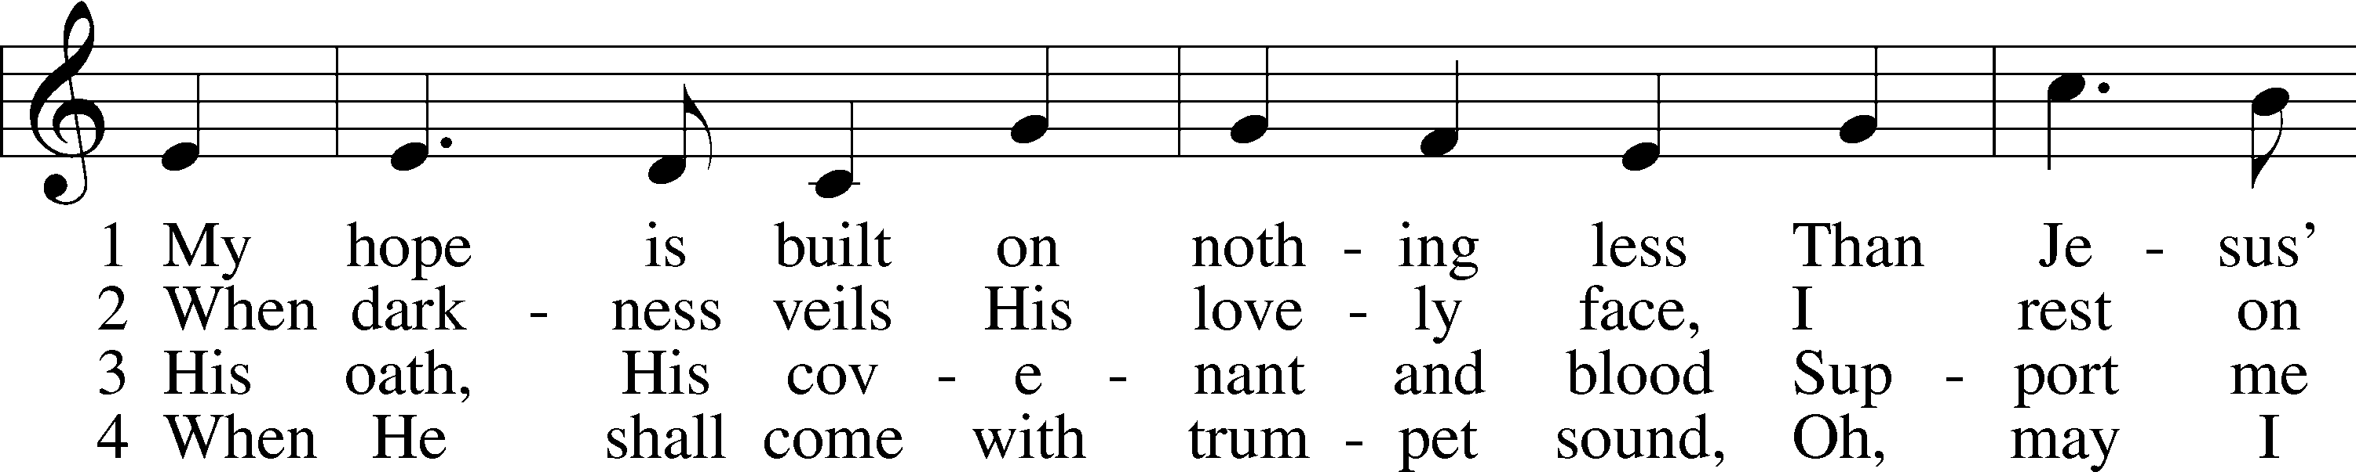
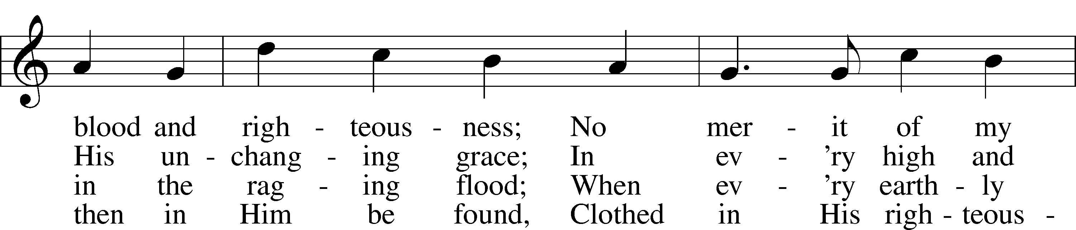
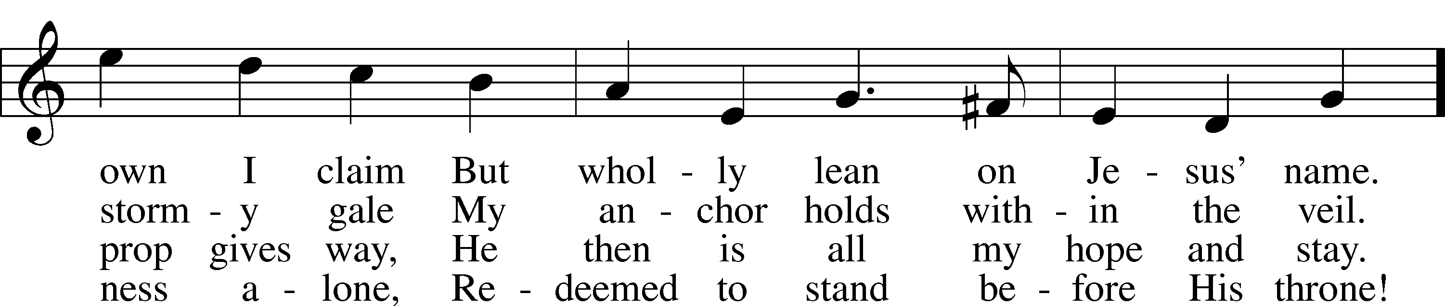
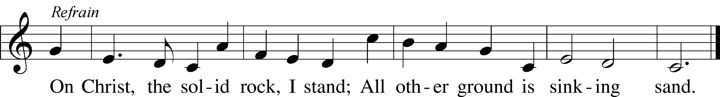
Tune and text: Public domain

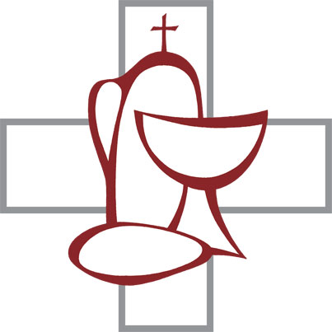
730 What Is the World to Me LSB 730
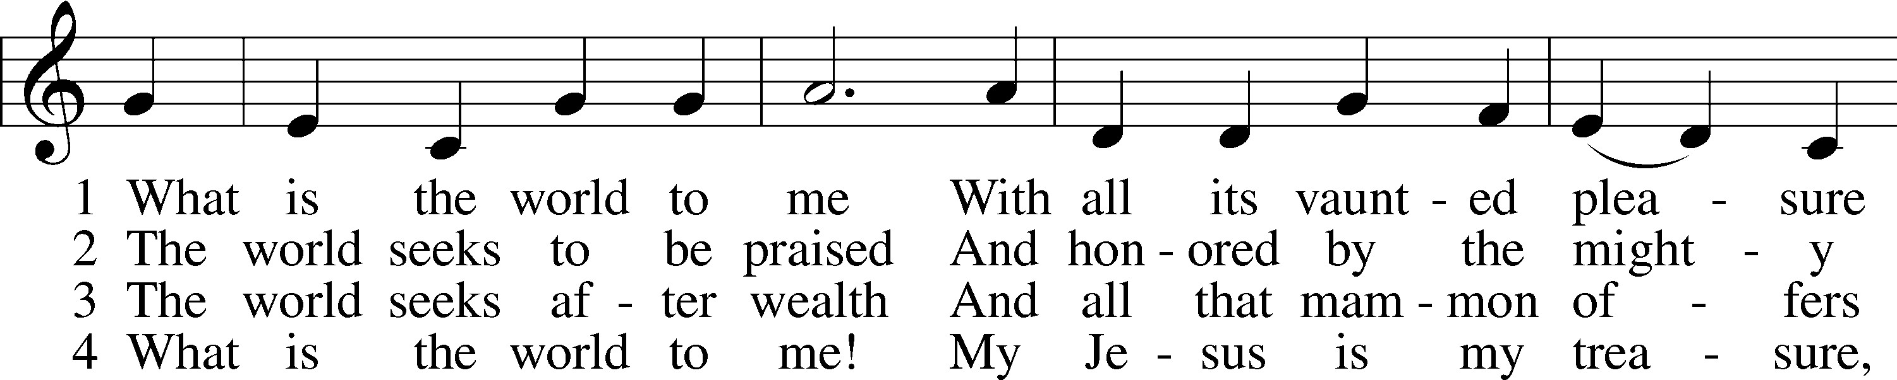
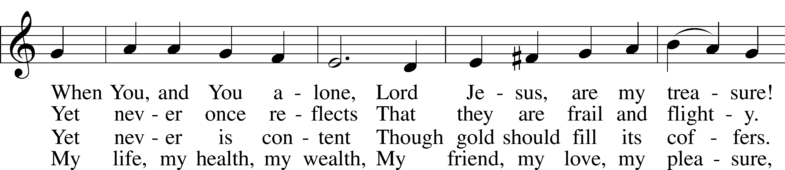
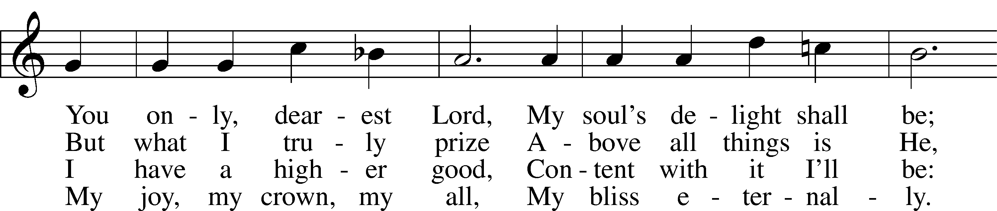
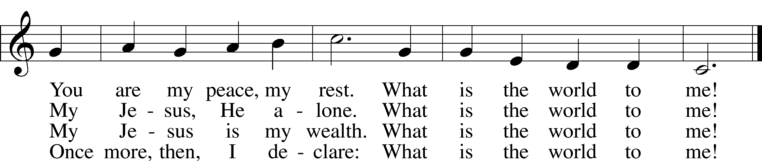
Tune and text: Public domain

802 Immortal, Invisible, God Only Wise LSB 802
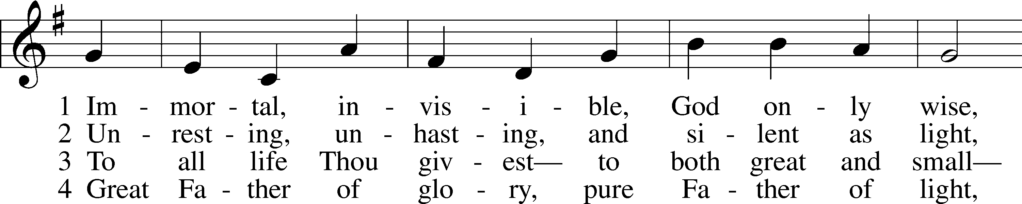
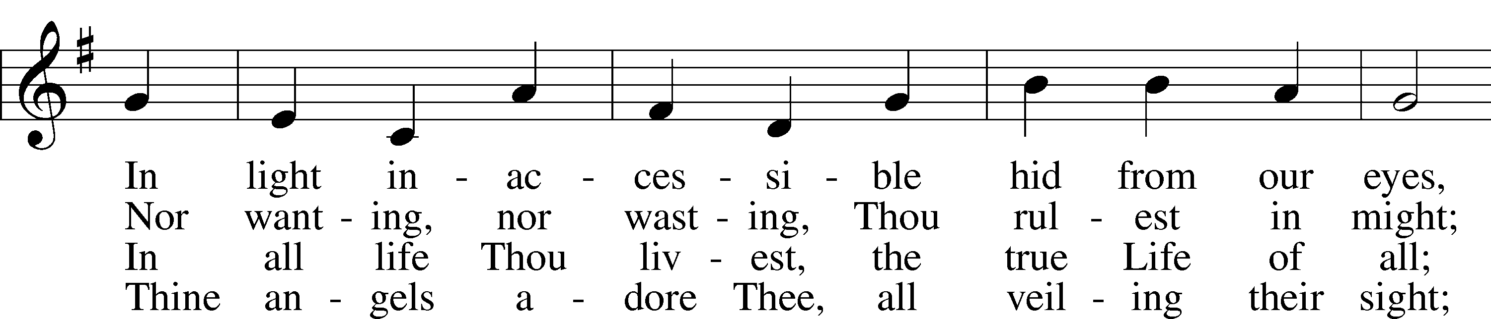
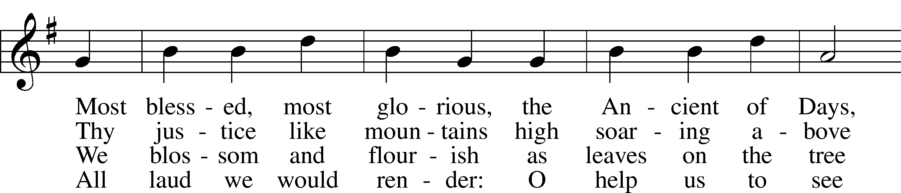
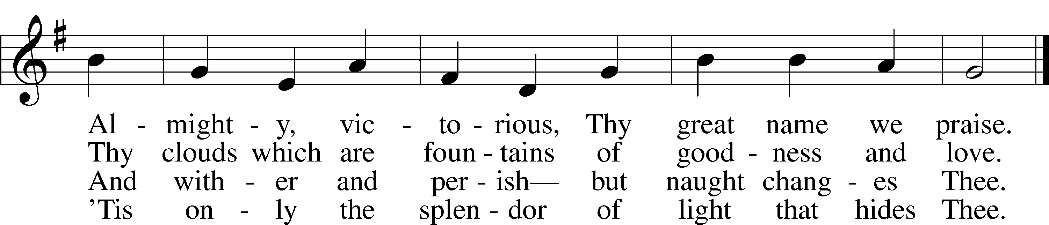
Text and tune: Public domain

Stand

Dismissal

Thank the Lord [Psalm 105:1–3, 42–43]; [1 Chronicles 16:8–10] LSB 164
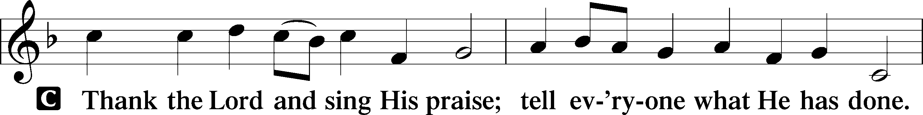
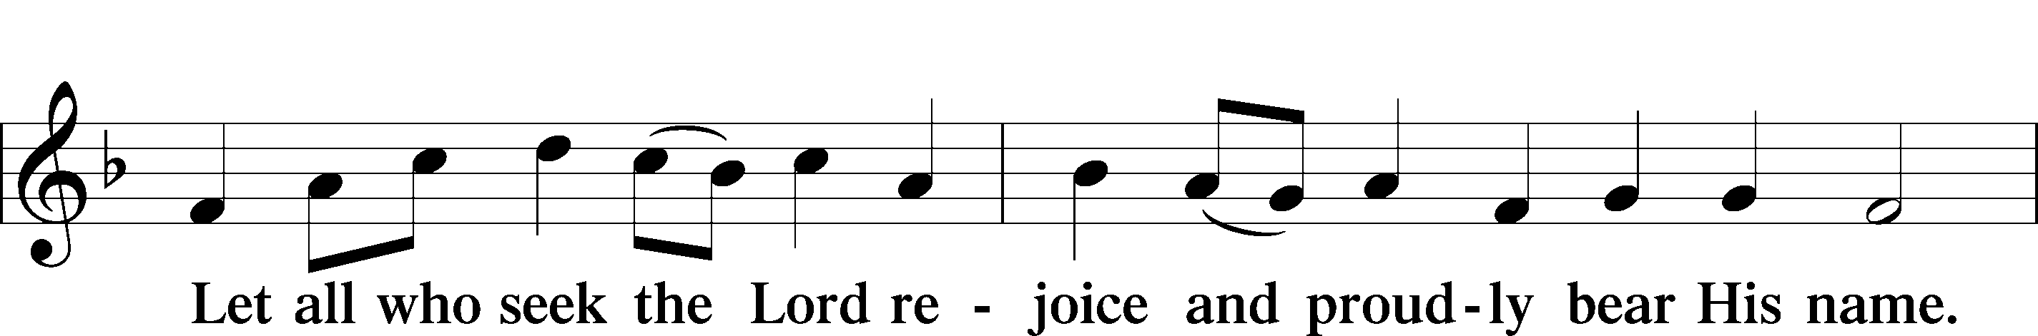
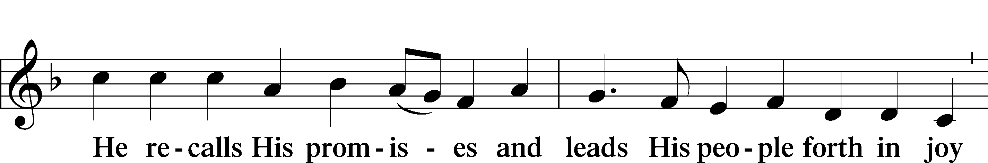
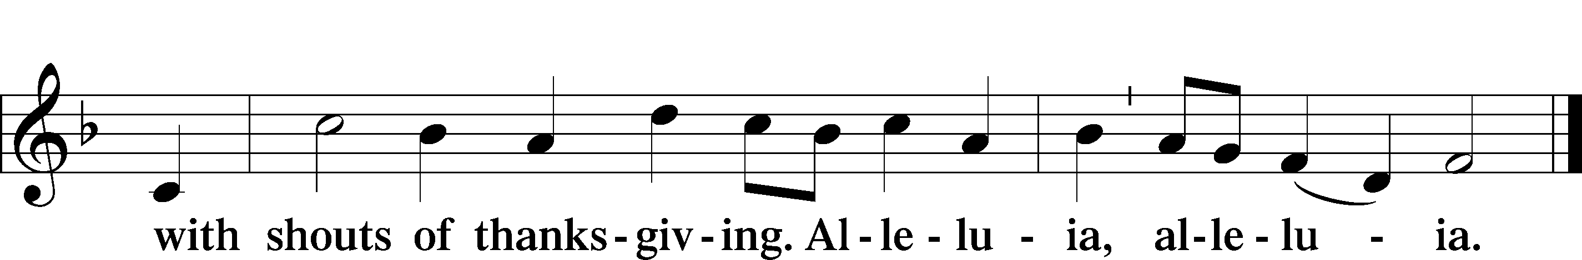

Post-Communion Collect
P Let us pray.
We give thanks to You, almighty God, that You have refreshed us through this salutary gift, and we implore You that of Your mercy You would strengthen us through the same in faith toward You and in fervent love toward one another; through Jesus Christ, Your Son, our Lord, who lives and reigns with You and the Holy Spirit, one God, now and forever.
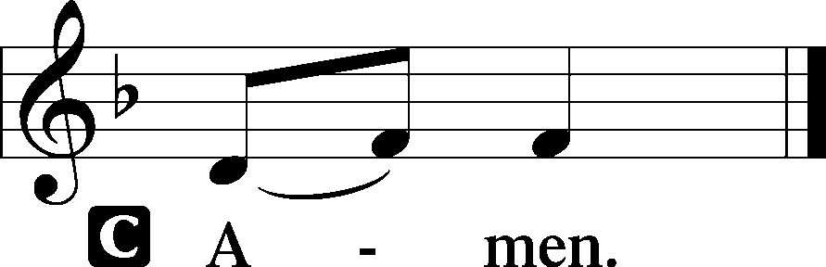

Luther's Morning Prayer
C I thank You, my heavenly Father, through Jesus Christ, Your dear Son, that You have kept me this night from all harm and danger; and I pray that You would keep me this day also from sin and every evil, that all my doings and life may please You. For into Your hands I commend myself, my body and soul, and all things. Let Your holy angel be with me, that the evil foe may have no power over me.
Amen.

Benediction Numbers 6:24–26 LSB 166
A final blessing from God this morning before we leave.

P The Lord bless you and keep you.
The Lord make His face shine on you and be gracious to you.
The Lord look upon you with favor and T give you peace.

662 Onward, Christian Soldiers LSB 662
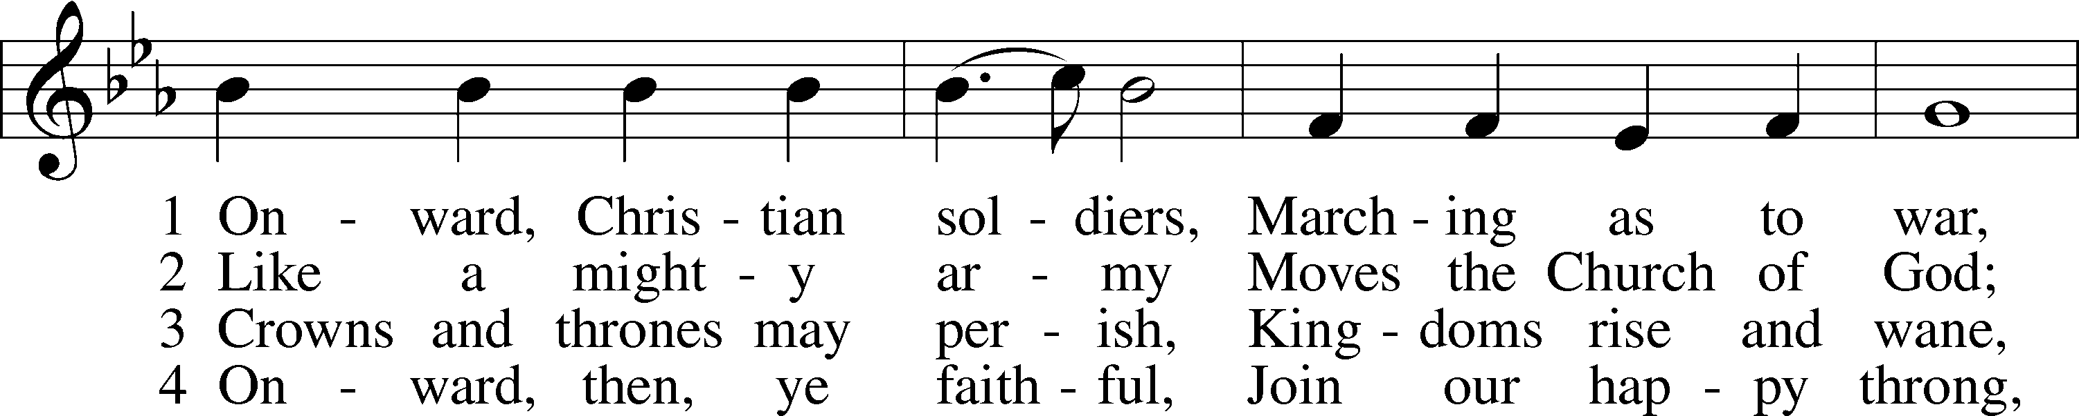
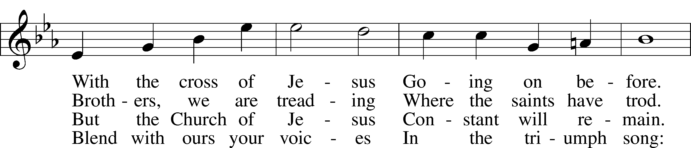
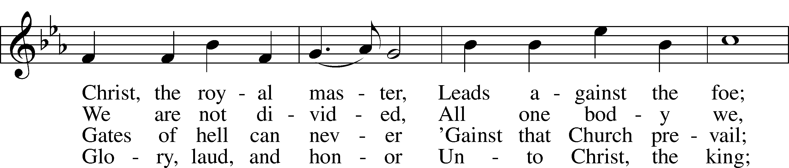
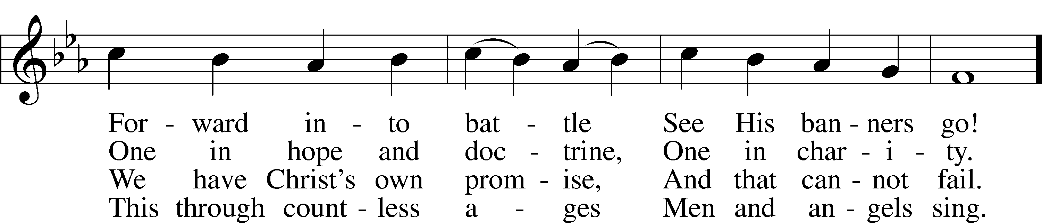
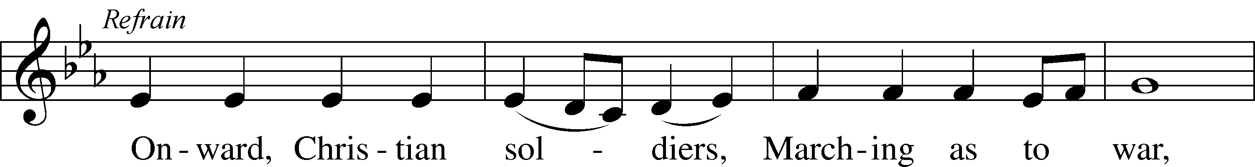
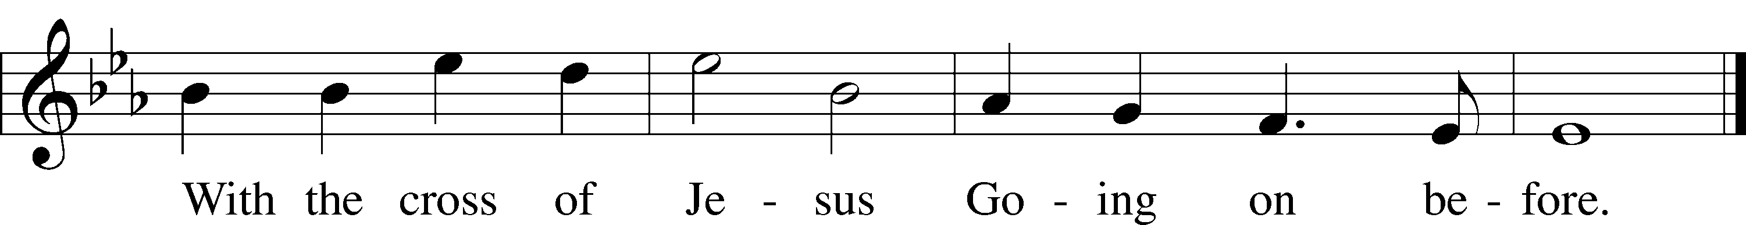
Text and tune: Public domain

Acknowledgments
Unless otherwise indicated, Scripture quotations are from the ESV® Bible (The Holy Bible, English Standard Version®), copyright © 2001 by Crossway, a publishing ministry of Good News Publishers. Used by permission. All rights reserved.
Created by Lutheran Service Builder © 2018 Concordia Publishing House.
-- Week at a Glance --

Sunday  August 23 | 8:00, 9:15, & 10:30 am  5:00 pm | Worship Service w/ Communion  Youth Group (7th-12th grades)
Monday
August 24
Tuesday  August 25 | 9:00 am | LWML Work Day
Wednesday  August 26 | 7:00 pm | Pastor’s Bible Class
Thursday
August 27
Friday
August 28
Saturday  August 29 | 10:00 am | Men’s Bible Study (via Zoom)
Sunday  August 30 | 8:00, 9:15, & 10:30 am  3:00 pm | Worship Service w/ Communion  Movie in the gym
-- Announcements --

Celebrating
Birthdays: Jalen F., Cailin J. (23rd); Paige C., Galen H. (24th); Morgan C. (25th); LaJean R., Lincoln S. (26th); Robyn F. (27th); Matthew G. (28th); Matt L., Earl P. (29th)
Baptism Birthdays: Emil B., Natasha M., Helen M. (23rd); Chase F. (25th); Baylee A., Ellie A., Jay W. (27th); Chas M., Chenoa M., Maliyah M., Kory S. (29th)
Anniversaries: Yancy & Jennifer A. (25th); DelRay & Kadie C. (26th)

Overflow Seating
Our 8:00 Sunday morning service has been at maximum (distanced) capacity for the past several weeks. So we are offering a separate sign-up slot for “overflow” seating in the gym during our 8 AM service. The live-stream of the worship service will be played on a tv screen so that you can still participate in worship, and you may come to the sanctuary to receive Holy Communion during that portion of the service. Thank you for your patience as we navigate this less than ideal situation together!

Welcome
Today at our 9:15 am service, we welcome Ms. Rachel Weinhold (our new TLS teacher) into membership here at Christ! Introduce yourself and tell her hello!

Adult Bible Class
Join Pastor Ben on Wednesdays at 7 pm for a study on the coming week’s lectionary readings – sign up to attend in-person (*now meeting in the church basement), or e-mail the office to attend via Zoom.

New Members Class
Are you interested in becoming a member here at Christ? Did you recently transfer from another LCMS church? Are you a long-time member who just wants a refresher course on what it means to be Lutheran? Pastor Ben will be starting a 12-week class on Wednesday, September 2nd at 6 pm. Contact the church office if you are interested.

Youth Group
TONIGHT! 7th-12th grade youth will meet here at church for Bible study and fellowship on Sunday, August 23rd at 5pm. If you don’t feel comfortable meeting in-person but would like to join us via Zoom, please contact Amanda Adams.

Movie Day
The congregation is invited to meet in the gym next Sunday (August 30th) at 3:00 pm for a movie day! If you wish to sit on something other than a folding chair, please bring that with you. Individual snacks will be provided.
-- Announcements --

Confirmation Classes
7th and 8th grade Confirmation classes will begin in September. If your child is in either of these grades and you have not spoken with Amanda yet, please contact her ASAP.

Bible Reading Challenge
As a congregation, we’re going to start a “Gospel in 40 Days” Bible reading challenge in September. Pick up reading calendar in the coffee lobby or download a copy from our website. By reading a few chapters each day from Sept. 1st through Oct. 10th, you can make it through all four Gospels. (And we have a fun prize planned for those who finish!)

Part-Time Positions at TLS
After-school care workers are needed at Topeka Lutheran School each weekday beginning Thursday, September 3. Necessary qualifications include a love of children and the ability to follow safety protocols regarding the coronavirus and best child supervision practices. Applicants must be at least 16 years old.

Substitute teachers are needed at all age levels. Applicants must meet the qualification for an emergency substitute license (a minimum of 60 college credits), as well as a love of children and the ability to follow safety protocols regarding the coronavirus and best child supervision practices.

If you are interested in learning more about these job opportunities, please contact Chris Francik at 785-357-0382 or francik@topekalutheran.org.

Part-Time Positions at CYC
The Center for Young Children is in need of responsible individuals that love to work with young children. We have part-time positions in our infant room, toddler rooms, and preschool rooms. E-mail Valerie at cyc@topekalutheran.org or pick up an application at 1732 SW Gage Blvd. Applicants will have to meet licensing requirements.

Topeka Lutheran School PTL
With current mandates requiring social distancing, mask wearing, and smaller gatherings, the logistics of PTL events and fundraisers will be very challenging this school year. Last year, we discussed adding picnic tables to the paved areas next to the playground at the school for fellowship, learning, and lunch time. We have decided to proceed with this project and are brainstorming on fundraising ideas for additional work at the school. If you'd like to make a special donation toward the outdoor tables, please mail a check to TLS and make the check payable to "Topeka Lutheran School PTL". The tables will cost around $600 each and we hope to purchase 6 of them. Or if you would like to donate using Thrivent Action Team dollars to a specific project, we would be glad to work with you on the details.
-- Announcements --

Disinfecting Wipes
The Center for Young Children is in need of disinfecting wipes. Many stores are limiting the number an individual can buy at one time, so it makes it difficult to keep wipes on hand. If you see wipes, please consider picking some up for CYC.

LWML Work Day
We will be holding a work day on Tuesday, August 25th at 9:00 am in the church basement.

LWR Care Kits
During the month of August, LWML will be collecting Care Kit items for Lutheran World Relief. The following items are needed: towels (52” x 27” maximum size), bars of soap, nail clippers, toothbrushes, and sturdy wide tooth combs. Donations may be placed in the bin in the coffee lobby.

Thrivent Cards
Thrivent members -- if you have unused Action Teams, please contact Amanda Adams (dceadams@christlcms.org or 785-266-6263). We are planning multiple projects to help us continue connecting as a congregation and keeping us in God’s Word during this time of limited in-person interaction.

Prayer Chain
Do you have a prayer request? Would you like to join our e-mail prayer chain?
Contact the church office (office@christlcms.org).

Remembered in our Prayers
Charlie P., Alice M., Luke H., Betty C., Julie J., Don L., Brittian K.(grandson of Sondra K.), Lance L., Jerry M., Bob T., Jean B. (sister of Pauline C.), Judy P. (Lynne D.’s aunt), Mert B., Larry R., Ruu C., Angela (Mary D.’s daughter), Judy (Colleen B.’s neighbor), Noel (Colleen B.’s brother), Vera (Barbara B.’s aunt), Don C., Gary (Ruth S.’s son), Rene A. for a speedy adoption process for Barbara, our front line/essential workers, and others named in your heart. Pray for the Topeka Rescue Mission, the Schumachers and their ministry in Ghana, and missionaries around the world. We pray especially for those around the world being persecuted for their faith in the one, true God and the suffering they endure. Please continue to pray for Pastor Ben, Amanda, our staff and their families as they do our Lord’s work here at Christ Lutheran. We pray for the staff and students of TLS and the Center for Young Children. We also pray for those who serve in the armed forces, first responders, and for our country and government. Prayers of thanksgiving for our Lord and Savior and the new life we have in Him.
The Lord Jesus Christ Is the Son of the Living God

Jesus asked His disciples: “But who do you say that I am?” (Matt. 16:15). The question is also put to us: Who do you say that He is? Flesh and blood do not reveal this to us, but by the ministry of the Gospel, the Father in heaven reveals His Son to us on earth, who has become flesh and suffered death for our salvation. Thus, we believe and confess that He is “the Christ, the Son of the living God” (Matt. 16:16). As He died for our transgressions and was raised for our justification, He looses us from all our sins and preserves our life within His Church, against which even “the gates of hell shall not prevail” (Matt. 16:18–19). His salvation is forever, and His righteousness “will never be dismayed” (Is. 51:6). He comforts us with the Gospel in His Church, so that “joy and gladness will be found in her, thanksgiving and the voice of song” (Is. 51:3). Therefore, “according to the measure of faith that God has assigned” (Rom. 12:3), we also offer ourselves “as a living sacrifice, holy and acceptable to God” (Rom. 12:1) through Jesus Christ, our Lord.

Offerings
We have multiple options for your gifts, tithes, and offerings. You can text CHRISTLCMS to 77977 to give via text message, or sign up for online giving at pushpay.com/pay/christlcms for a one-time or recurring gift. Or, use the “My Church by PushPay” app, with keyword CHRISTLCMS. You may also mail your offering to the church office (3509 SW Burlingame Rd, Topeka, KS 66611). Direct links with more information are available on the church website (christlcms.org/giving).

Stewardship Corner

Budgeted Weekly Needs: $ 7,300
Offerings Received – Week of 8/16 $ 8,483

Budgeted Needs (Jan-July) $224,053
Offerings Received (Jan-July) $216,800

*****

Matt. 16:27 – “For the Son of Man is going to come with his angels in the glory of his Father, and then he will repay each person according to what he has done.” St Paul talks about rewards on the Last Day in 1 Corinthians 3, and Jesus says more about this “repaying” in Matt. 19:27-30. Bottom line: Your good works can’t buy you heaven, but in Christ your good works do matter. They are pleasing to your Heavenly Father, and they will be rewarded. In other words, our sacrifices for the Lord’s Kingdom are not in vain, and they are not unnoticed by your Father. This should encourage you in your faithfulness.

