First Sunday after Christmas
December 27th, 2020

8:00 AM, 9:15 AM, & 10:30 AM

Christ Lutheran Church
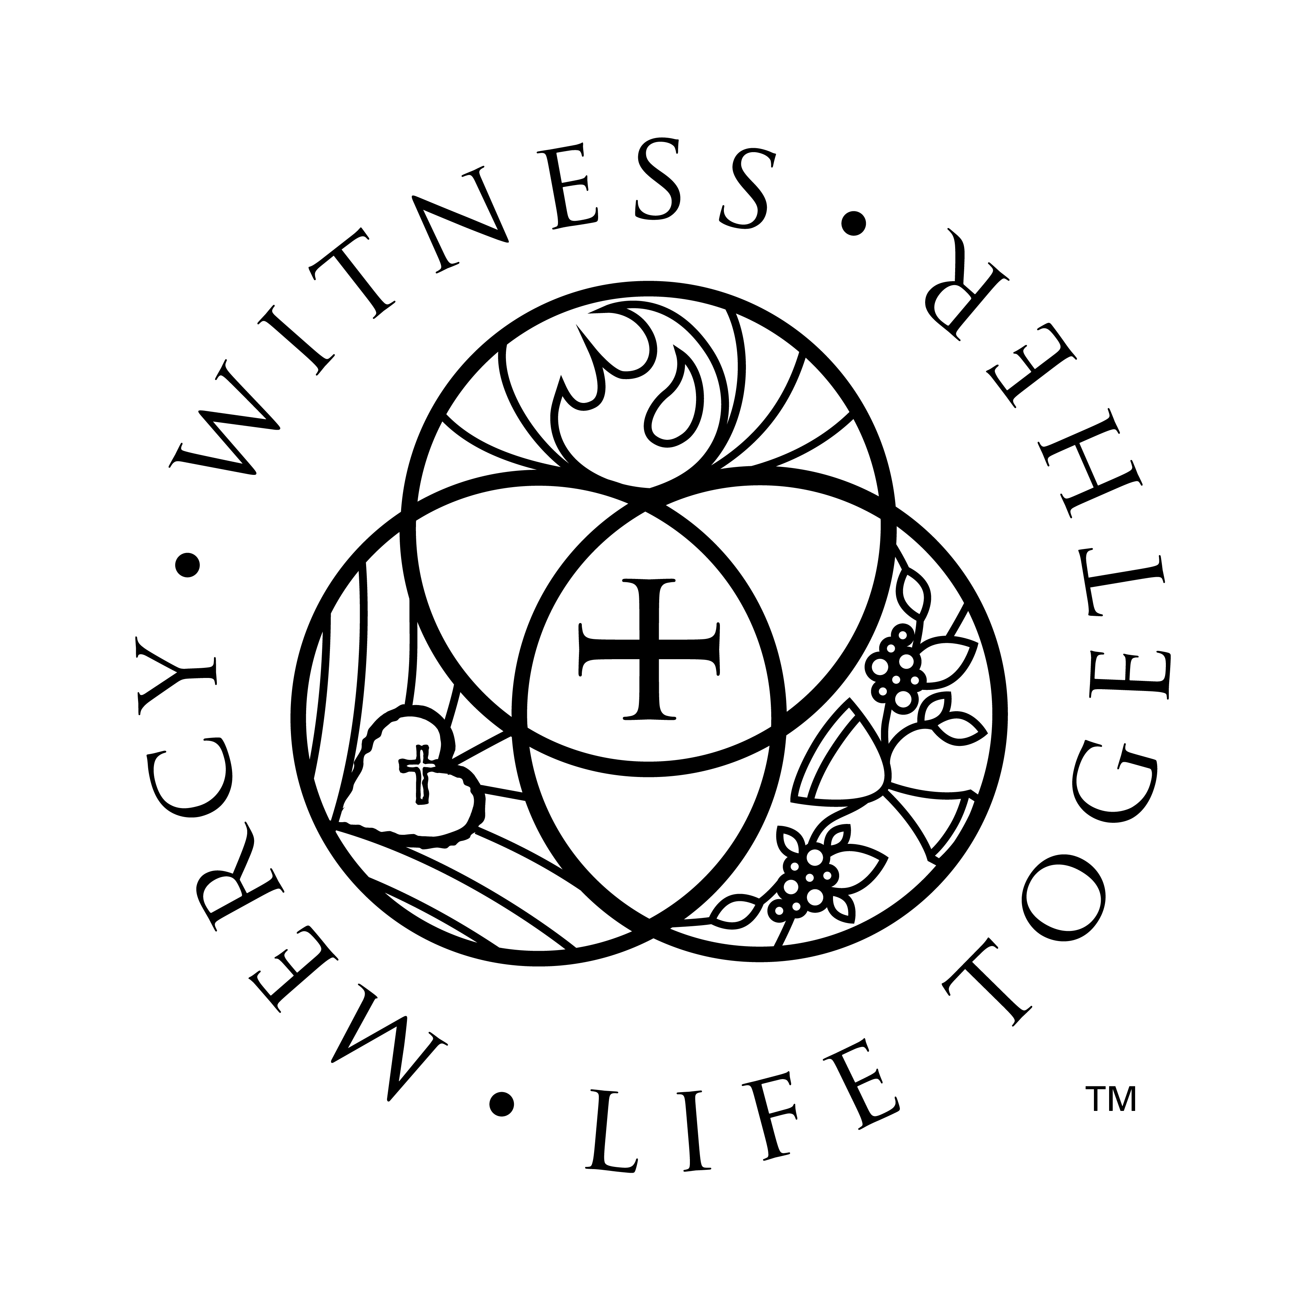
3509 SW Burlingame Rd.
Topeka, KS 66611
785-266-6263
www.christlcms.org

Rev. Ben Micheel, Pastor

Amanda Adams, DCE

Chris Francik, TLS Principal

Welcome and Opening Prayer

367 Angels from the Realms of Glory LSB 367
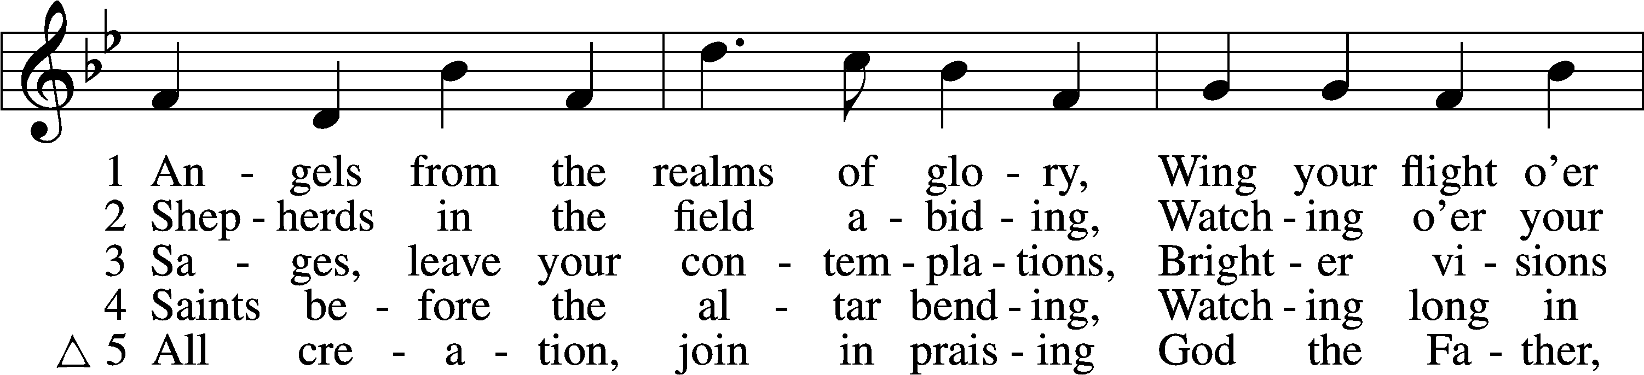
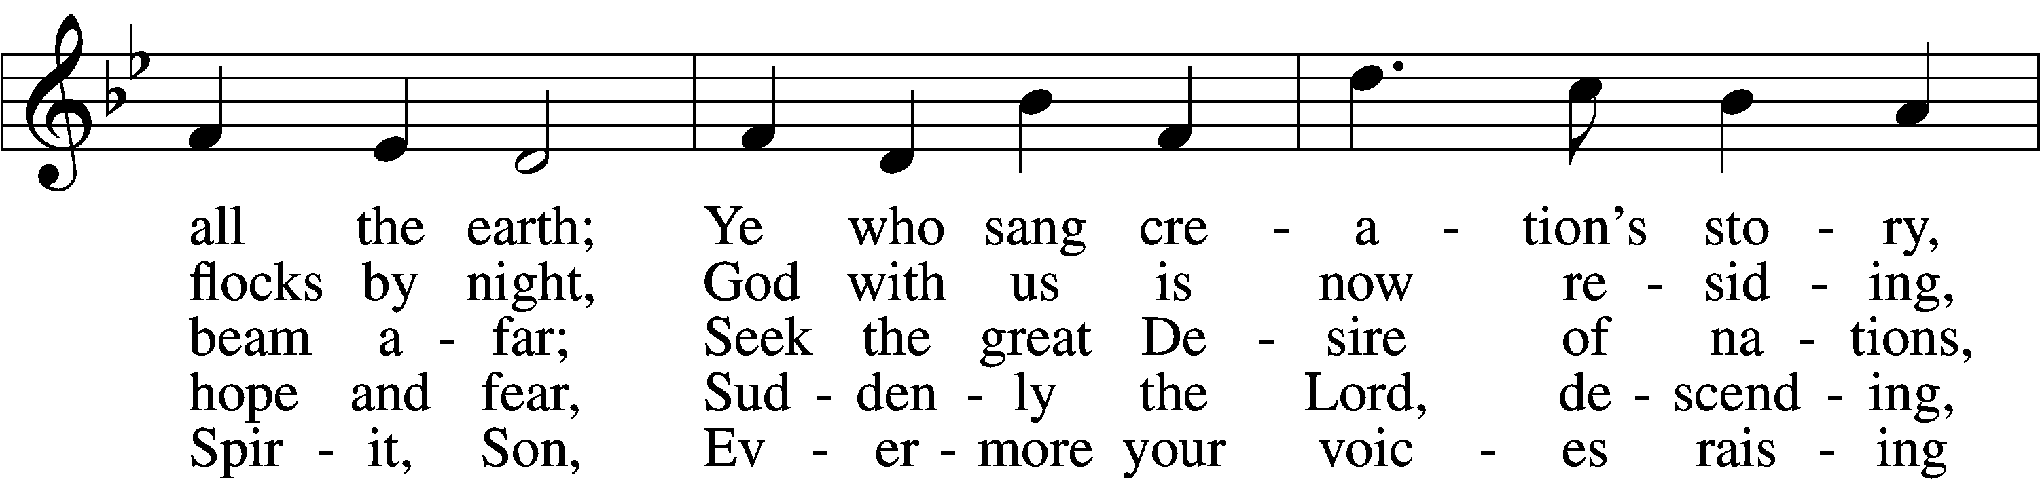
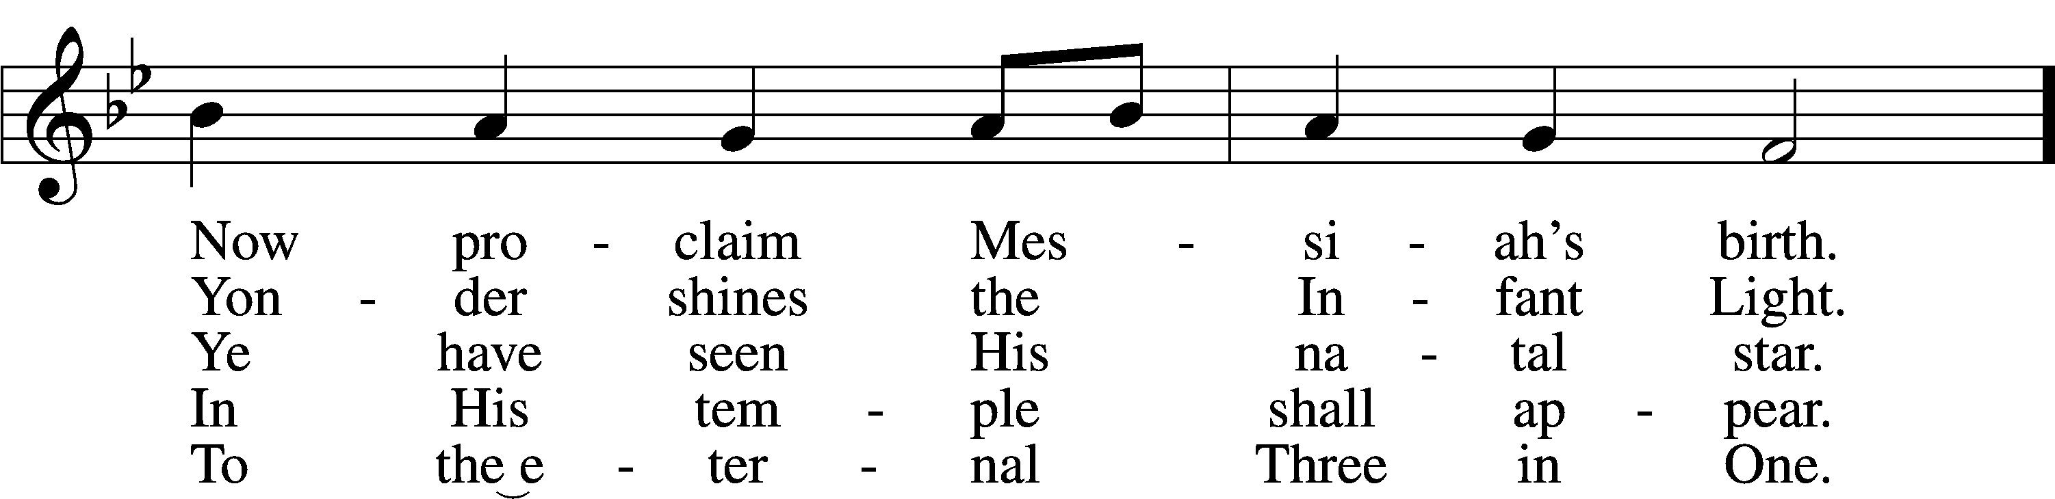
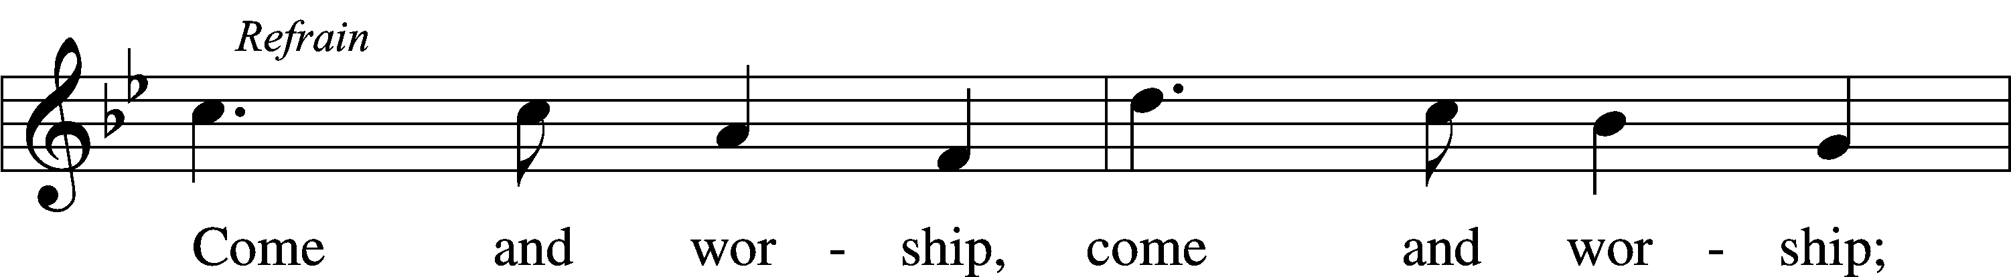
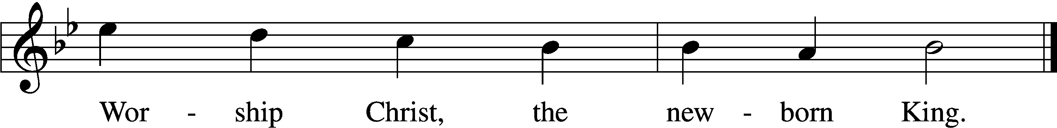
Text and tune: Public domain
Stand

Divine Service Setting Four, page 203
T Confession and Absolution T
Confession, to confess to God our sins and sinful nature. Absolution, “To absolve of sin and wrongdoing,” more specifically, to affirm God’s forgiveness to all who sincerely confess their sins to Him.

The sign of the cross may be made by all in remembrance of their Baptism.

Invocation
P In the name of the Father and of the T Holy Spirit.
C Amen.

Exhortation Psalm 124:8; Psalm 130:3–4; Luke 18:13 203
P Our help is in the name of the Lord,
C who made heaven and earth.

P If You, O Lord, kept a record of sins, O Lord, who could stand?
C But with You there is forgiveness; therefore You are feared.

P Since we are gathered to hear God’s Word, call upon Him in prayer and praise, and receive the body and blood of our Lord Jesus Christ in the fellowship of this altar, let us first consider our unworthiness and confess before God and one another that we have sinned in thought, word, and deed, and that we cannot free ourselves from our sinful condition. Together as His people let us take refuge in the infinite mercy of God, our heavenly Father, seeking His grace for the sake of Christ, and saying: God, be merciful to me, a sinner.

Confession of Sins LSB 203
C Almighty God, have mercy upon us, forgive us our sins, and lead us to everlasting life. Amen.

Absolution [John 20:19–23] LSB 203
P Almighty God in His mercy has given His Son to die for you and for His sake forgives you all your sins. As a called and ordained servant of Christ, and by His authority, I therefore forgive you all your sins in the name of the Father and of the T Son and of the Holy Spirit.
C Amen.

Service of the Word

Introit Psalm 98:1–4; antiphon: Isaiah 52:10
P The Lord has bared his holy arm before the eyes of all the nations,
C and all the ends of the earth shall see the salvation of our God.
P Oh sing to the Lord a new song, for he has done marvelous things!
C His right hand and his holy arm have worked salvation for him.
P The Lord has made known his salvation;
C he has revealed his righteousness in the sight of the nations.
P He has remembered his steadfast love and faithfulness to the house of Israel.
C All the ends of the earth have seen the salvation of our God.
P Make a joyful noise to the Lord, all the earth;
C break forth into joyous song and sing praises! Glory be to the Father and to the Son and to the Holy Spirit; as it was in the beginning,
is now, and will be forever. Amen.
P The Lord has bared his holy arm before the eyes of all the nations,
C and all the ends of the earth shall see the salvation of our God.

Kyrie Mark 10:47 204
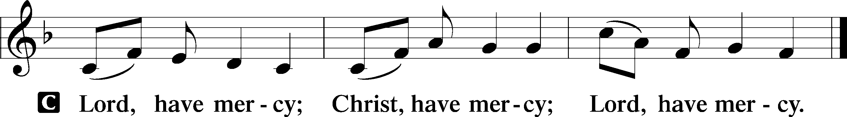

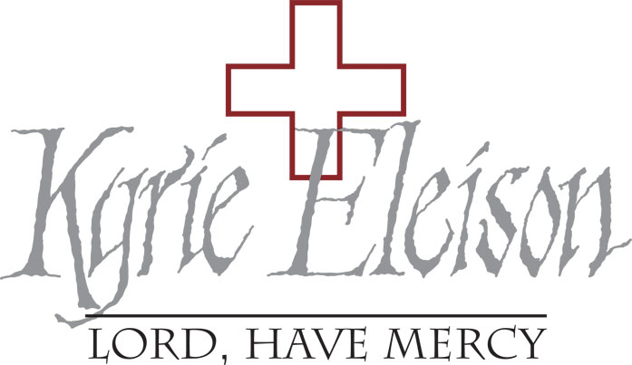
Gloria in Excelsis Luke 2:14; John 1:29 LSB 204
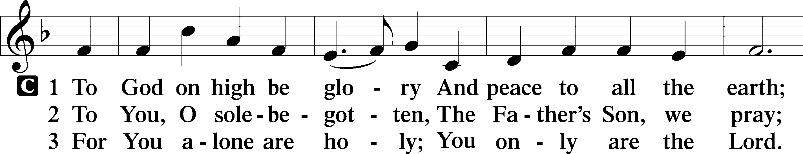
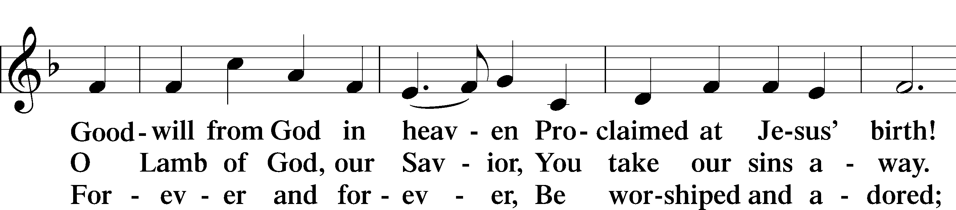
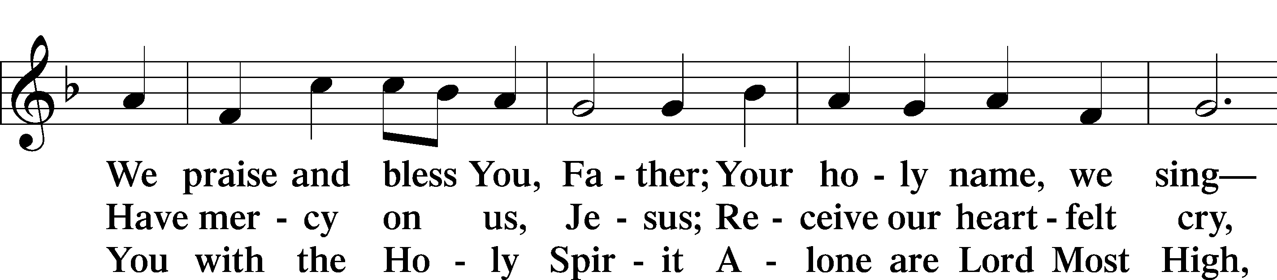
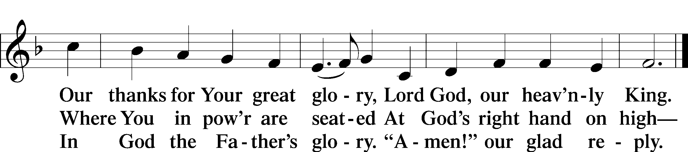

Salutation and Collect of the Day
“Salutation” is a word from Latin meaning, “to salute” or “to greet.” "Collect" (KAH-lekt), a brief structured prayer, usually consisting of five parts: address to God,basis for the prayer, petition, desired benefit or result, and trinitarian conclusion. The Collect of the Day also "collects" the message of the day's Gospel reading.

P The Lord be with you.
C And also with you.

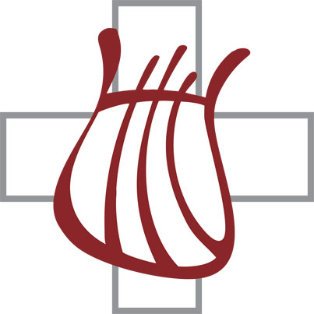
P Let us pray.
O God, our Maker and Redeemer, You wonderfully created us and in the incarnation of Your Son yet more wondrously restored our human nature. Grant that we may ever be alive in Him who made Himself to be like us; through Jesus Christ, our Lord, who lives and reigns with You and the Holy Spirit, one God, now and forever.

C Amen.

Old Testament Reading Isaiah 61:10—62:3
A The Old Testament Reading is from Isaiah, chapter 61.

10I will greatly rejoice in the Lord;
my soul shall exult in my God,
for he has clothed me with the garments of salvation;
he has covered me with the robe of righteousness,
as a bridegroom decks himself like a priest with a beautiful headdress,
and as a bride adorns herself with her jewels.
11For as the earth brings forth its sprouts,
and as a garden causes what is sown in it to sprout up,
so the Lord God will cause righteousness and praise
to sprout up before all the nations.
1For Zion’s sake I will not keep silent,
and for Jerusalem’s sake I will not be quiet,
until her righteousness goes forth as brightness,
and her salvation as a burning torch.
2The nations shall see your righteousness,
and all the kings your glory,
and you shall be called by a new name
that the mouth of the Lord will give.
3You shall be a crown of beauty in the hand of the Lord,
and a royal diadem in the hand of your God.

A This is the Word of the Lord.
C Thanks be to God.

Epistle Galatians 4:4–7
A The Epistle is from Galatians, chapter 4.

4When the fullness of time had come, God sent forth his Son, born of woman, born under the law, 5to redeem those who were under the law, so that we might receive adoption as sons. 6And because you are sons, God has sent the Spirit of his Son into our hearts, crying, “Abba! Father!” 7So you are no longer a slave, but a son, and if a son, then an heir through God.

A This is the Word of the Lord.
C Thanks be to God.

Stand

Alleluia and Verse

Alleluia 205
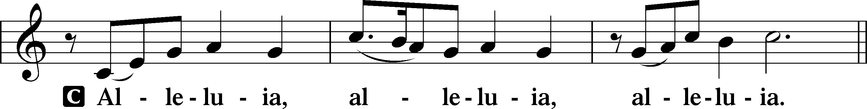

Verse John 20:31 LSB 205
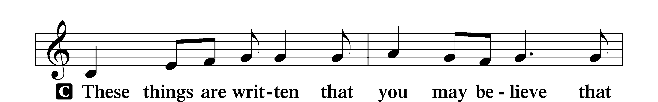
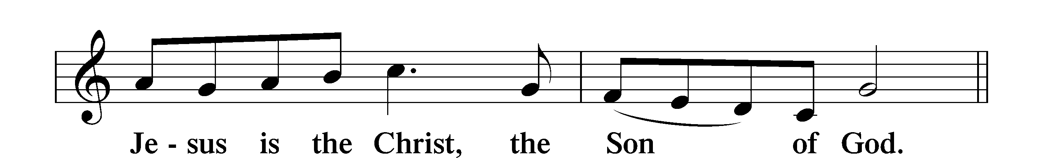

Alleluia 205
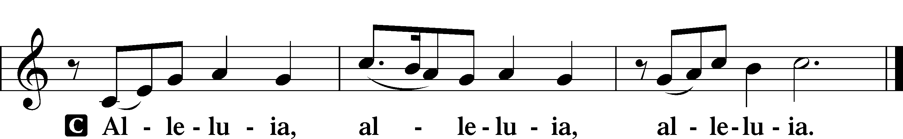

Holy Gospel Luke 2:22–40
P The Holy Gospel according to St. Luke, the second chapter.
C Glory to You, O Lord.

22When the time came for their purification according to the Law of Moses, [Mary and Joseph] brought [Jesus] up to Jerusalem to present him to the Lord 23(as it is written in the Law of the Lord, “Every male who first opens the womb shall be called holy to the Lord”) 24and to offer a sacrifice according to what is said in the Law of the Lord, “a pair of turtledoves, or two young pigeons.” 25Now there was a man in Jerusalem, whose name was Simeon, and this man was righteous and devout, waiting for the consolation of Israel, and the Holy Spirit was upon him. 26And it had been revealed to him by the Holy Spirit that he would not see death before he had seen the Lord’s Christ. 27And he came in the Spirit into the temple, and when the parents brought in the child Jesus, to do for him according to the custom of the Law, 28he took him up in his arms and blessed God and said,
29“Lord, now you are letting your servant depart in peace,
according to your word;
30for my eyes have seen your salvation
31that you have prepared in the presence of all peoples,
32a light for revelation to the Gentiles,
and for glory to your people Israel.”
33And his father and his mother marveled at what was said about him. 34And Simeon blessed them and said to Mary his mother, “Behold, this child is appointed for the fall and rising of many in Israel, and for a sign that is opposed 35(and a sword will pierce through your own soul also), so that thoughts from many hearts may be revealed.”
36And there was a prophetess, Anna, the daughter of Phanuel, of the tribe of Asher. She was advanced in years, having lived with her husband seven years from when she was a virgin, 37and then as a widow until she was eighty-four. She did not depart from the temple, worshiping with fasting and prayer night and day. 38And coming up at that very hour she began to give thanks to God and to speak of him to all who were waiting for the redemption of Jerusalem.
39And when they had performed everything according to the Law of the Lord, they returned into Galilee, to their own town of Nazareth. 40And the child grew and became strong, filled with wisdom. And the favor of God was upon him.

P This is the Gospel of the Lord.
C Praise to You, O Christ.

Nicene Creed
Creed comes from the Latin “credo” which means “I believe." We confess our Christian faith in one of the three creeds (short statement of belief) agreed upon by the ancient church.

C I believe in one God,
the Father Almighty,
maker of heaven and earth
and of all things visible and invisible.

And in one Lord Jesus Christ,
the only-begotten Son of God,
begotten of His Father before all worlds,
God of God, Light of Light,
very God of very God,
begotten, not made,
being of one substance with the Father,
by whom all things were made;
who for us men and for our salvation came down from heaven
and was incarnate by the Holy Spirit of the virgin Mary
and was made man;
and was crucified also for us under Pontius Pilate.
He suffered and was buried.
And the third day He rose again according to the Scriptures
and ascended into heaven
and sits at the right hand of the Father.
And He will come again with glory to judge both the living and the dead,
whose kingdom will have no end.

And I believe in the Holy Spirit,
the Lord and giver of life,
who proceeds from the Father and the Son,
who with the Father and the Son together is worshiped and glorified,
who spoke by the prophets.
And I believe in one holy Christian and apostolic Church,
I acknowledge one Baptism for the remission of sins,
and I look for the resurrection of the dead
and the life T of the world to come. Amen.

Sit
389 Let All Together Praise Our God LSB 389, sts 1-4, 6-7
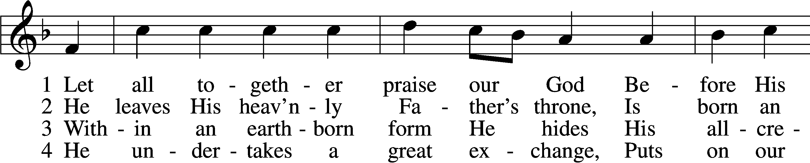
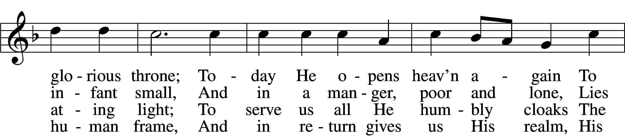
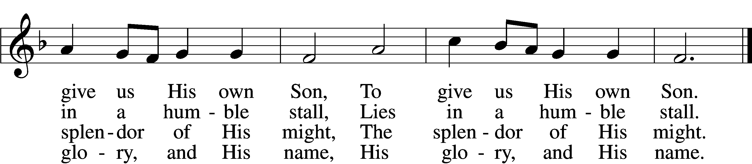

6 He is the key and He the door
To blessèd paradise;
The angel bars the way no more.
To God our praises rise,
To God our praises rise.

D 7 Your grace in lowliness revealed,
Lord Jesus, we adore
And praise to God the Father yield
And Spirit evermore;
We praise You evermore.
Text (st. 2) and tune: Public domain
Text (sts. 1, 3–7): © 1969 Concordia Publishing House. Used by permission: LSB Hymn License no. 110002199

Sermon

Offering
For those gathered with us in-person, an offering plate will be at the back of the room for a contactless drop-off for your gifts, tithes, and offerings as you leave today’s service.

For those still joining us remotely, we have multiple options for giving. You can text CHRISTLCMS to 77977 to give via text message, or sign up for online giving at pushpay.com/pay/christlcms for a one-time or recurring gift. Or, use the “My Church by PushPay” app, with keyword CHRISTLCMS. You may also mail your offering to the church office (3509 SW Burlingame Rd, Topeka, KS 66611).
Direct links with more information are available on the church website (christlcms.org/giving).

If you have prayer requests, please e-mail them to our church office (office@christlcms.org) or call the office at (785) 266-6263. We will include them in next week’s service, and also share them with our prayer chain if desired.

Stand

Prayer of the Church 1 Timothy 2:1-4
At the end of each petition, the pastor will say, “Lord, in Your mercy,”
to which the congregation will respond, “Hear our prayer.”

P …through Jesus Christ, Your son, our Lord, who lives and reigns with You and the Holy Spirit, one God, now and forever.
C Amen.

Service of the Sacrament

Preface 2 Timothy 4:22; [Colossians 3:1]; [Psalm 136] LSB 208
P The Lord be with you.
C And also with you.

P Lift up your hearts.
C We lift them to the Lord.

P Let us give thanks to the Lord our God.
C It is right to give Him thanks and praise.

P It is truly good, right, and salutary that we should at all times and in all places give thanks to You, O Lord, holy Father, almighty and everlasting God, for the countless blessings You so freely bestow on us and all creation. Above all, we give thanks for Your boundless love shown to us when You sent Your only-begotten Son, Jesus Christ, into our flesh and laid on Him our sin, giving Him into death that we might not die eternally. Because He is now risen from the dead and lives and reigns to all eternity, all who believe in Him will overcome sin and death and will rise again to new life. Therefore with angels and archangels and with all the company of heaven we laud and magnify Your glorious name, evermore praising You and saying:

Sanctus Isaiah 6:3; Matthew 21:9 208
(SAHNK-toose),"Sanctus" is Latin for "holy".

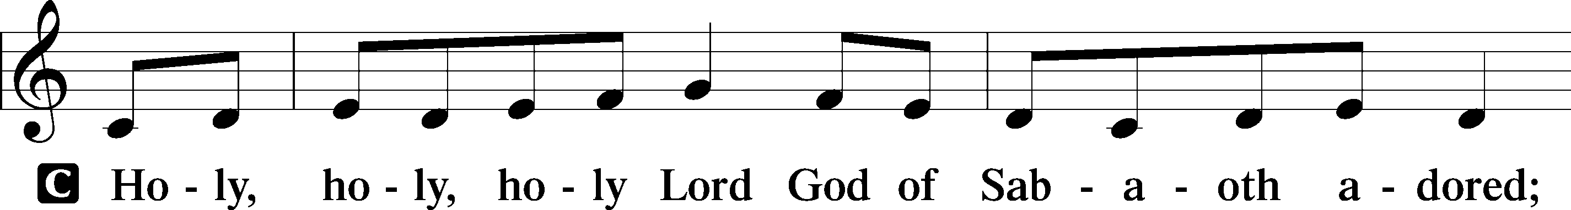
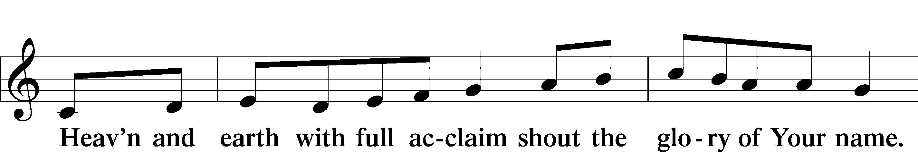
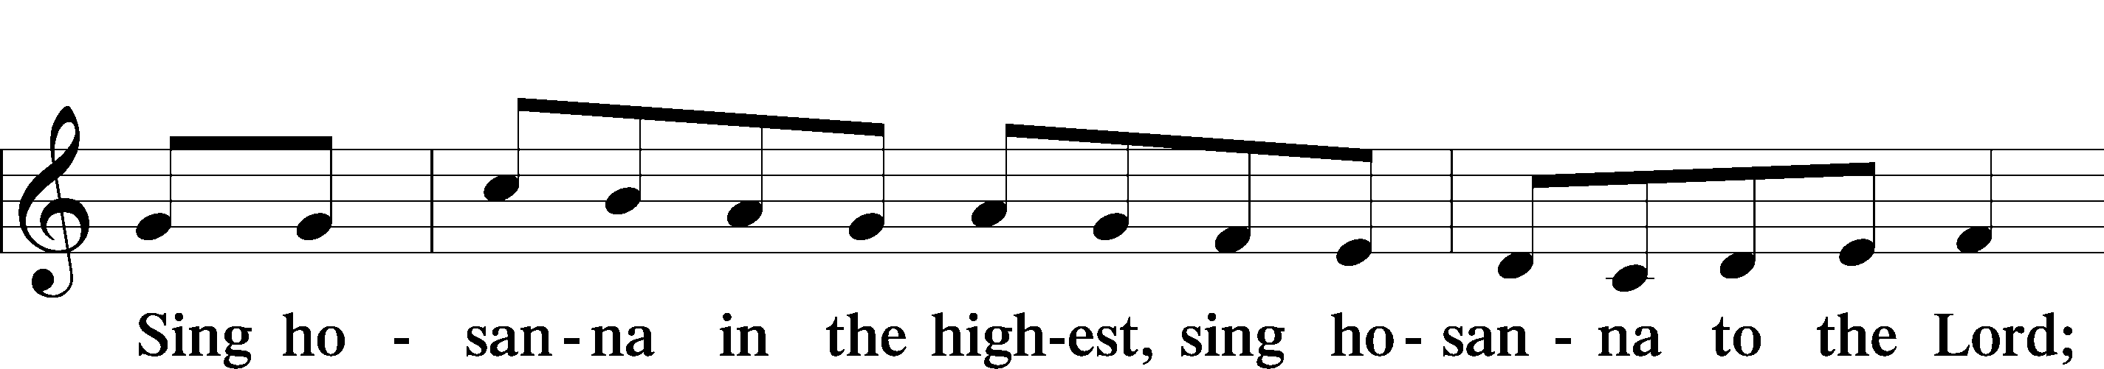
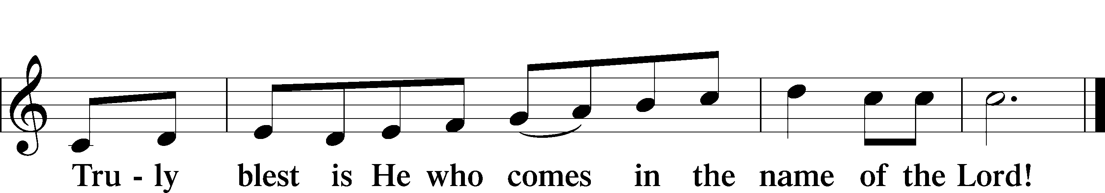

Prayer of Thanksgiving
P Blessed are You, O Lord our God, king of all creation, for You have had mercy on us and given Your only-begotten Son that whoever believes in Him should not perish but have eternal life.

In the beginning You created all things by Your Word; and in the fullness of time Your Word became flesh and dwelt among us, full of grace and truth.

Let Your Word made flesh dwell richly among us that, faithfully eating His body and drinking His blood, we may receive the fullness of Your grace and truth in Christ Jesus, our Lord.

Hear us as we pray in His name and as He has taught us:

Lord’s Prayer
C Our Father who art in heaven,
hallowed be Thy name,
Thy kingdom come,
Thy will be done on earth
as it is in heaven;
give us this day our daily bread;
and forgive us our trespasses
as we forgive those
who trespass against us;
and lead us not into temptation,
but deliver us from evil.
For Thine is the kingdom
and the power and the glory
forever and ever. Amen.

The Words of Our Lord
P Our Lord Jesus Christ, on the night when He was betrayed, took bread, and when He had given thanks, He broke it and gave it to the disciples and said: “Take, eat; this is My T body, which is given for you. This do in remembrance of Me.”

In the same way also He took the cup after supper, and when He had given thanks, He gave it to them, saying: “Drink of it, all of you; this cup is the new testament in My T blood, which is shed for you for the forgiveness of sins. This do, as often as you drink it, in remembrance of Me.”

Pax Domini
(PAKS DOH-mee-nee), Latin for "peace of the Lord" (John 20:19).

P The peace of the Lord be with you always.
C Amen.

Agnus Dei John 1:29 LSB 210
(AHG-noose DAY-ee). Latin for “Lamb of God.”

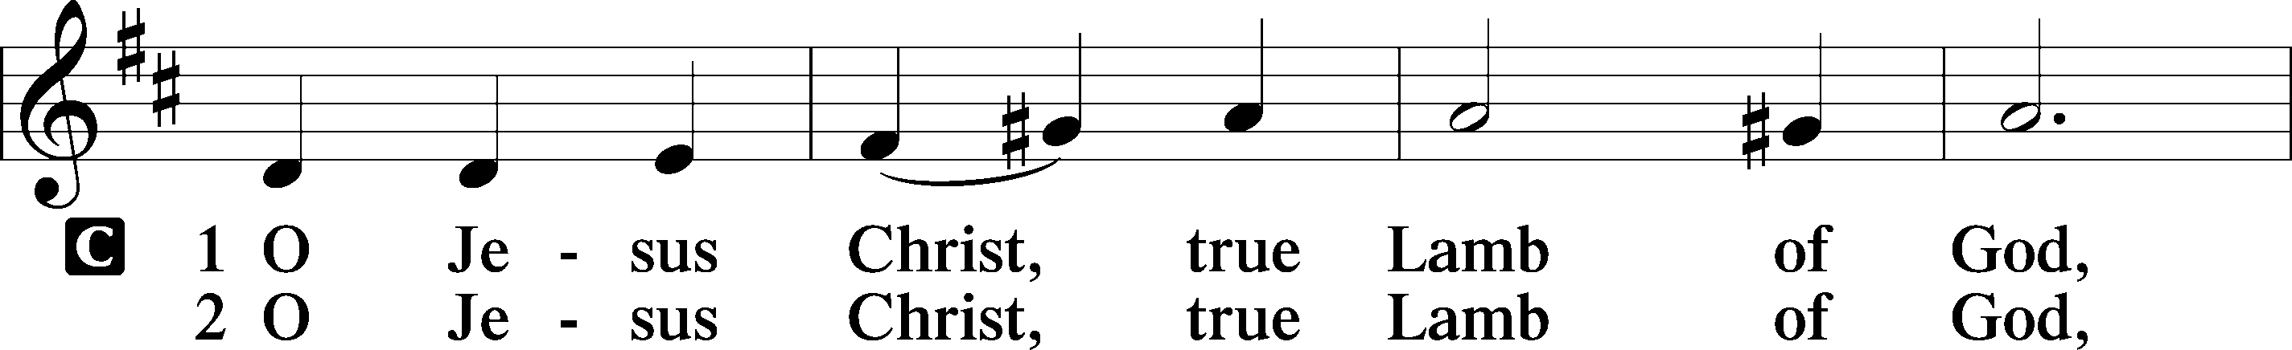
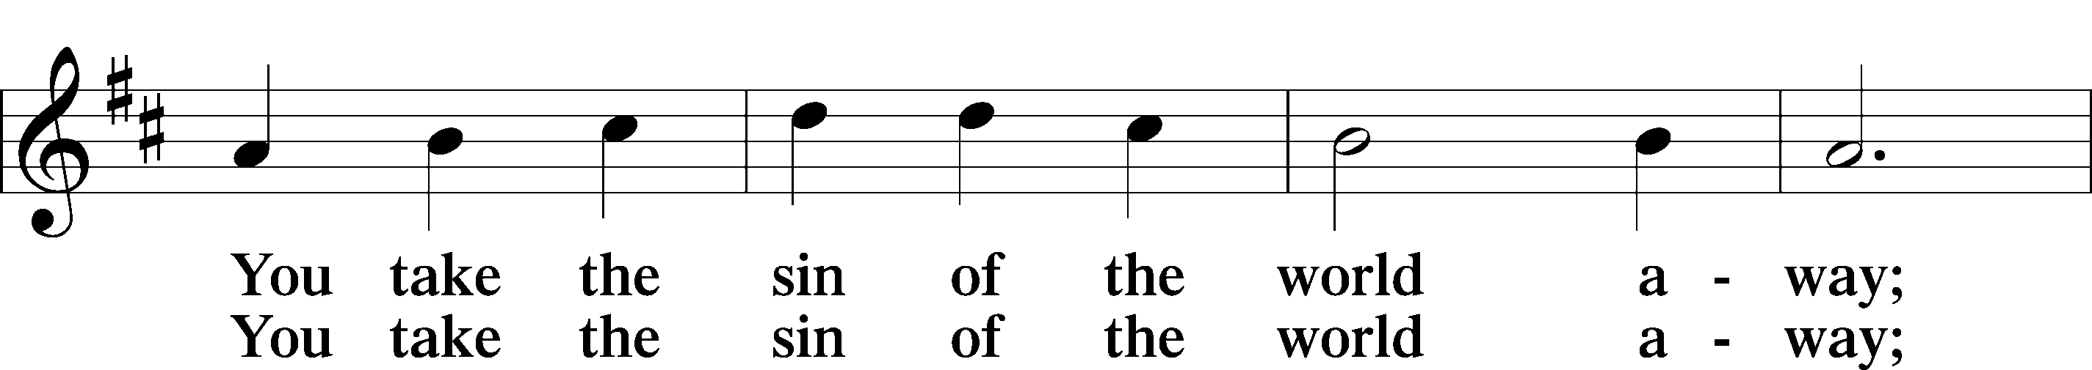
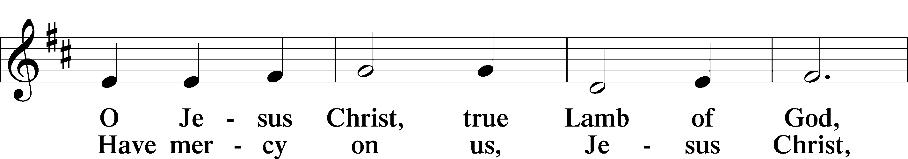
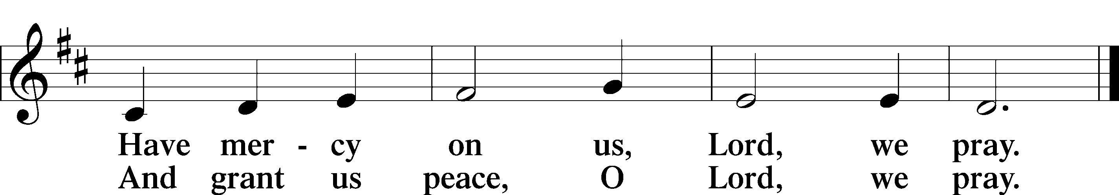

Sit

Distribution
Communion is reserved for those who are members of the Lutheran Church-Missouri Synod or members of a church body in fellowship with the LCMS unless special arrangements have been made with the pastor. The pastor and those who assist him receive the body and blood of Christ first. Then they will distribute it to those who cannot come up to the front of the sanctuary due to physical ailments. Following that the ushers will dismiss the people from their pews to proceed to the front. All are invited up to receive a blessing.

387 Joy to the World LSB 387
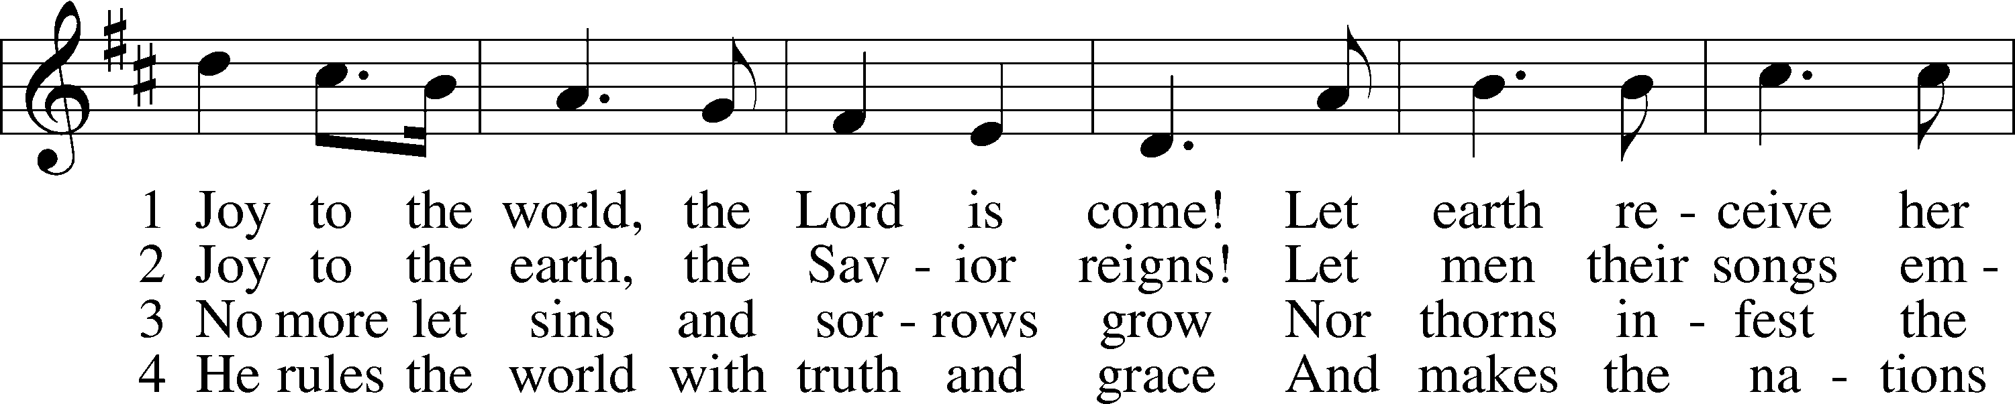
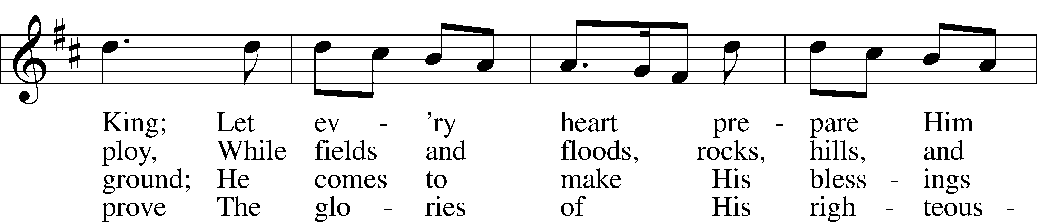
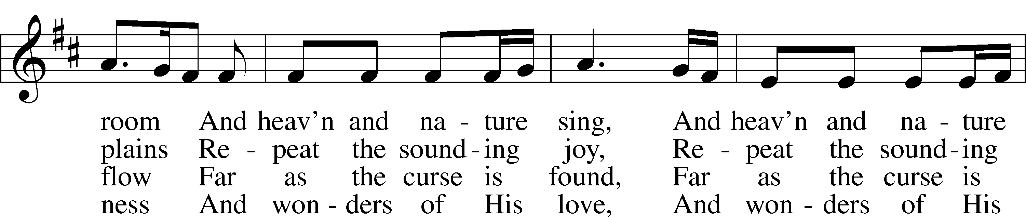
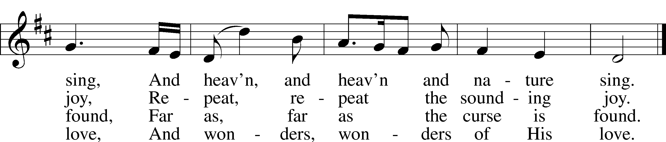
Text and tune: Public domain

384 Of the Father’s Love Begotten LSB 384
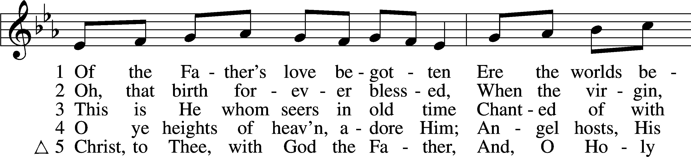
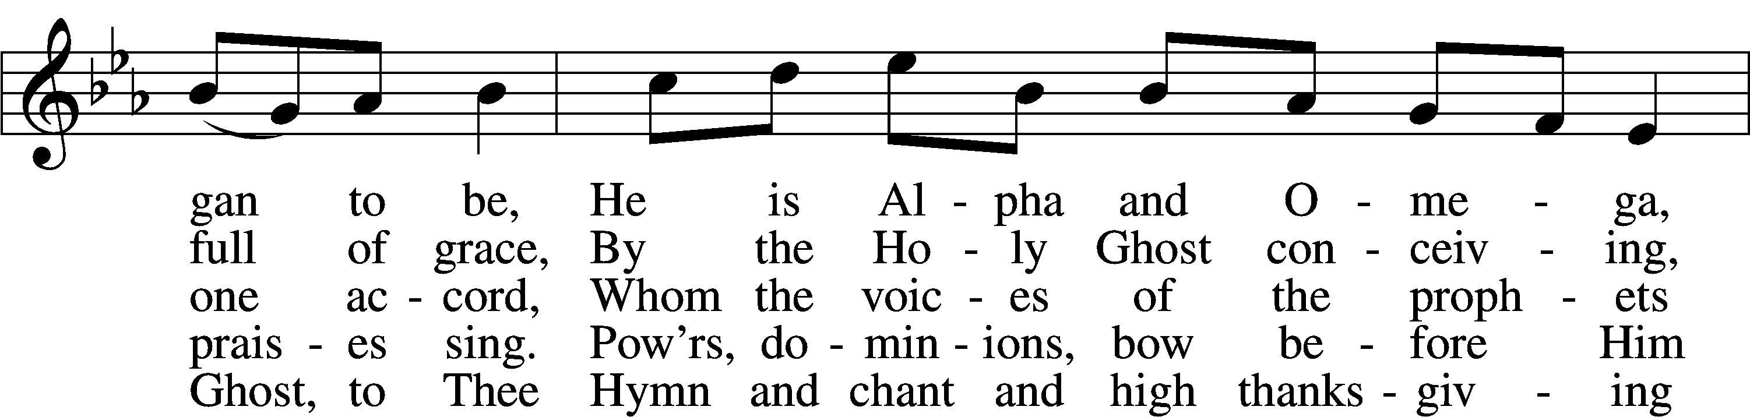
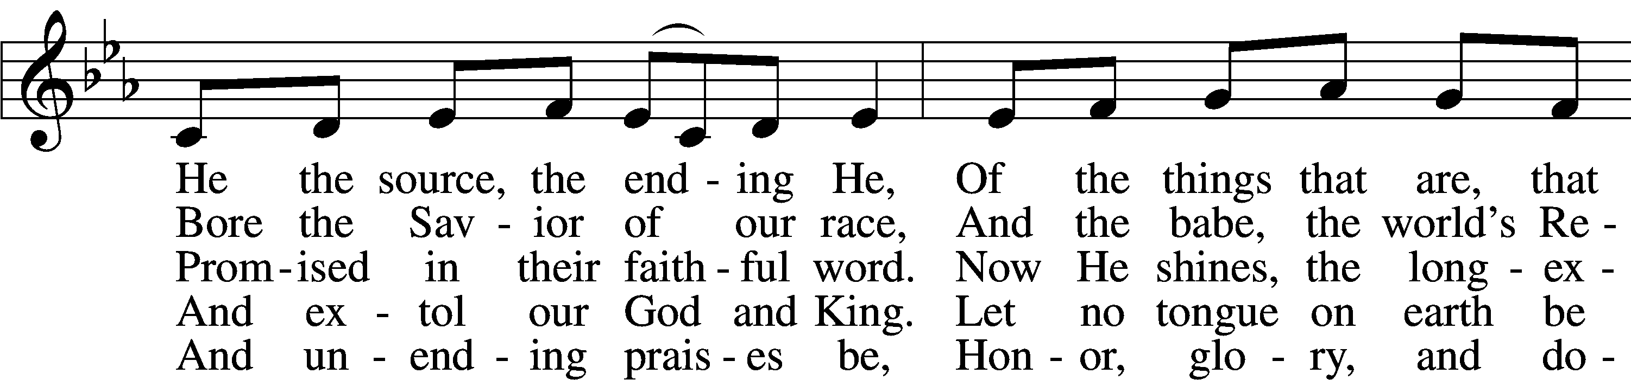
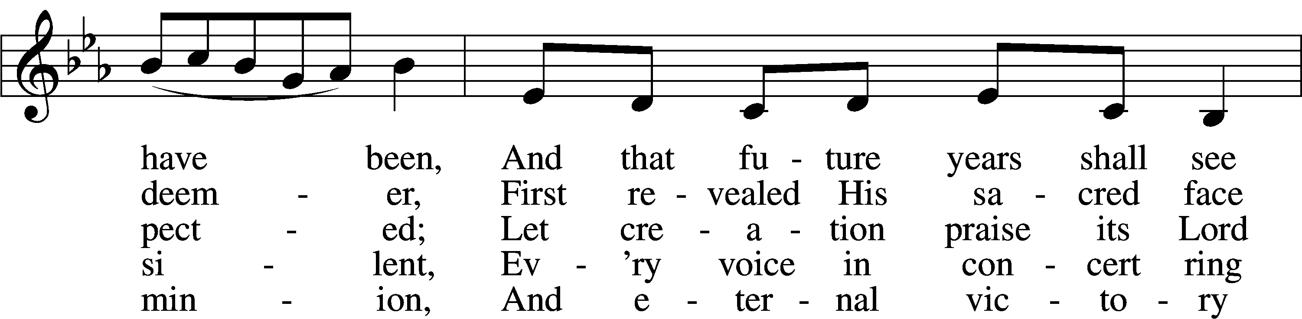
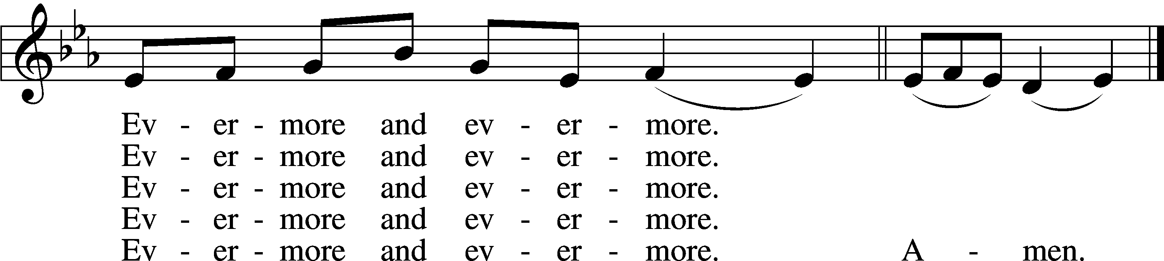
Text and tune: Public domain

382 We Praise You, Jesus, at Your Birth LSB 382
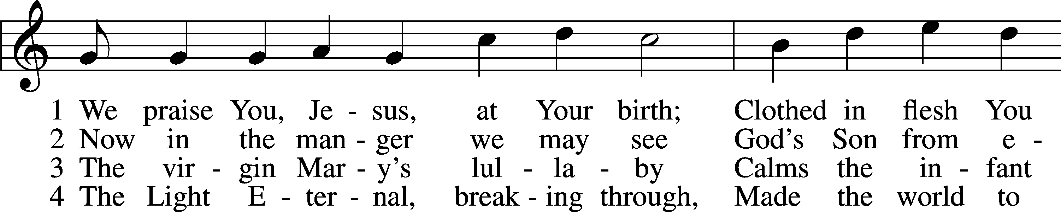
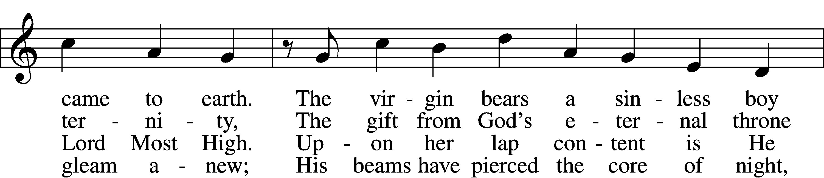
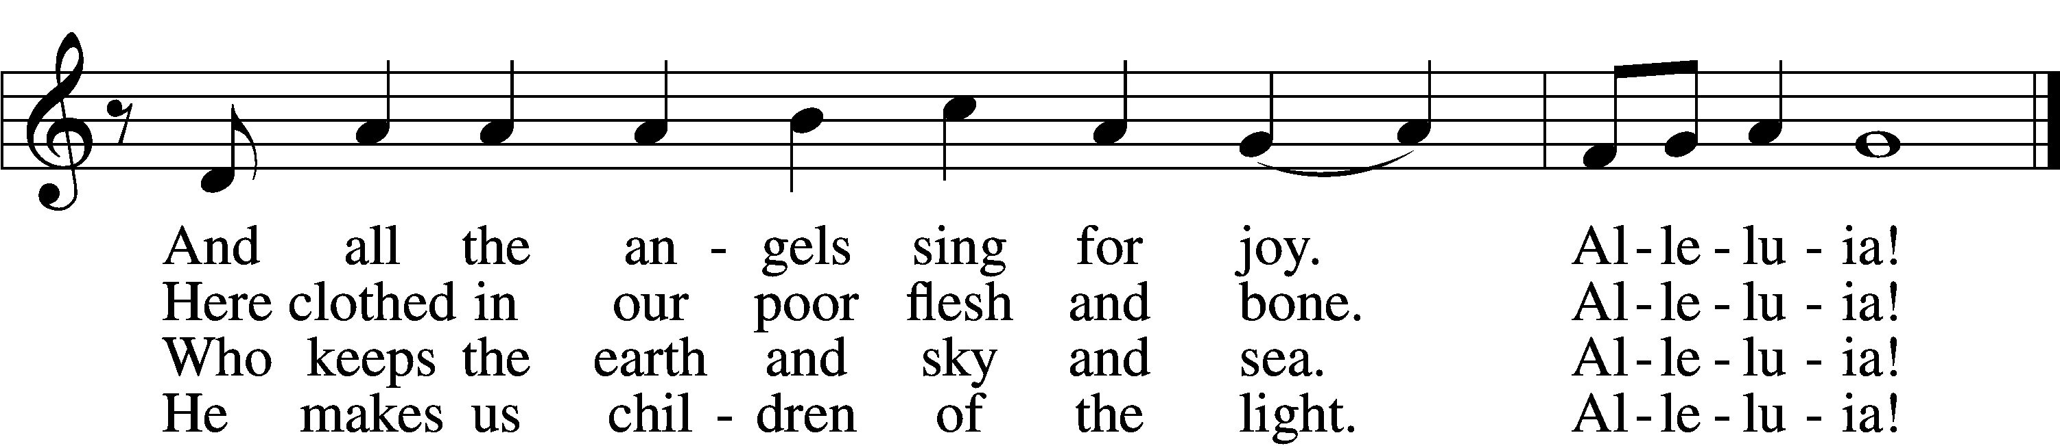

5 The very Son of God sublime
Entered into earthly time
To lead us from this world of cares
To heaven’s courts as blessèd heirs.
Alleluia!

6 In poverty He came to earth
Showing mercy by His birth;
He makes us rich in heav’nly ways
As we, like angels, sing His praise.
Alleluia!

7 All this for us our God has done
Granting love through His own Son.
Therefore, all Christendom, rejoice
And sing His praise with endless voice.
Alleluia!
Tune: Public domain
Text (sts. 1, 3, 5–7): © 2006 Concordia Publishing House; (sts. 2, 4): © 1978 Concordia Publishing House. Used by permission: LSB Hymn License no. 110002199

Stand

Dismissal
Nunc Dimittis Luke 2:29–32 LSB 211
(NUNK dih-MIH-tuss). Latin for “now [let your servant] depart,” from the Song of Simeon.

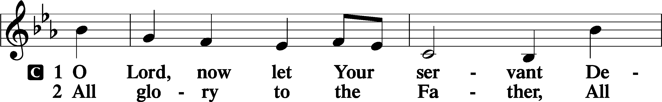
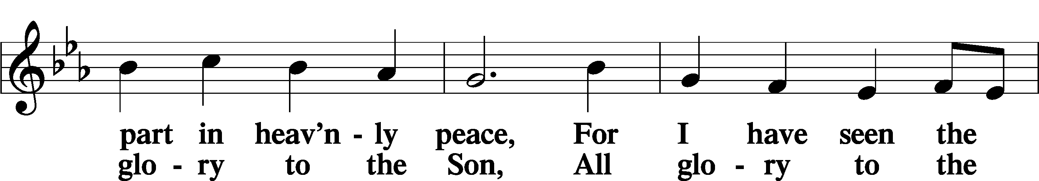
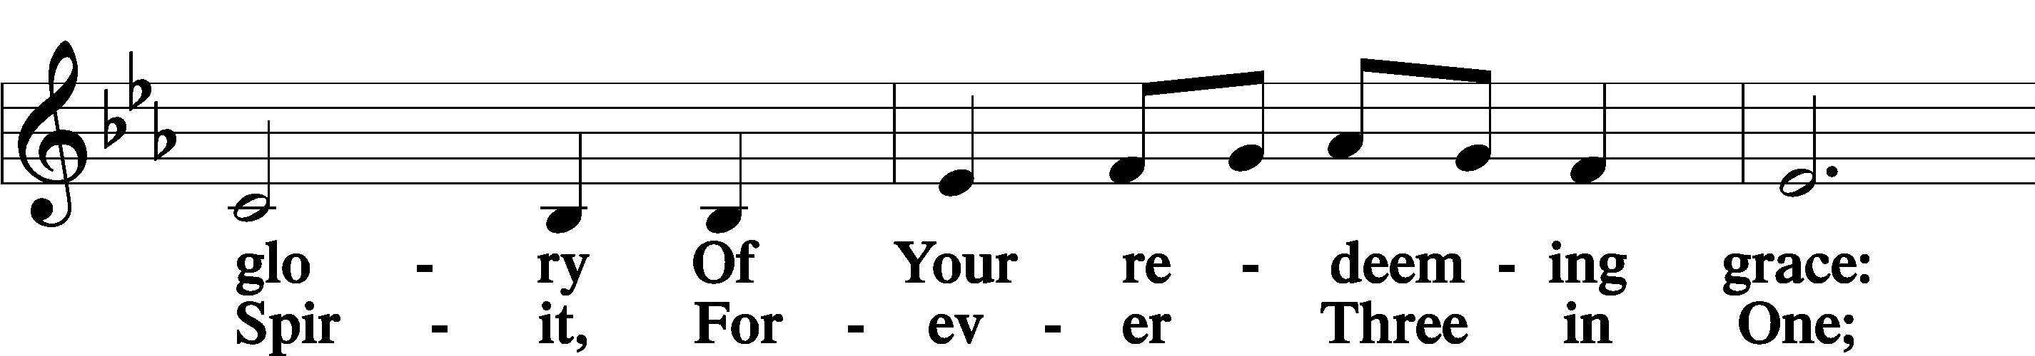
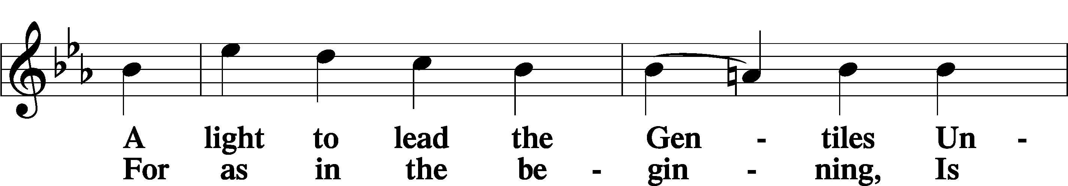
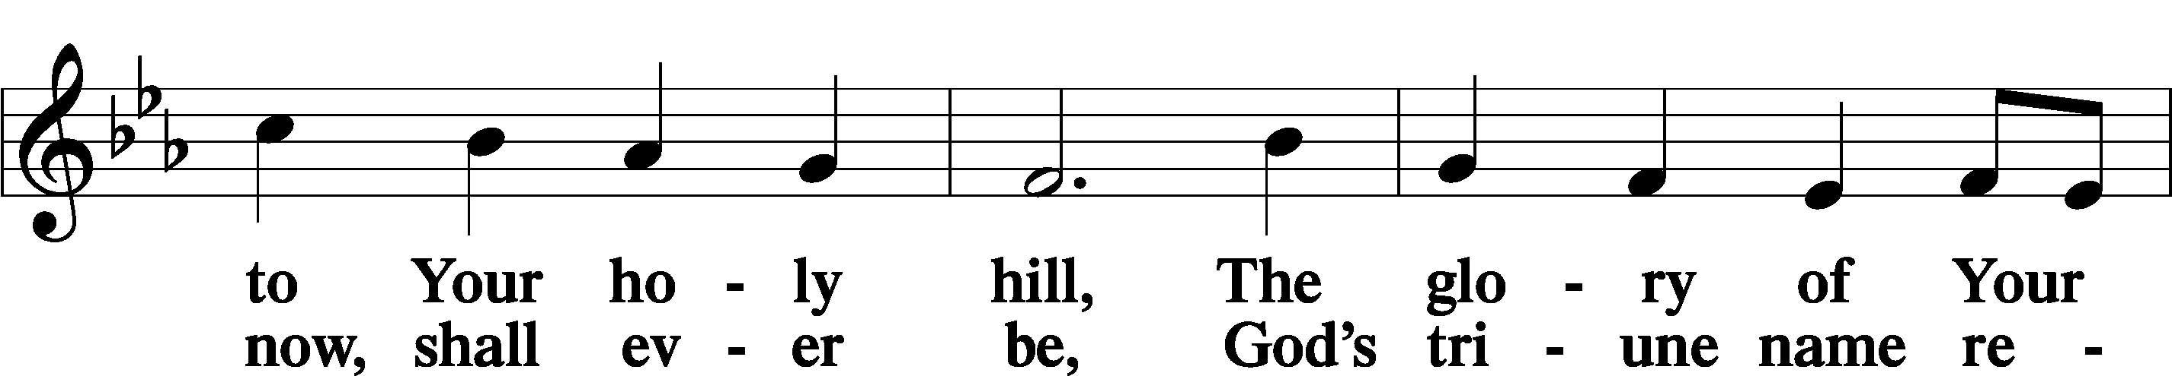
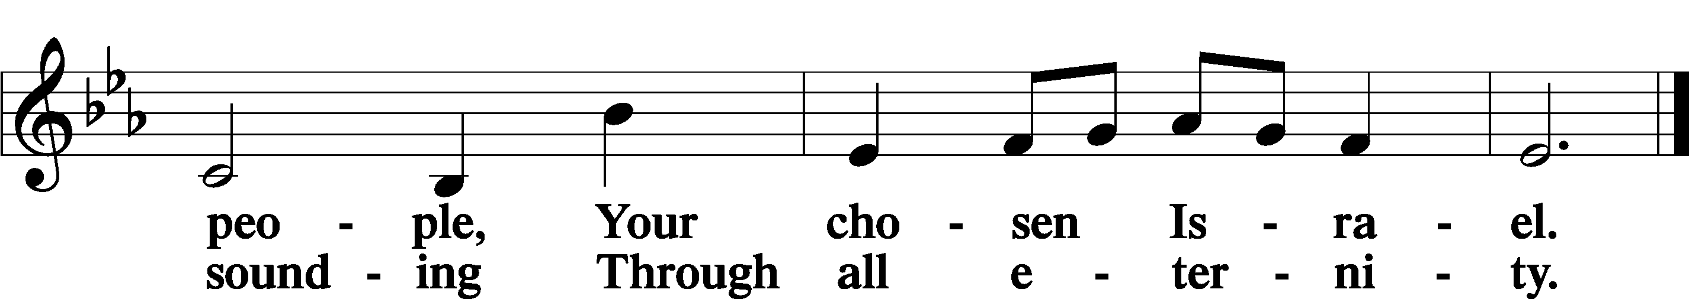

Post-Communion Collect
P Let us pray.
We give thanks to You, almighty God, that You have refreshed us through this salutary gift, and we implore You that of Your mercy You would strengthen us through the same in faith toward You and in fervent love toward one another; through Jesus Christ, Your Son, our Lord, who lives and reigns with You and the Holy Spirit, one God, now and forever.
C Amen.

Luther's Morning Prayer
C I thank You, my heavenly Father, through Jesus Christ, Your dear Son, that You have kept me this night from all harm and danger; and I pray that You would keep me this day also from sin and every evil, that all my doings and life may please You. For into Your hands I commend myself, my body and soul, and all things. Let Your holy angel be with me, that the evil foe may have no power over me.
Amen.

Benedicamus Psalm 103:1 LSB 212
(beh-neh-dih-KAH-moose), Latin for "bless we [the Lord]." We give thanks to God for everything He has done for us in Jesus Christ.

P Let us bless the Lord.
C Thanks be to God.

Benediction
A final blessing from God this morning before we leave.

P The Lord bless you and keep you.
The Lord make His face shine on you and be gracious to you.
The Lord look upon you with favor and T give you peace.
C Amen.

924 Lord, Dismiss Us with Your Blessing LSB 924
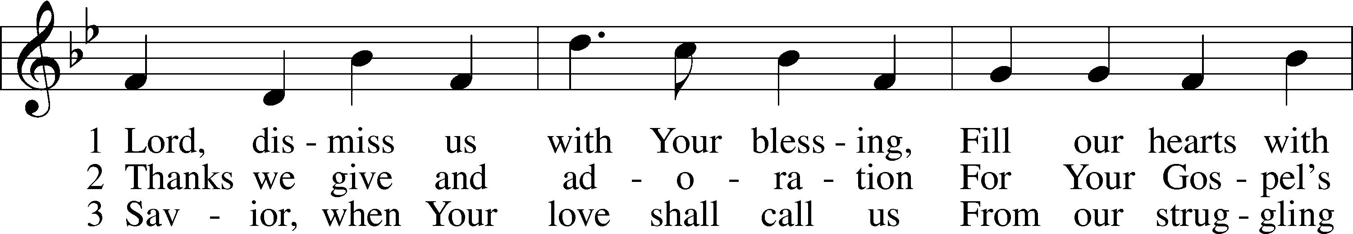
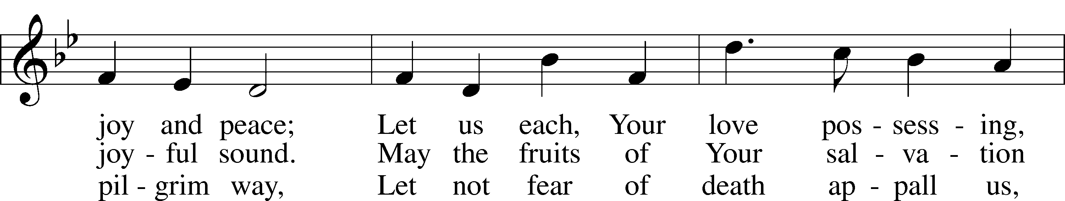
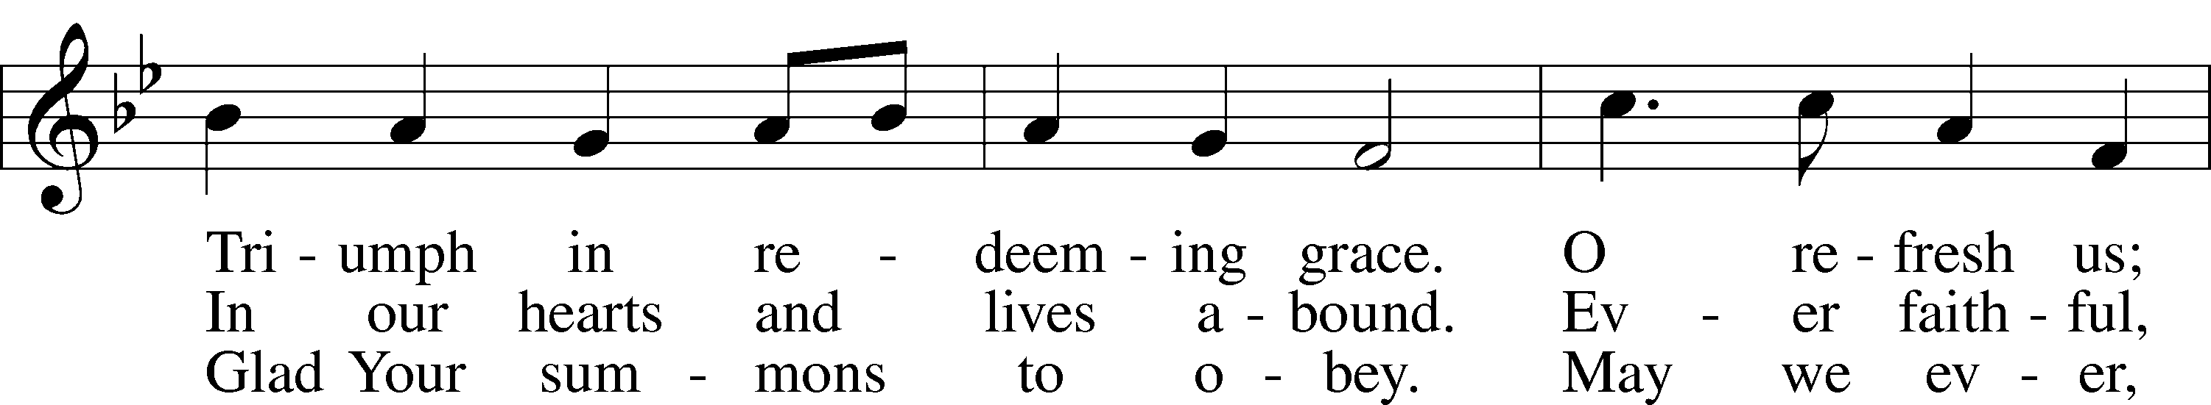
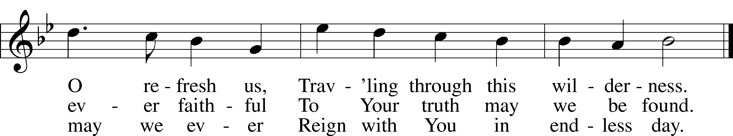
Text and tune: Public domain

Acknowledgments
Unless otherwise indicated, Scripture quotations are from the ESV® Bible (The Holy Bible, English Standard Version®), copyright © 2001 by Crossway, a publishing ministry of Good News Publishers. Used by permission. All rights reserved.
Created by Lutheran Service Builder © 2020 Concordia Publishing House.
-- Week at a Glance --

Sunday  December 27 | 8:00, 9:15, & 10:30 am | Worship Service w/ Communion
Monday
December 28
Tuesday
December 29
Wednesday  December 30 | 7:00 pm | Pastor’s Adult Bible Class
Thursday  December 31 | 7:00 pm | New Year’s Eve Worship Service  w/ Communion
Friday  January 1 |  | New Year’s Day – Church Office CLOSED
Saturday
January 2
Sunday  January 3 | 8:00, 9:15, & 10:30 am | Worship Service w/ Communion

-- Announcements --

Celebrating
Birthdays: Wayne B., Jared H., Shawn H. (27th); Kassidee N. (28th); Sharon G., Josie H., Kaitlyn M., Kaylyn S., Chuck S. (29th); Carlos B., Patricia M. (30th); Jim L., Ben O., Trentan W., Sharon W. (1st); Thomas H. (2nd); Bianca L., Sloan W. (3rd)
Baptism Birthdays: Marty C. (27th); Marjean P., Robert P., Darin S. (28th); Jeanette B., Rylan M. (31st); Harley B., Dennis B., Margaret B., Colleen B., Chris C., Virginia C., Ron G., Carlie G., Chris G., Sondra K., Jim L., Loretta M., Lee M., Jayel M., Melissa M., Gladys N., Chris N., Hanna R., Chuck S., Carolyn W., Jeanette W. (1st)
Anniversaries: Thomas & Sharon H. (27th); Bill & Charlene O. (31st)

Worship Service Updates
We have three worship service times: Sunday mornings at 8 am, 9:15 am, and 10:30 am. These services are capped at 45 people each to allow for proper distancing. Please continue to sign up through the church website. Thank you for your patience as we navigate this ever-changing situation!

New Year’s Eve Worship Services
Join us on December 31st at 7 PM for our New Year’s Eve Worship Service! Please sign up through our website.

Children/Youth Sunday School
Children’s Sunday School (Pre-K through 6th grade). DCE Amanda will continue
posting weekly lessons and resources to the members area of our website (christlcms.org/members) – contact the church office if you need the password.
Youth (7th-12th grades) Sunday School is once again meeting in-person in the basement youth room.

Pastor’s Bible Class
Pastor Ben’s Bible Class is now back to its regular day/time on Wednesdays at 7 pm. This class is available both in person and via Zoom. Please e-mail the church office if you need the link. This class takes a closer look at the lectionary readings for the coming Sunday.

Thank You
We are blessed to have such a caring congregation. Thank you for all of your Christmas cards and greetings throughout this season. They are much appreciated.
-- Pastor Ben, DCE Amanda, & Office Manager Mel

-- Announcements --

Year End Giving
To be considered a 2020 contribution, gifts/offerings must be received by December 31st. Thank you for your continued generosity during this unprecedented year.

Financial Peace University
Planning for the future is hard when you’re still paying for the past! Listen—there’s a better way! Join our Financial Peace University class, and we’ll learn how to beat debt and make a plan for the future together! Interested? The class meets here at Christ starting January 14th, 2021. You can sign up and start your 14-day free trial of Financial Peace at FPU.com/1129296. If you have any questions, please contact Bessie Tolbert at 785.218.4356.
Remembered in our Prayers
Charlie P., Alice M., Luke H., Betty C., Julie J., Don L., Brittian K.(Sondra K.’s grandson), Lance L., Jerry M., Bob T., Glenna L., Jean B. (sister Pauline C.’s sister), Judy P. (Lynne D.’s aunt), Mert B., Angela (Mary D.’s daughter), Judy (Colleen B.’s neighbor), Noel (Colleen B.’s brother), Kathy (Brenda Z.’s sister-in-law), Martin E., Anna (Frank J.’s mother), Shirley (Frank J.’s grandmother), Melanie (Sharon L.’s daughter), Ella (Marsha S.’s granddaughter), Julie (Heather S.’s cousin), Willa H., Charlie & Adair H., Brian C., Bob (David B.’s brother), Sherry (Liz J.’s sister-in-law), Wayne P., Dana H. and family, John & Susan A., Gretchen & Marvin (Marcus K.’s parents), Rene A. for a speedy adoption process for Barbara, our front line/essential workers, and others named in your heart. Pray for the Topeka Rescue Mission, the Schumachers and their ministry in Ghana, and missionaries around the world. We pray especially for those around the world being persecuted for their faith in the one, true God and the suffering they endure. Please continue to pray for Pastor Ben, Amanda, our staff and their families as they do our Lord’s work here at Christ Lutheran. We pray for the staff and students of TLS and the Center for Young Children. We also pray for those who serve in the armed forces, first responders, and for our country and government. Prayers of thanksgiving for our Lord and Savior and the new life we have in Him.

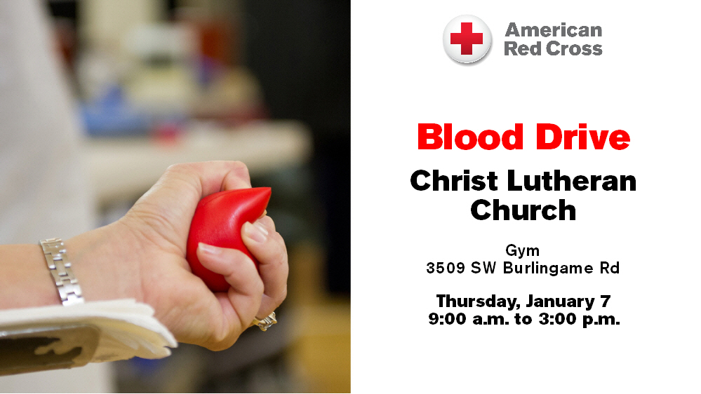

Christ Lutheran Church -- Outreach Calendar 2021
The Evangelism Committee has decided to follow up on Pastor’s very great idea of having a monthly outreach activity to the community. We have a wonderful church family and there is no better time than now to share our love with people in our community. Many times members of our congregation want to “DO” something to minister to people but just don’t know what to do. Well, here is your opportunity. Below is a list of the things we have planned. There is a sign-up sheet on the bulletin board for you to indicate interest in helping with any of these projects.

January: Community Blood Drive
February: Soup R Bowl Food Drive
March: Community Blood Drive,
Read Across America
April: Serving meals to kids
over spring break,
Easter Egg Hunt
May: Baby Bottle Collection, Baby Shower
Community Blood Drive
June: Parking lot party or Concert, Bouncy houses for neighborhood
July: Movie on the lawn
Community Blood Drive

August: Church Picnic
Neighborhood cookout, Night Out Against Crime
September: Encourage teachers
at local schools,
Community Blood Drive
October: Trunk or Treat
November: Veterans’ Recognition,
Food project to HiCrest neighborhood,
Thanksgiving boxes,
Community Blood Drive
December: Christmas shoeboxes
Adopt a family,
Breakfast with Santa

The Time Has Fully Come for Redemption and Purification
through Jesus Christ, Our Lord

“When the fullness of time had come, God sent forth his Son,” born of the woman, “to redeem those who were under the law” (Gal. 4:4–5). Therefore, “according to the Law of Moses,” Mary and Joseph “brought him up to Jerusalem to present him to the Lord” (Luke 2:22). There He was received and taken up into the arms of Simeon, who was righteous and devout, “waiting for the consolation of Israel” (Luke 2:25). Simeon praised God and blessed the parents by confessing the cross for which this child was appointed. “At that very hour,” old and faithful Anna, who had watched, prayed and worshiped in the temple for so long, came up and “began to give thanks to God and to speak of him to all who were waiting for the redemption of Jerusalem” (Luke 2:38). The Lord causes “righteousness and praise to sprout up before all the nations” (Is. 61:11). We also “greatly rejoice in the Lord,” because this child has clothed us “with the garments of salvation,” covered us “with the robe of righteousness” and called us “by a new name” (Is. 61:10; 62:2).

Offerings
We have multiple options for your gifts, tithes, and offerings. You can text CHRISTLCMS to 77977 to give via text message, or sign up for online giving at pushpay.com/pay/christlcms for a one-time or recurring gift. Or, use the “My Church by PushPay” app, with keyword CHRISTLCMS. You may also mail your offering to the church office (3509 SW Burlingame Rd, Topeka, KS 66611). Direct links with more information are available on the church website (christlcms.org/giving).

Stewardship Corner

Budgeted Weekly Needs: $ 7,300
Offerings Received – Week of 12/20 $ 8,700

Budgeted Needs (Jan-Nov) $352,088
Offerings Received (Jan-Nov) $323,864

*****

Luke 2:39 – “And when they had performed everything according to the Law of the Lord…” The Law of God is good. Of course, it always shows us our sins, but that is good, too! We need to be driven back to the forgiveness of Christ. And the Law also shows us the truly blessed way to live. As Mary and Joseph found their joy in a godly life, so should we see the Law as a guide for Christian living and the roadmap for saying thank you to the Lord for all His grace and mercy to us.
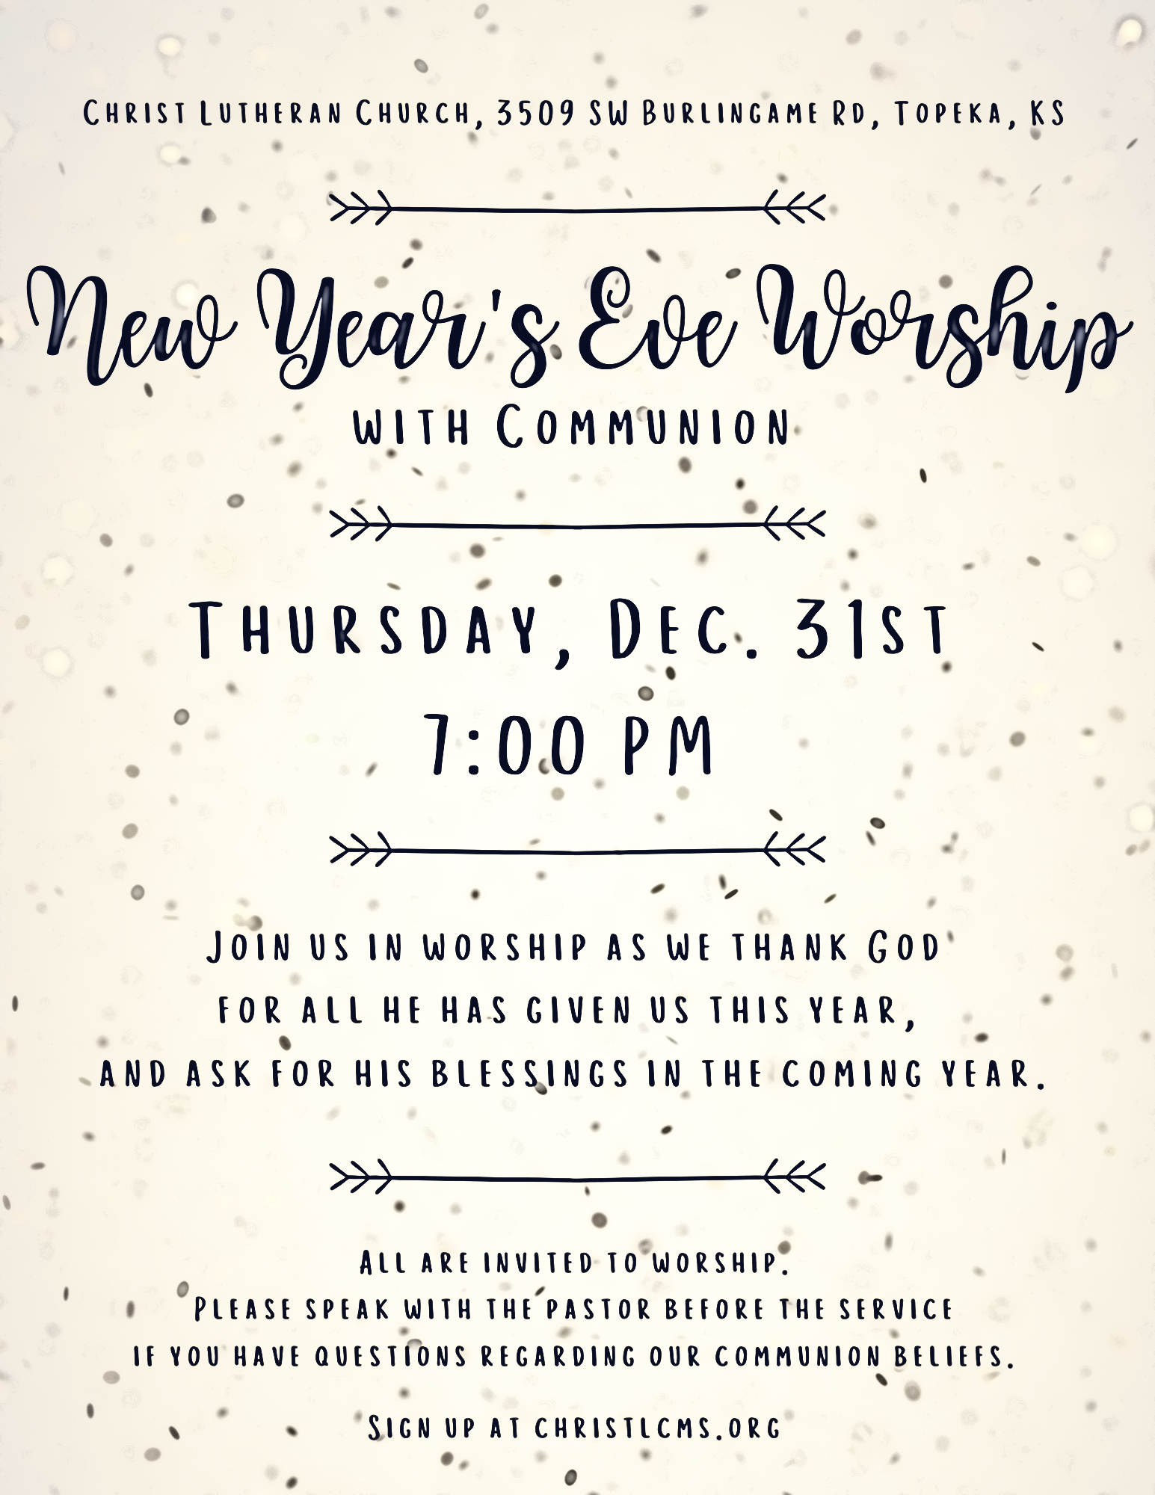
Poinsettias
Allen Family – In memory of
Claude, Sharleen, & Jim Allen, Eugene Schadt
Phil & Jolene Balch – In memory of
Mildred & Glen Balch, Herb & Enola Meyerhoff
Becker Family – In memory of Leila Becker
Donna Boyer – In memory of Bill Boyer, Lucy Broadbent
Lewis, Jennifer, Dylan, & Kyle Butts – In memory of Charley McDowell
Lewis, Jennifer, & Kyle Butts – In honor of Dylan Butts
Darleen Carpenter – In memory of Lee Carpenter
Ginger Chang – In memory of Ruu Chang
Bob & Judy Crites – In honor of all our family
Eddie & Connie Dawson – In memory of Edward Sr. & Ann Dawson
Lynne Dryer & Chase Ford – In memory of Lura Lee Dryer
Carlie Gurske – In honor of John, David, Chris, Scott, & Kensleigh
Holmer Family – In memory of Terry Holmer
Betty Hunter – In memory of Jim Hunter
Wayne & Barbara Kellner – In memory of
Bluford & Irene Kellner and Vance & Pauline Wiltner
Judy Kennedy – In memory of Luther, Ian, & Ron Schmidt
Matt & Mel Lang – In memory of loved ones gone before us
Lee & Janet Maynard – In memory of Walter & Clara Meyer,
Grace Maynard Caskey, Barbara Mountain, Kenneth Maynard
Walt & Kendra Malone – In memory of
Willma & Walter Brandes, DeWitt Malone, and Geraldine Ross
Gladys Neuhaus – In memory of Allen & Kenneth
Richard Schuette – In memory of
Betty Schuette, Herb Schuette, Emily Schuette
Kimberly Saxton Scruggs – In memory of Mr. & Mrs. W.H. Saxton
Arloa Tichenor – In memory of Dean Tichenor
Genevieve Wymore – In memory of Charles Wymore

