Christmas Day
The Nativity of Our Lord
December 25, 2023
9:30 AM
“Peace Came to Earth”

Christ Lutheran Church
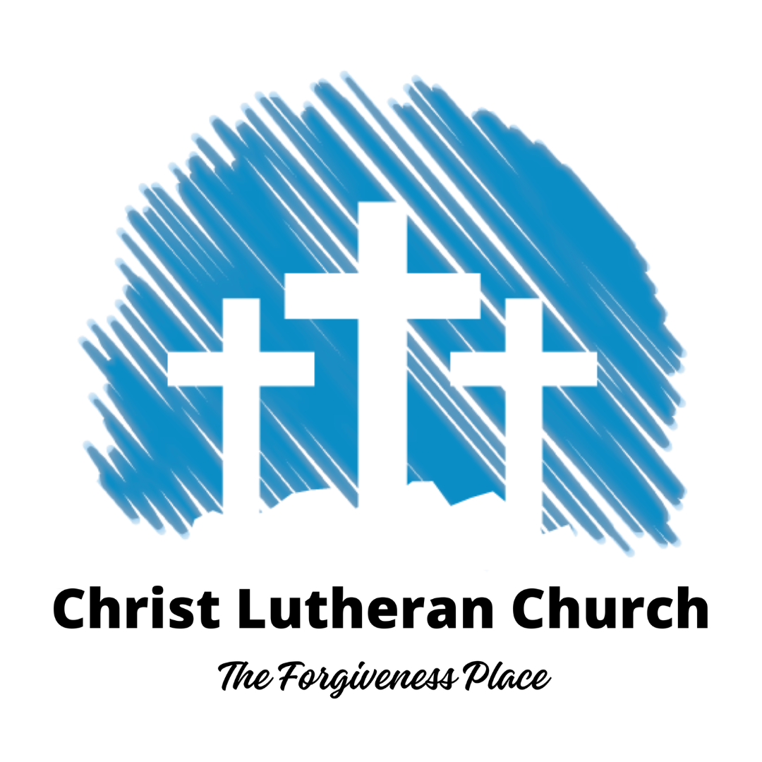
3509 SW Burlingame Rd.
Topeka, KS 66611
785-266-6263
www.christlcms.org

Rev. Ben Micheel, Pastor

Amanda Adams, DCE

As We Gather
Please take time to fill out the fellowship pad located near the center aisle in your pew. If you have any prayer requests, feel free to use a prayer request card from the pew rack in front of you, and place it in the offering plate after the sermon. (For those joining us online, please contact the church office.) We will include these requests in our prayers during worship and share them with our prayer chain (if desired).

Holy Communion
The Lord’s Supper is celebrated at this congregation in the confession and glad confidence that, as he says, our Lord gives into our mouths not only bread and wine but his very body and blood to eat and to drink for the forgiveness of sins and to strengthen our union with him and with one another. Our Lord invites to his table those who trust his words, repent of all sin, and set aside any refusal to forgive and love as he forgives and loves us, that they may show forth his death until he comes.

Because those who eat and drink our Lord’s body and blood unworthily do so to their great harm and because Holy Communion is a confession of the faith which is confessed at this altar, any who are not yet instructed, in doubt, or who hold a confession differing from that of this congregation and The Lutheran Church—Missouri Synod, and yet desire to receive the sacrament, are asked first to speak with the pastor or an elder.

For further study, see Matthew 5:23f.; 10:32f.; 18:15-35; 26:26-29; 1 Cor. 11:17-34.

Welcome and Opening Prayer

380 Hark! The Herald Angels Sing LSB 380
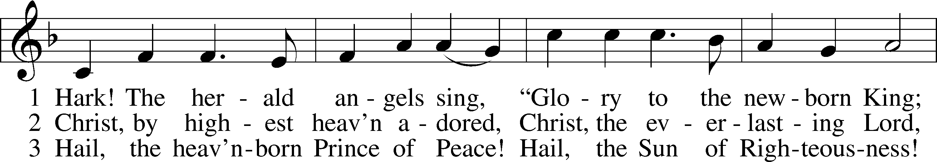
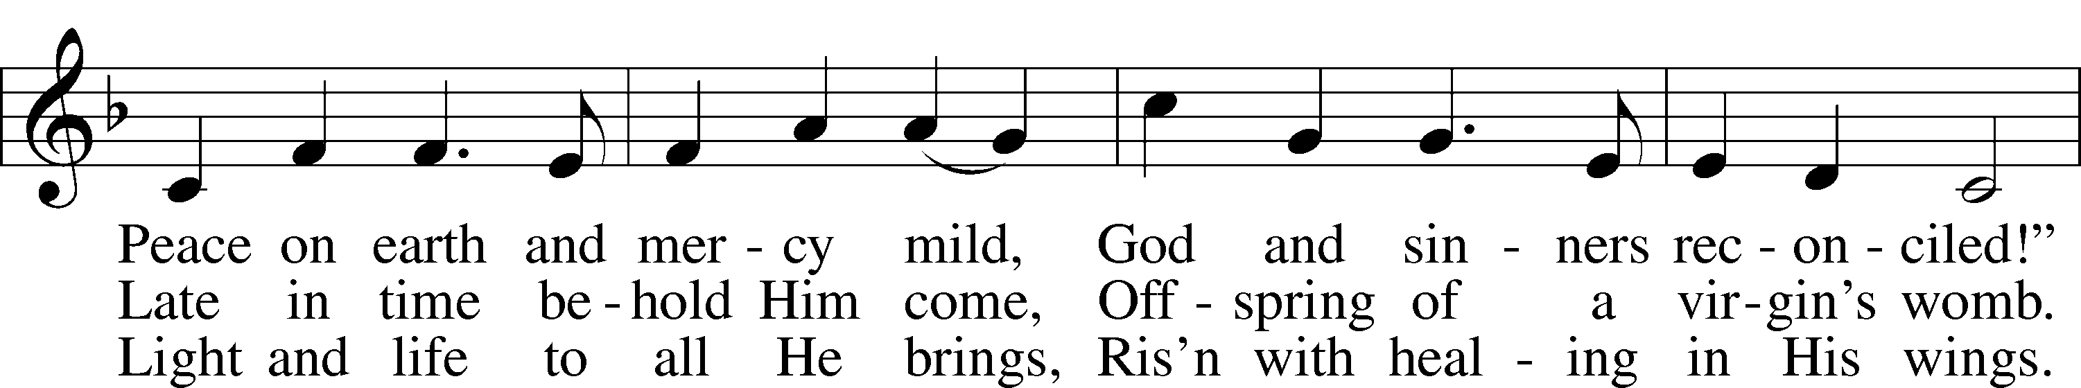
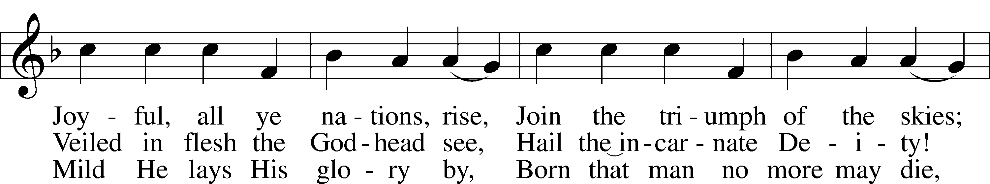
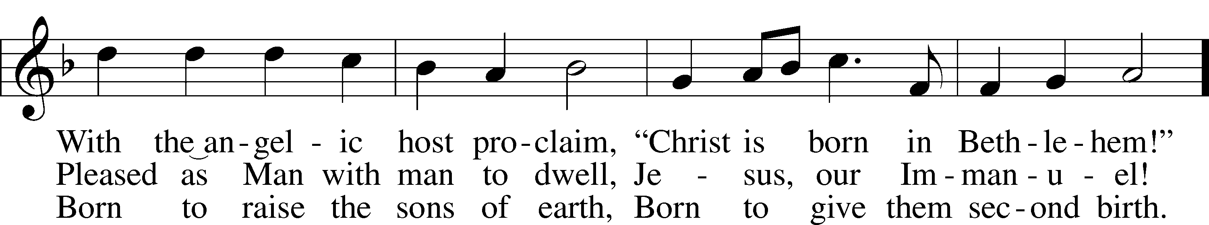
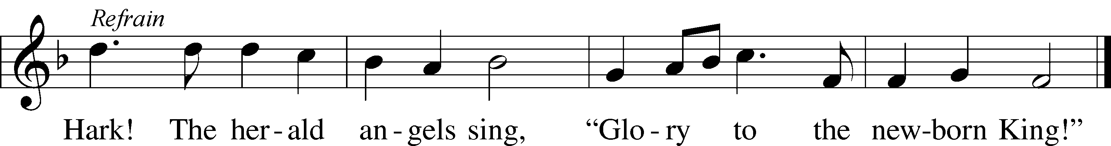
Text: Charles Wesley, 1707–88, alt.
Tune: Felix Mendelssohn, 1809–47
Text and tune: Public domain

Stand

Divine Service Setting One, page 151
T Confession and Absolution T
Confession, to confess to God our sins and sinful nature. Absolution, “To absolve of sin and wrongdoing,” more specifically, to affirm God’s forgiveness to all who sincerely confess their sins to Him.

The sign of the cross may be made by all in remembrance of their Baptism.

Invocation Matthew 28:19b; 18:20
P In the name of the Father and of the T Son and of the Holy Spirit.
C Amen.

Exhortation 1 John 1:8–9 151
P If we say we have no sin, we deceive ourselves, and the truth is not in us.
C But if we confess our sins, God, who is faithful and just, will forgive our sins and cleanse us from all unrighteousness.

Silence for reflection on God’s Word and for self-examination. Consider: Have you loved God with all your heart, all your soul, and all your strength? Have you loved your neighbor as yourself?

Confession of Sins LSB 151
P Let us then confess our sins to God our Father.
C Most merciful God, we confess that we are by nature sinful and unclean. We have sinned against You in thought, word, and deed, by what we have done and by what we have left undone. We have not loved You with our whole heart; we have not loved our neighbors as ourselves. We justly deserve Your present and eternal punishment. For the sake of Your Son, Jesus Christ, have mercy on us. Forgive us, renew us, and lead us, so that we may delight in Your will and walk in Your ways to the glory of Your holy name. Amen.

Absolution [John 20:19–23] LSB 151
P Almighty God in His mercy has given His Son to die for you and for His sake forgives you all your sins. As a called and ordained servant of Christ, and by His authority, I therefore forgive you all your sins in the name of the Father and of the T Son and of the Holy Spirit.
C Amen.

Service of the Word

Introit Psalm 98:1–4; antiphon: Isaiah 9:6
P For to us a child is born, to us a son is given;
C and the government shall be upon his shoulder,
P and his name shall be called Wonderful Counselor,
C Mighty God, Everlasting Father, Prince of Peace.
P Oh sing to the Lord a new song, for he has done marvelous things!
C His right hand and his holy arm have worked salvation for him.
P The Lord has made known his salvation;
C he has revealed his righteousness in the sight of the nations.
P He has remembered his steadfast love and faithfulness to the house of Israel.
C All the ends of the earth have seen the salvation of our God.
P Make a joyful noise to the Lord, all the earth;
C break forth into joyous song and sing praises! Glory be to the Father and to the Son and to the Holy Spirit; as it was in the beginning, is now, and will be forever. Amen.
P For to us a child is born, to us a son is given;
C and the government shall be upon his shoulder,
P and his name shall be called Wonderful Counselor,
C Mighty God, Everlasting Father, Prince of Peace.

Kyrie Mark 10:47 152
A Greek phrase meaning, “Lord, have mercy!” A brief prayer not only imploring God’s mercy but rejoicing in it through Jesus Christ.

P In peace let us pray to the Lord.
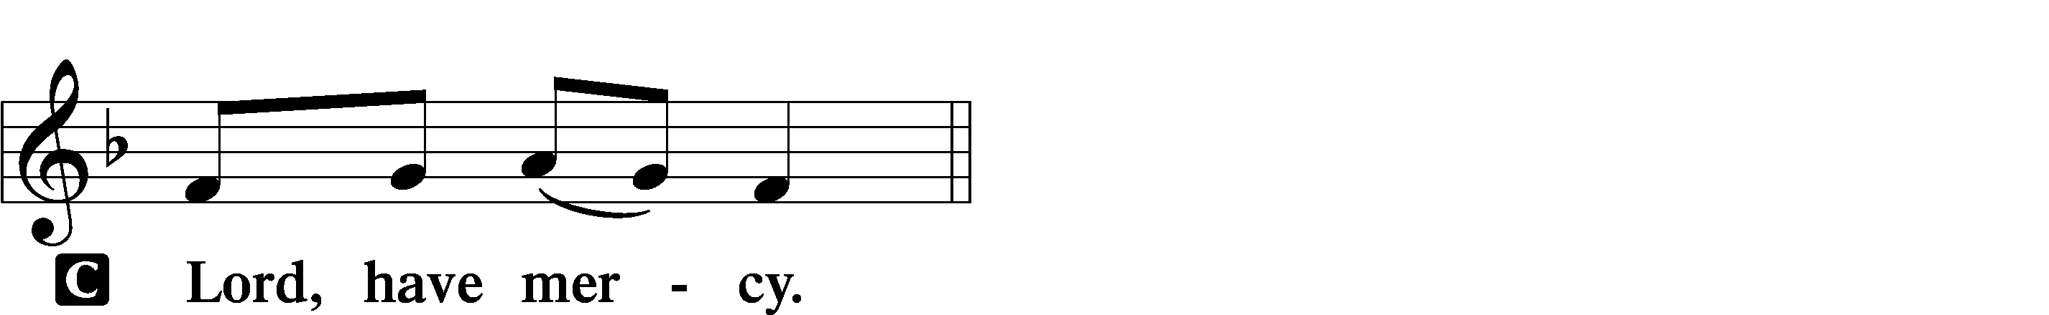

P For the peace from above and for our salvation let us pray to the Lord.
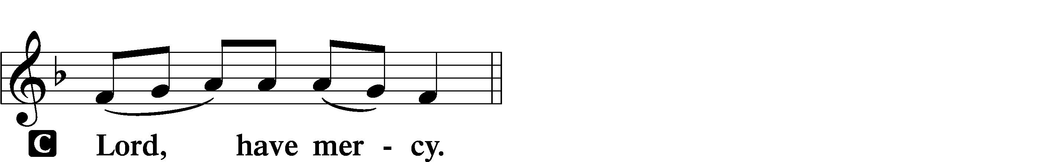

P For the peace of the whole world, for the well-being of the Church of God, and for the unity of all let us pray to the Lord.
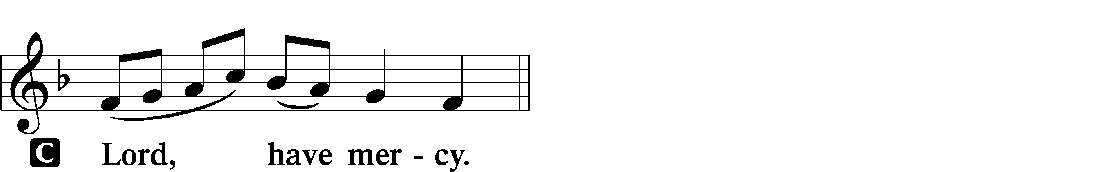

P For this holy house and for all who offer here their worship and praise let us pray to the Lord.
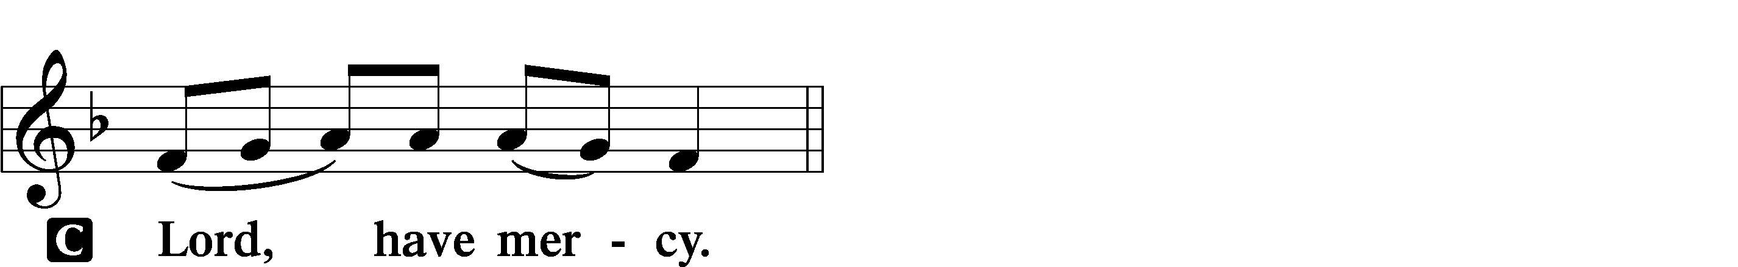

P Help, save, comfort, and defend us, gracious Lord.

Gloria in Excelsis Luke 2:14; John 1:29 LSB 154
P Glory to God in the highest, and peace to His people on earth.
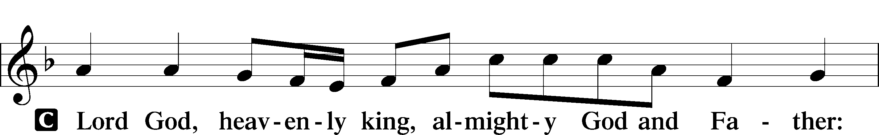
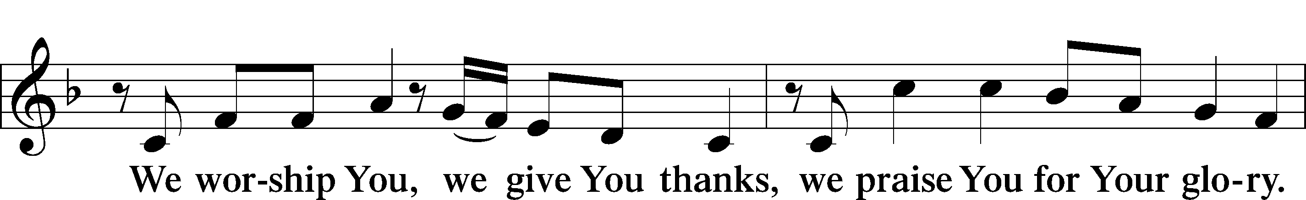
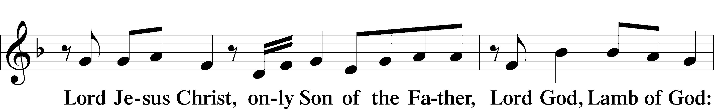
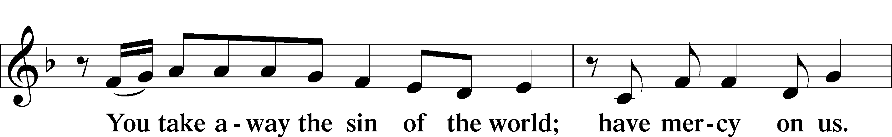
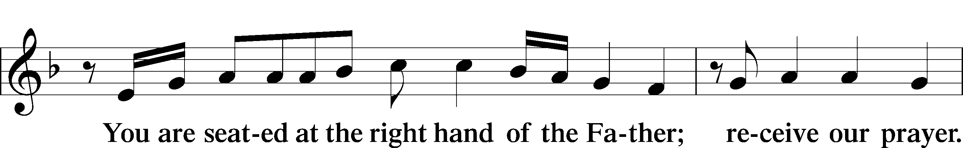
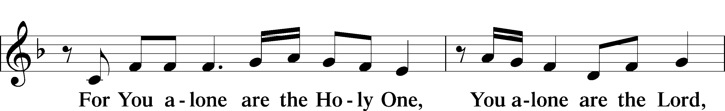
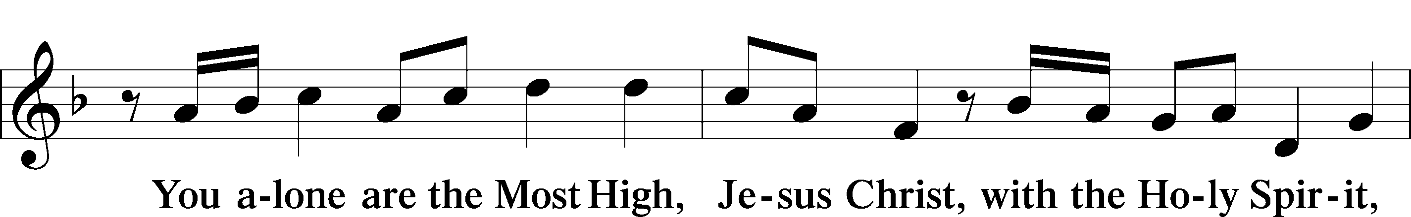
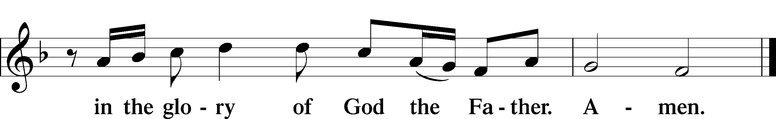

Salutation and Collect of the Day
“Salutation” is a word from Latin meaning, “to greet.” "Collect" (KAH-lekt), a brief structured prayer, usually consisting of five parts: address to God, basis for the prayer, petition, desired benefit or result, and trinitarian conclusion. The Collect of the Day also "collects" the message of the day's Gospel reading.

P The Lord be with you.
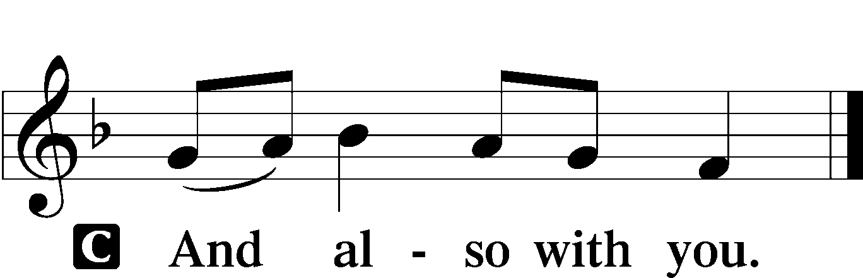

P Let us pray.
Almighty God, grant that the birth of Your only-begotten Son in the flesh may set us free from the bondage of sin; through Jesus Christ, Your Son, our Lord, who lives and reigns with You and the Holy Spirit, one God, now and forever.

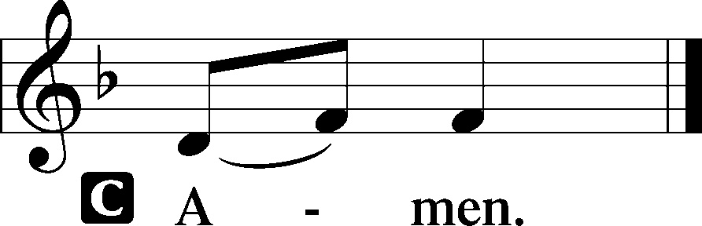

Sit

Epistle Hebrews 1:1–4
A The Epistle is from Hebrews, chapter 1.

1Long ago, at many times and in many ways, God spoke to our fathers by the prophets, 2but in these last days he has spoken to us by his Son, whom he appointed the heir of all things, through whom also he created the world. 3He is the radiance of the glory of God and the exact imprint of his nature, and he upholds the universe by the word of his power. After making purification for sins, he sat down at the right hand of the Majesty on high, 4having become as much superior to angels as the name he has inherited is more excellent than theirs.

A This is the Word of the Lord.
C Thanks be to God.

Stand

Alleluia and Verse 156
Hebrew word meaning "praise the LORD." Also spelled "Hallelujah".
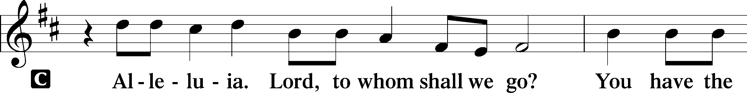
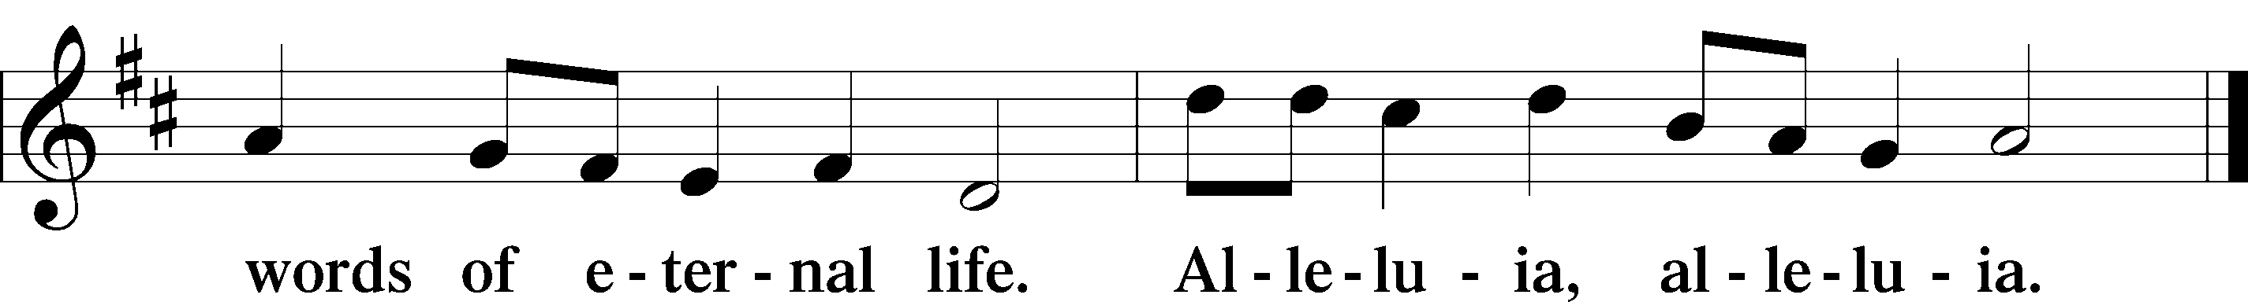

Holy Gospel Luke 2:8–20
P The Holy Gospel according to St. Luke, the second chapter.
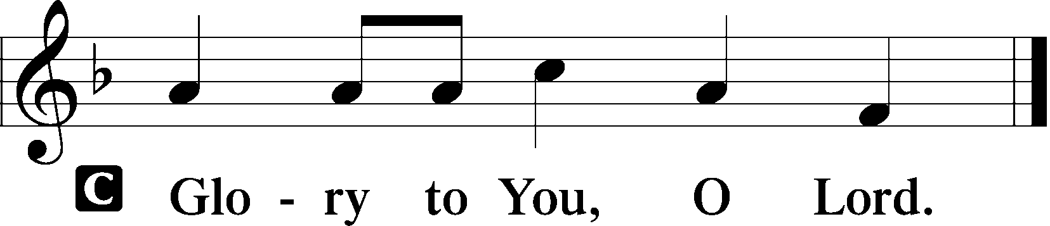

⁸And in the same region there were shepherds out in the field, keeping watch over their flock by night. ⁹And an angel of the Lord appeared to them, and the glory of the Lord shone around them, and they were filled with fear. ¹⁰And the angel said to them, “Fear not, for behold, I bring you good news of a great joy that will be for all the people. ¹¹For unto you is born this day in the city of David a Savior, who is Christ the Lord. ¹²And this will be a sign for you: you will find a baby wrapped in swaddling cloths and lying in a manger.” ¹³And suddenly there was with the angel a multitude of the heavenly host praising God and saying,
¹⁴“Glory to God in the highest,
and on earth peace among those with whom he is pleased!”
¹⁵When the angels went away from them into heaven, the shepherds said to one another, “Let us go over to Bethlehem and see this thing that has happened, which the Lord has made known to us.” ¹⁶And they went with haste and found Mary and Joseph, and the baby lying in a manger. ¹⁷And when they saw it, they made known the saying that had been told them concerning this child. ¹⁸And all who heard it wondered at what the shepherds told them. ¹⁹But Mary treasured up all these things, pondering them in her heart. ²⁰And the shepherds returned, glorifying and praising God for all they had heard and seen, as it had been told them.

P This is the Gospel of the Lord.
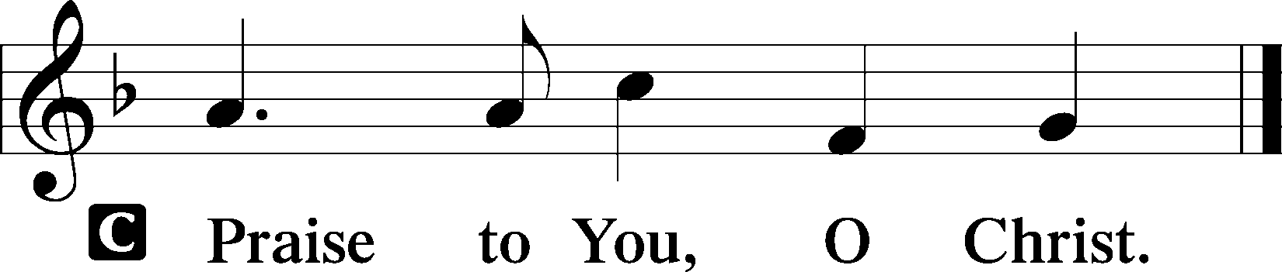
Nicene Creed
Creed comes from the Latin “credo” which means “I believe." We confess our Christian faith in one of the three creeds (short statement of belief) agreed upon by the ancient church.

C I believe in one God,
the Father Almighty,
maker of heaven and earth
and of all things visible and invisible.

And in one Lord Jesus Christ,
the only-begotten Son of God,
begotten of His Father before all worlds,
God of God, Light of Light,
very God of very God,
begotten, not made,
being of one substance with the Father,
by whom all things were made;
who for us men and for our salvation came down from heaven
and was incarnate by the Holy Spirit of the virgin Mary
and was made man;
and was crucified also for us under Pontius Pilate.
He suffered and was buried.
And the third day He rose again according to the Scriptures
and ascended into heaven
and sits at the right hand of the Father.
And He will come again with glory to judge both the living and the dead,
whose kingdom will have no end.

And I believe in the Holy Spirit,
the Lord and giver of life,
who proceeds from the Father and the Son,
who with the Father and the Son together is worshiped and glorified,
who spoke by the prophets.
And I believe in one holy Christian and apostolic Church,
I acknowledge one Baptism for the remission of sins,
and I look for the resurrection of the dead
and the life T of the world to come. Amen.

Sit
Children's Message Matthew 19:14; Mark 13:13-15; Luke 18:16
Children are invited to join Amanda Adams, our Director of Christian Education, at the front of the sanctuary for the Children's Message.

365 Away in a Manger LSB 365
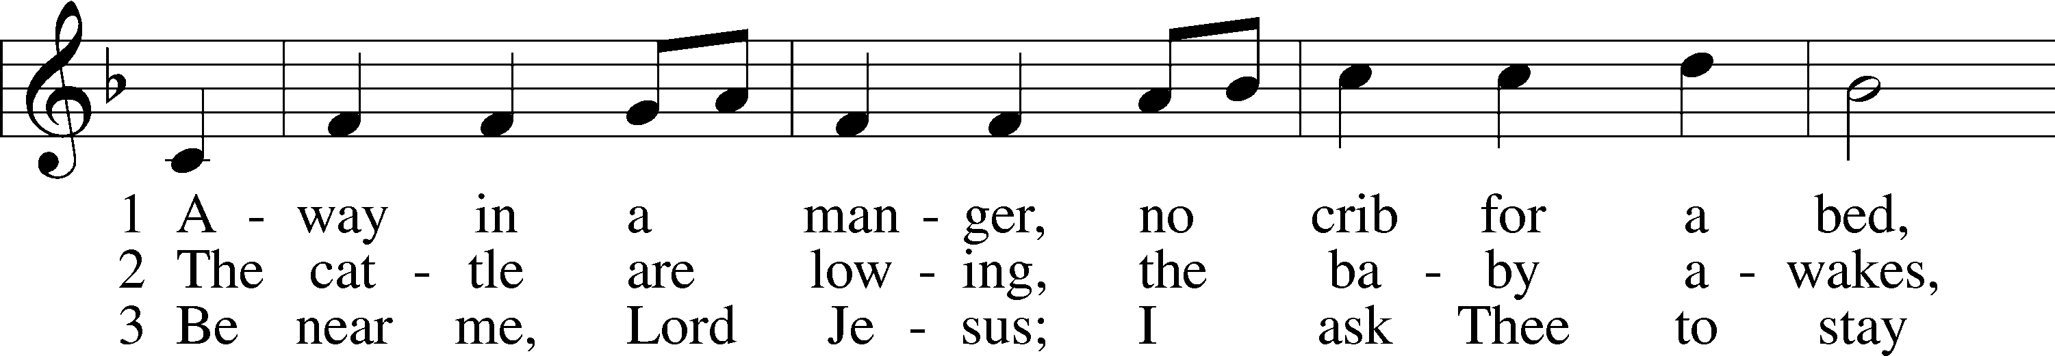
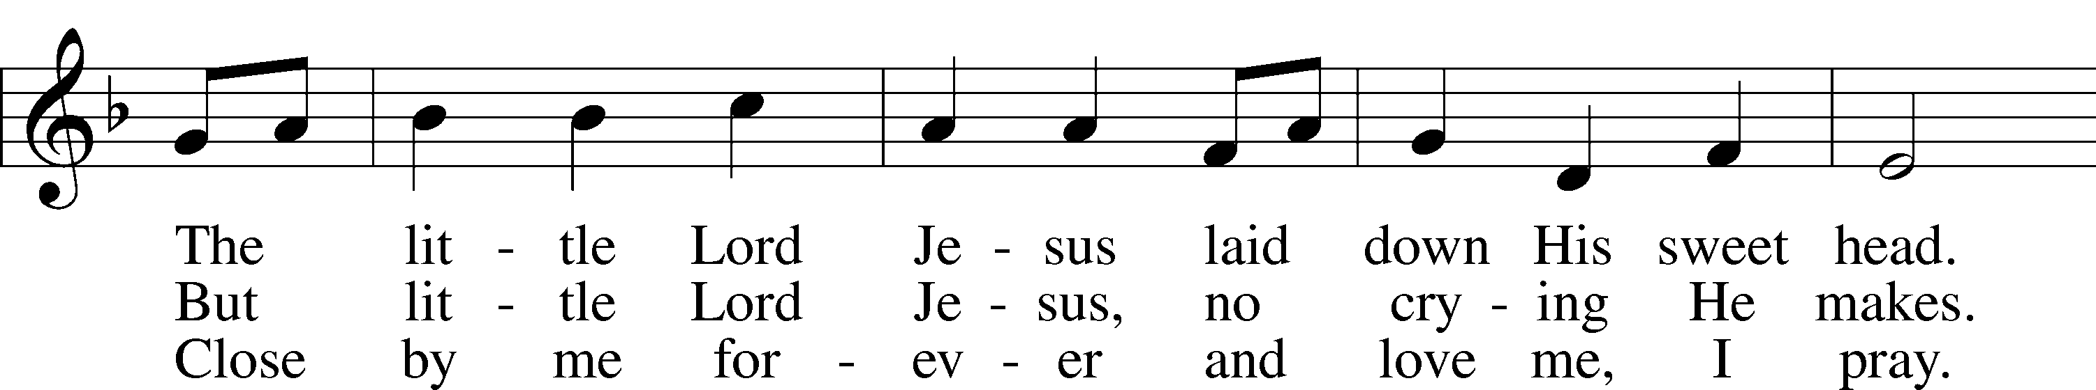
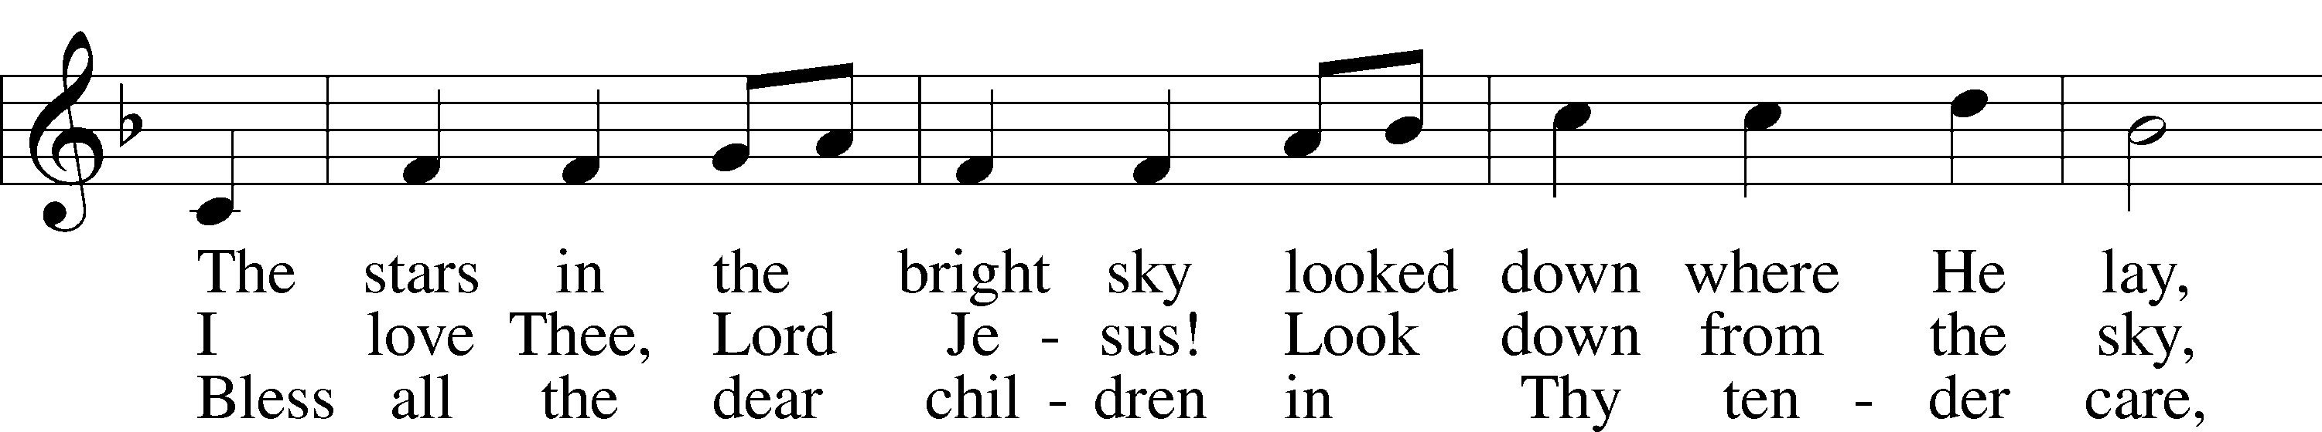
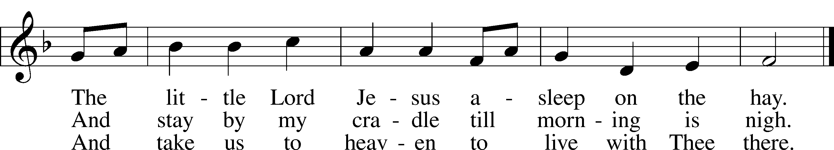
Text (sts. 1–2): Little Children’s Book, 1885, Philadelphia; (st. 3): Vineyard Songs, 1892, Louisville, alt.
Tune: William J. Kirkpatrick, 1838–1921
Text and tune: Public domain

Sermon Peace Came to Earth

Offering
If you brought your gift, tithe, or offering with you today, you may place it in the offering plate as it passes. We also have multiple options for electronic giving. You can sign up for online giving through Vanco at bit.ly/GivingChristLCMS for a one-time or recurring gift. You may also download the Vanco Mobile Faith Engagement app and search for Christ Lutheran Church in Topeka, KS. Direct links and additional information are available on the church website (christlcms.org/giving).

For those joining us remotely, you may use the electronic giving methods listed above, or you may mail your offering to the church office (3509 SW Burlingame Rd, Topeka, KS 66611).

Stand

Offertory Psalm 116:12–13, 17–19 LSB 159
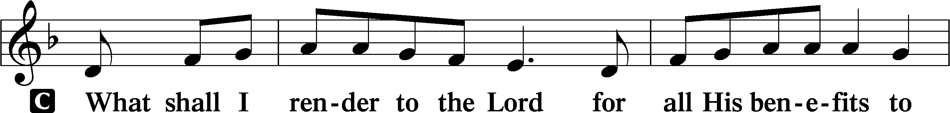
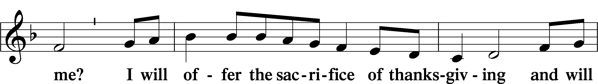
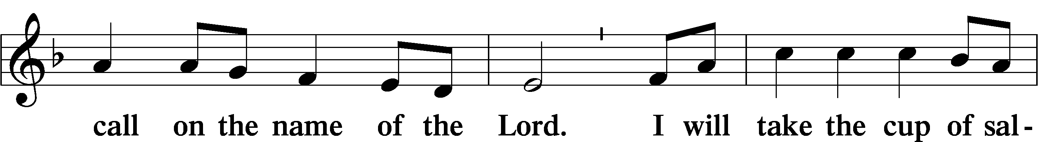
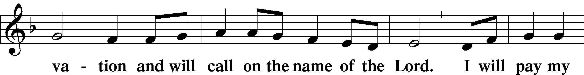
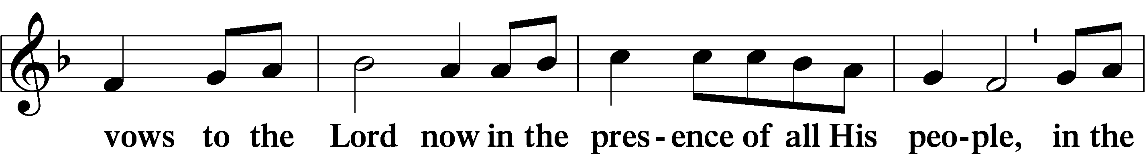
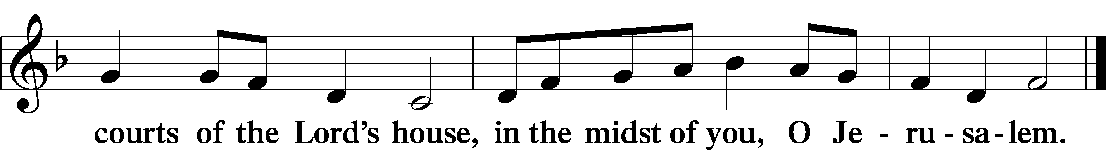

Prayer of the Church 1 Timothy 2:1-4
At the end of each petition, the pastor will say, “Lord, in Your mercy,”
to which the congregation will respond, “Hear our prayer.”

P …through Jesus Christ, Your son, our Lord, who lives and reigns with You and the Holy Spirit, one God, now and forever.
C Amen.

Service of the Sacrament

Preface 2 Timothy 4:22; [Colossians 3:1]; [Psalm 136] LSB 160
P The Lord be with you.
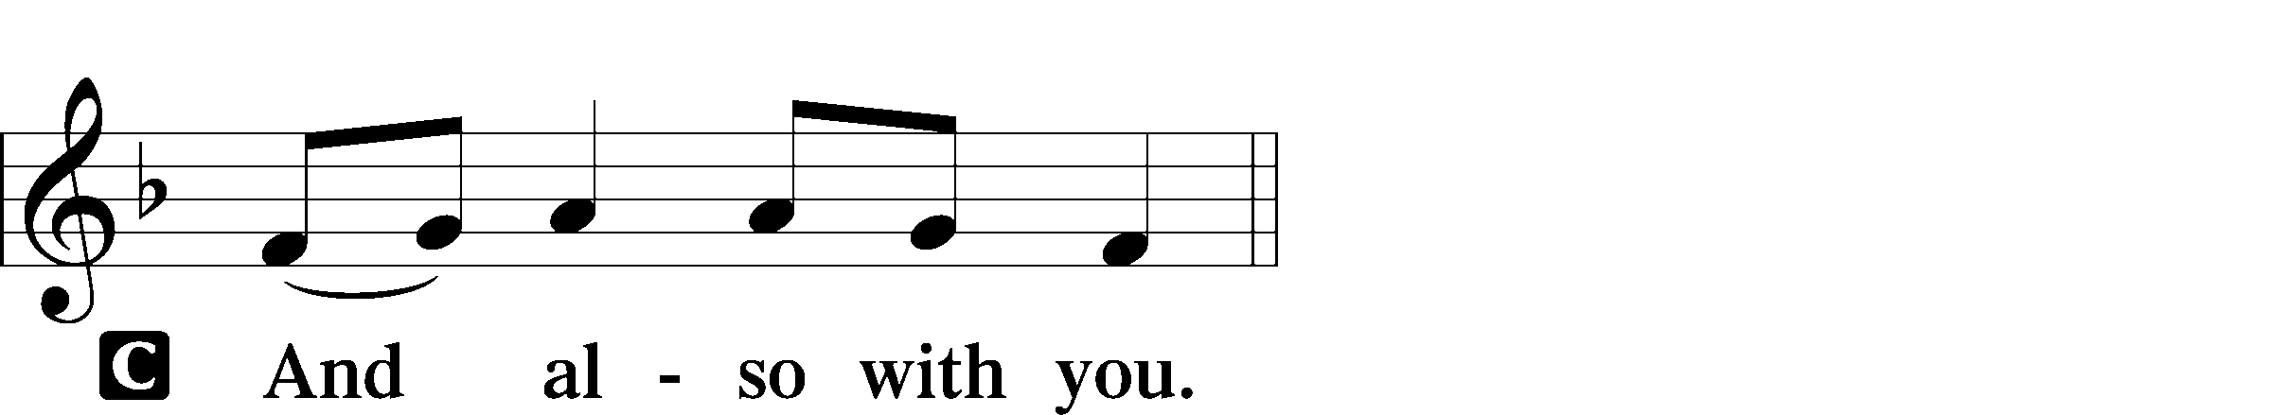

P Lift up your hearts.

P Let us give thanks to the Lord our God.
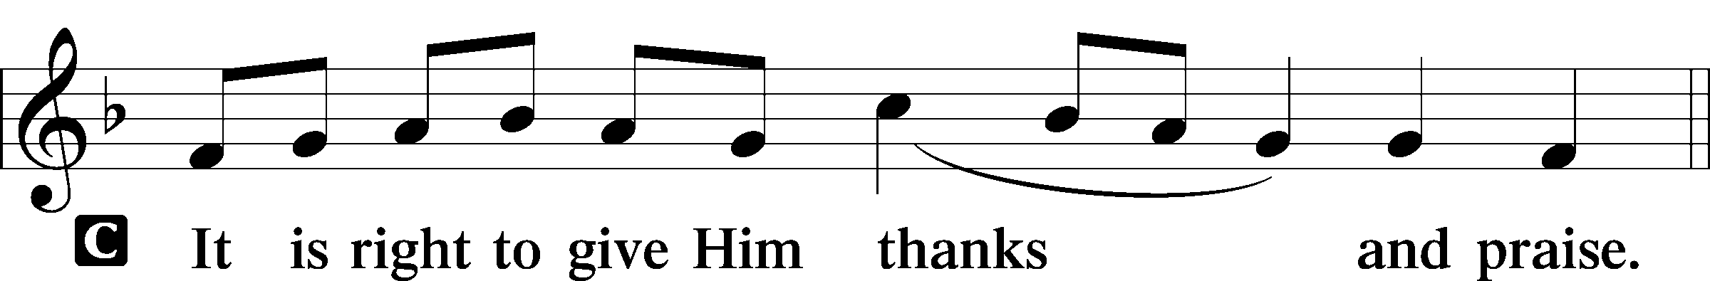

Proper Preface (Full)
P It is truly good, right, and salutary that we should at all times and in all places give thanks to You, holy Lord, almighty Father, everlasting God, through Jesus Christ, our Lord; for in the mystery of the Word made flesh You have given us a new revelation of Your glory that, seeing You in the person of Your Son, we may know and love those things which are not seen. Therefore with angels and archangels and with all the company of heaven we laud and magnify Your glorious name, evermore praising You and saying:

Sanctus Isaiah 6:3; Matthew 21:9 161
(SAHNK-toose),"Sanctus" is Latin for "holy".
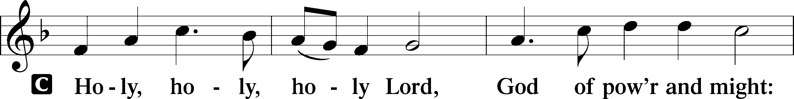
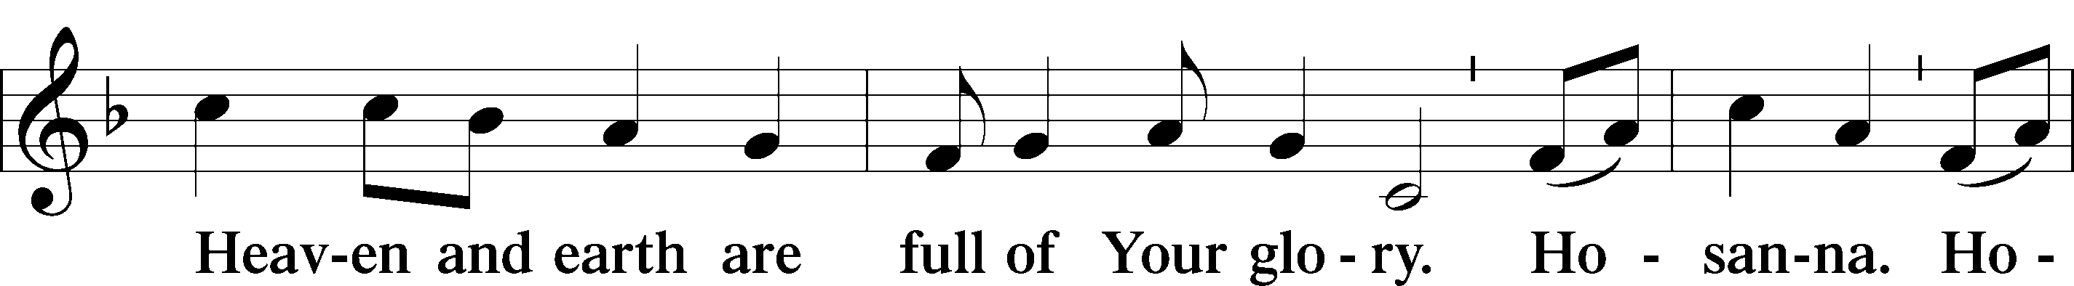
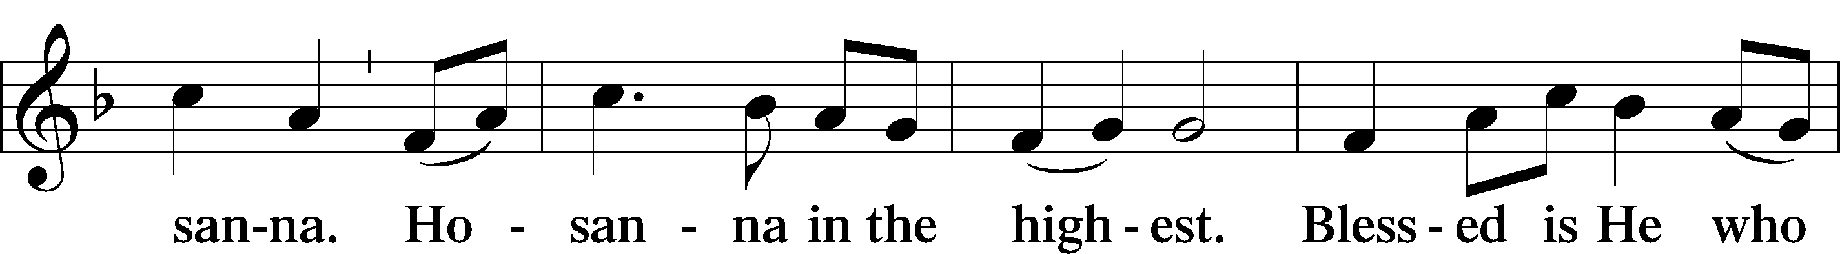
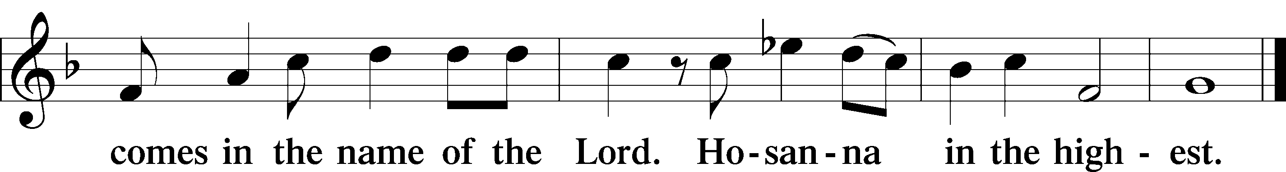

Prayer of Thanksgiving 161
P Blessed are You, Lord of heaven and earth, for You have had mercy on those whom You created and sent Your only-begotten Son into our flesh to bear our sin and be our Savior. With repentant joy we receive the salvation accomplished for us by the all-availing sacrifice of His body and His blood on the cross.

Gathered in the name and the remembrance of Jesus, we beg You, O Lord, to forgive, renew, and strengthen us with Your Word and Spirit. Grant us faithfully to eat His body and drink His blood as He bids us do in His own testament. Gather us together, we pray, from the ends of the earth to celebrate with all the faithful the marriage feast of the Lamb in His kingdom, which has no end. Graciously receive our prayers; deliver and preserve us. To You alone, O Father, be all glory, honor, and worship, with the Son and the Holy Spirit, one God, now and forever.
C Amen.

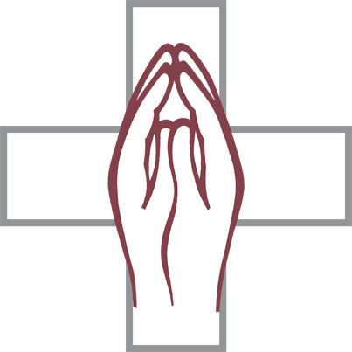
Lord’s Prayer Matthew 6:9–13 LSB 162
P Lord, remember us in Your kingdom and teach us to pray:
C Our Father who art in heaven,
hallowed be Thy name,
Thy kingdom come,
Thy will be done on earth
as it is in heaven;
give us this day our daily bread;
and forgive us our trespasses
as we forgive those
who trespass against us;
and lead us not into temptation,
but deliver us from evil.
For Thine is the kingdom
and the power and the glory
forever and ever. Amen.

The Words of Our Lord
P Our Lord Jesus Christ, on the night when He was betrayed, took bread, and when He had given thanks, He broke it and gave it to the disciples and said: “Take, eat; this is My T body, which is given for you. This do in remembrance of Me.”

In the same way also He took the cup after supper, and when He had given thanks, He gave it to them, saying: “Drink of it, all of you; this cup is the new testament in My T blood, which is shed for you for the forgiveness of sins. This do, as often as you drink it, in remembrance of Me.”

Pax Domini John 20:19 163
(PAKS DOH-mee-nee), Latin for "peace of the Lord" (John 20:19).

P The peace of the Lord be with you always.
Agnus Dei John 1:29 LSB 163
(AHG-noose DAY-ee). Latin for “Lamb of God.”

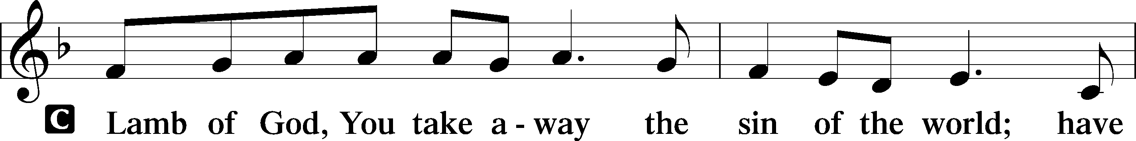
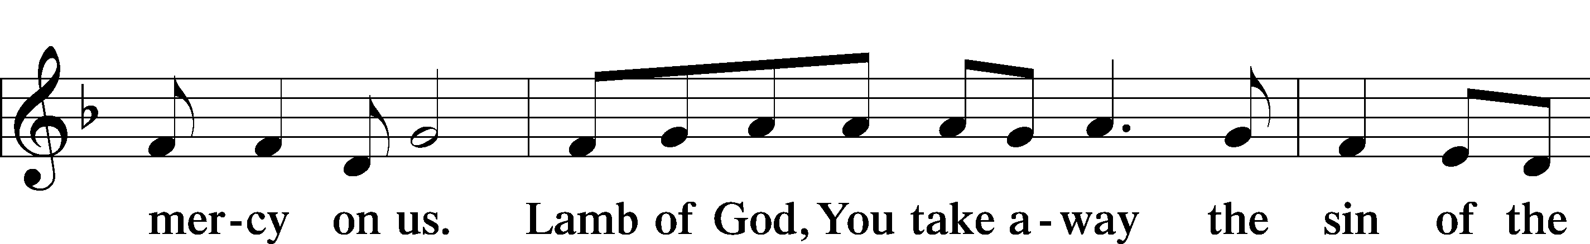
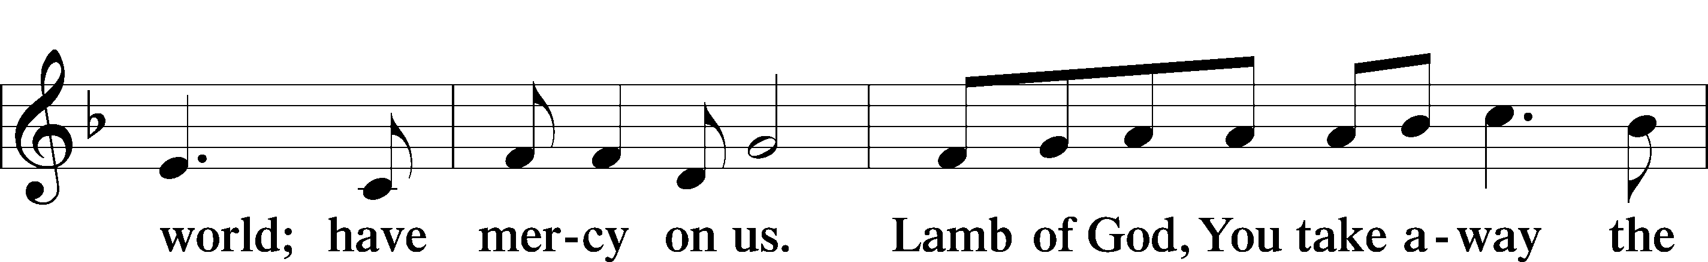
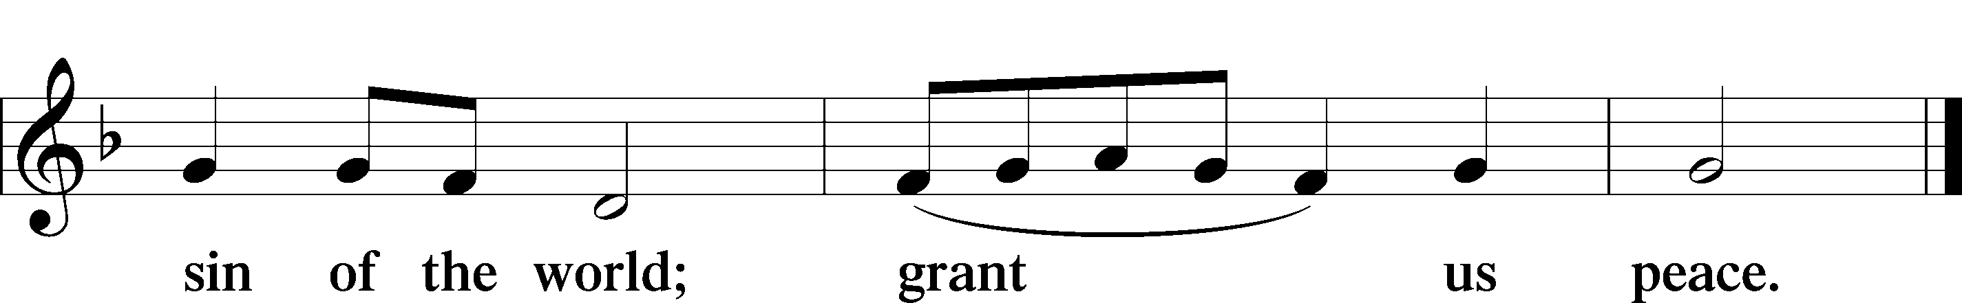

Sit

Distribution
The pastor and those who assist him receive the body and blood of Christ first. Then they will distribute it to those who cannot come up to the altar rail due to physical ailments. Following that the ushers will dismiss the people from their pews to go to the altar rail. The congregation will be ushered down the middle aisle to go up to the rail and when dismissed from there will use the side aisle to return to their seats. All are invited up to receive a blessing.

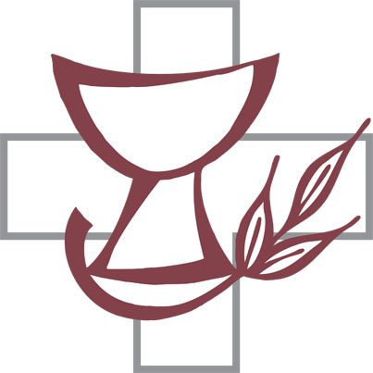
370 What Child Is This LSB 370
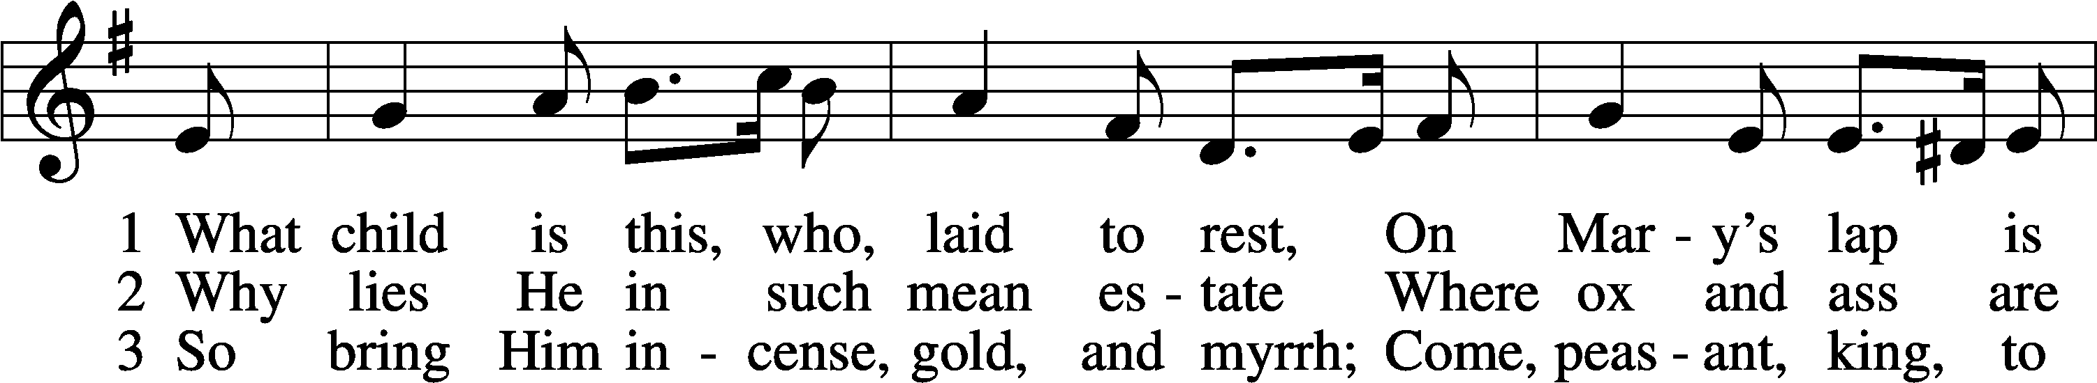
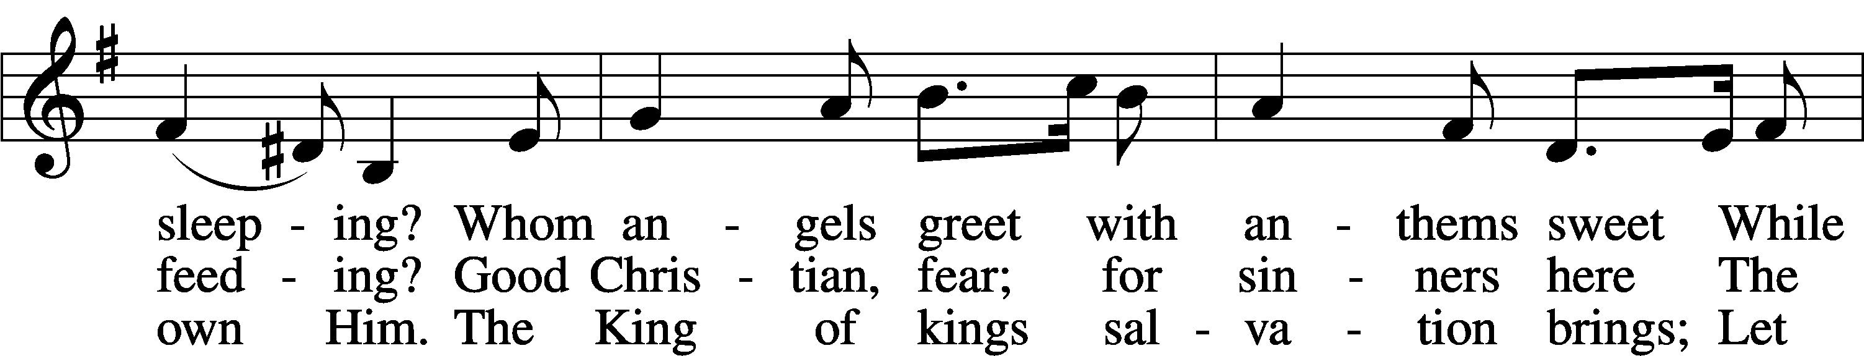
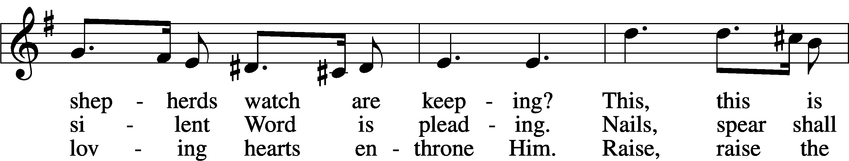
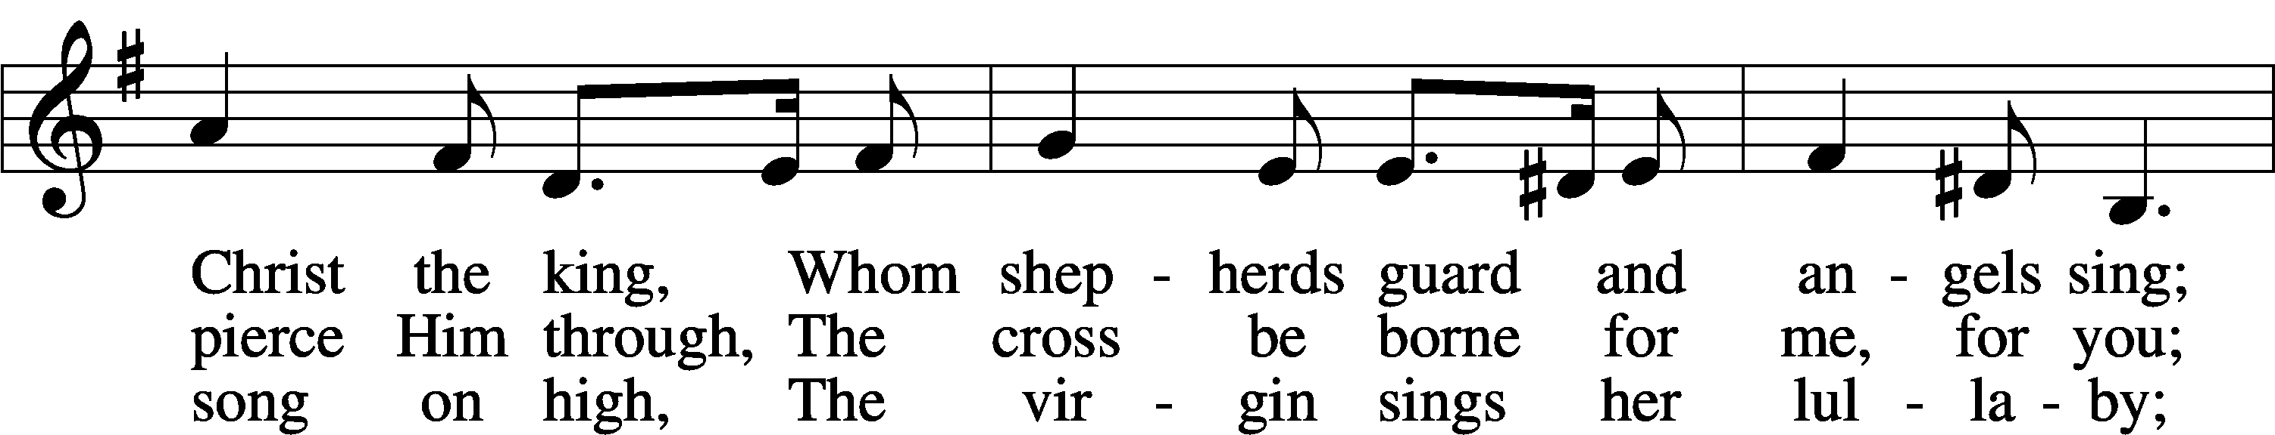
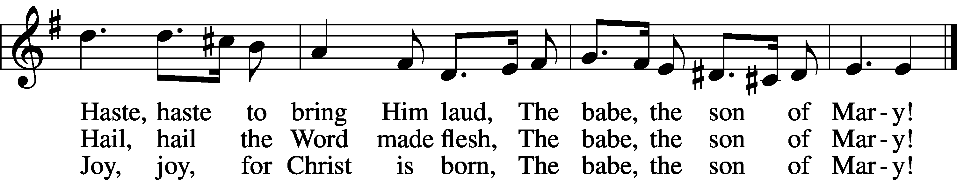
Text: William C. Dix, 1837–98
Tune: English, 16th cent.
Text and tune: Public domain

376 Once in Royal David’s City LSB 376
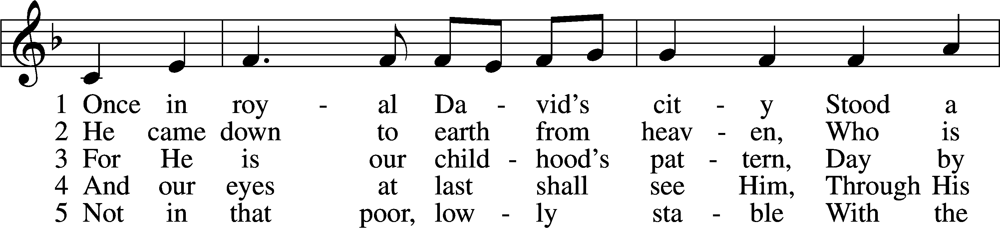
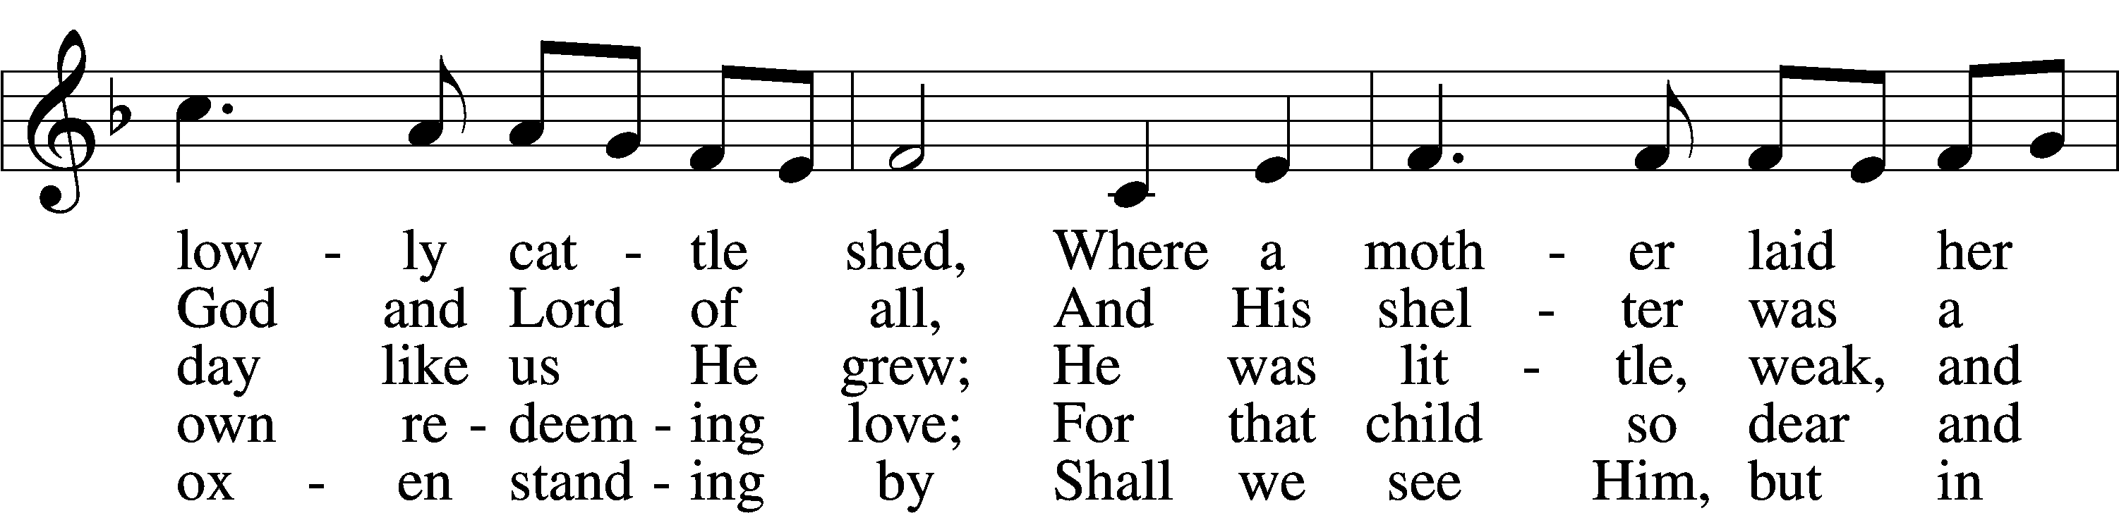
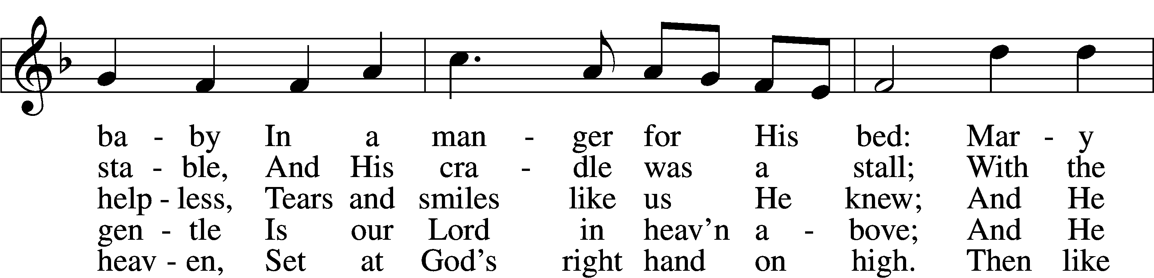
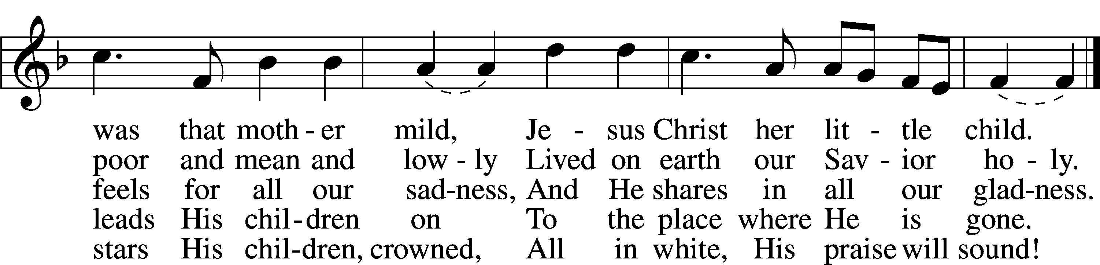
Text: Cecil F. Alexander, 1818–95, alt.
Tune: Henry J. Gauntlett, 1805–76
Text and tune: Public domain

388 Go Tell It on the Mountain LSB 388
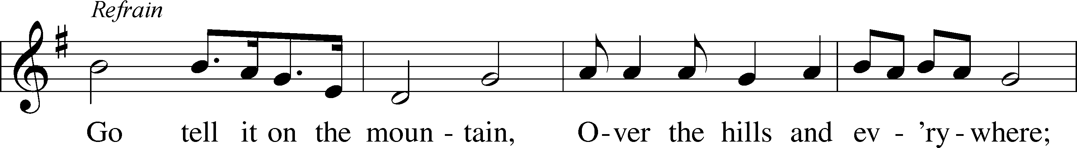
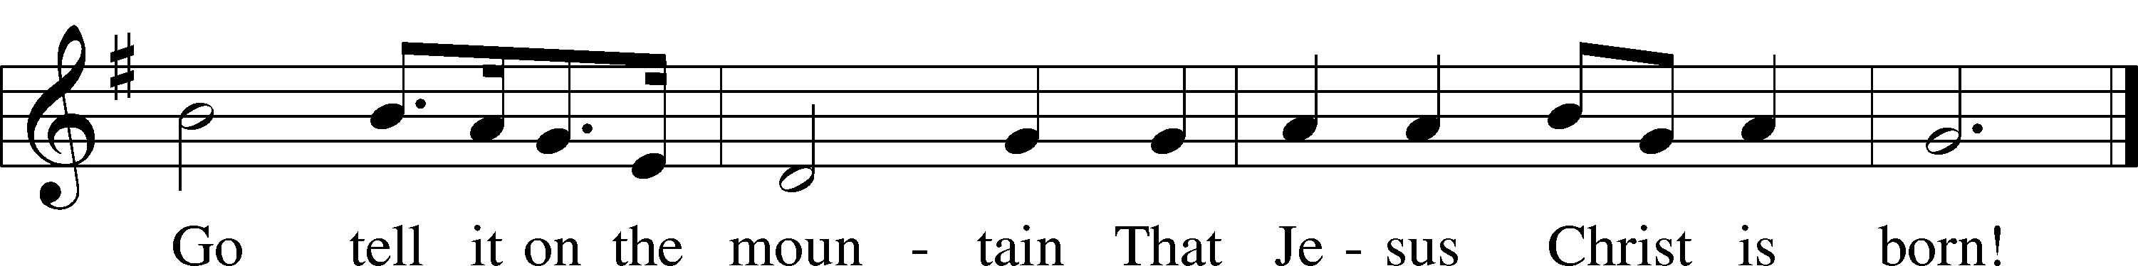
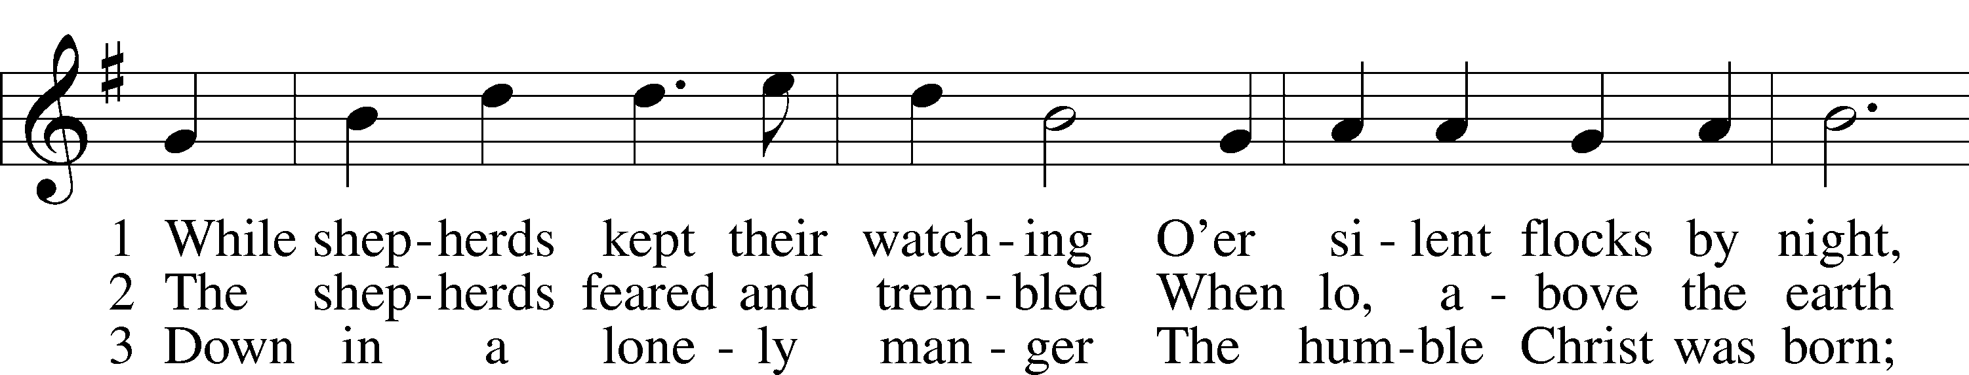
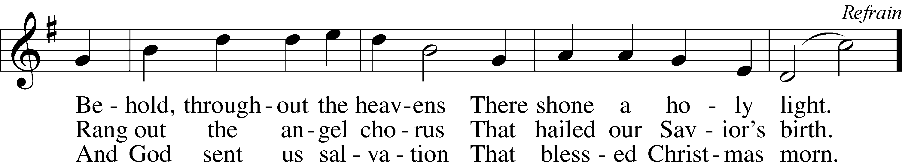
Text (sts. 1–3): John W. Work II, 1873–1925, alt.
Text (ref) and tune: African American spiritual; Text and tune: Public domain

Stand

Thank the Lord [Psalm 105:1–3, 42–43]; [1 Chronicles 16:8–10] LSB 164
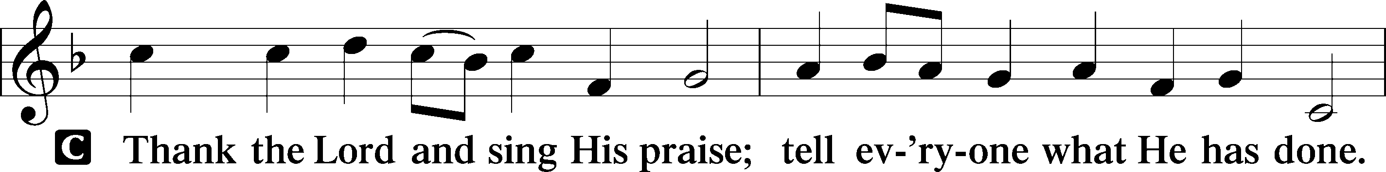
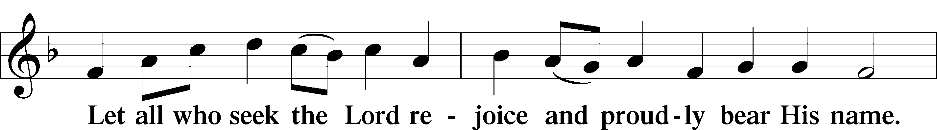
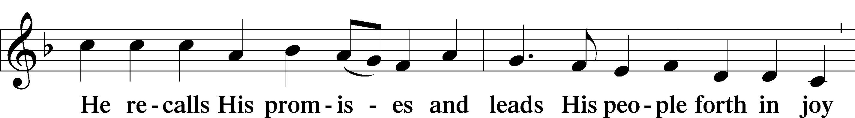
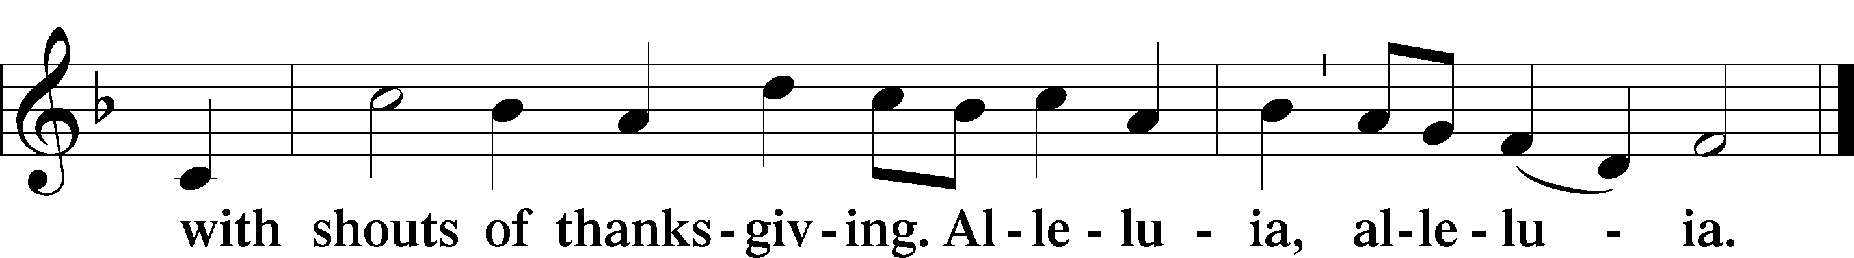
Post-Communion Collect
P Let us pray.
We give thanks to You, almighty God, that You have refreshed us through this salutary gift, and we implore You that of Your mercy You would strengthen us through the same in faith toward You and in fervent love toward one another; through Jesus Christ, Your Son, our Lord, who lives and reigns with You and the Holy Spirit, one God, now and forever.
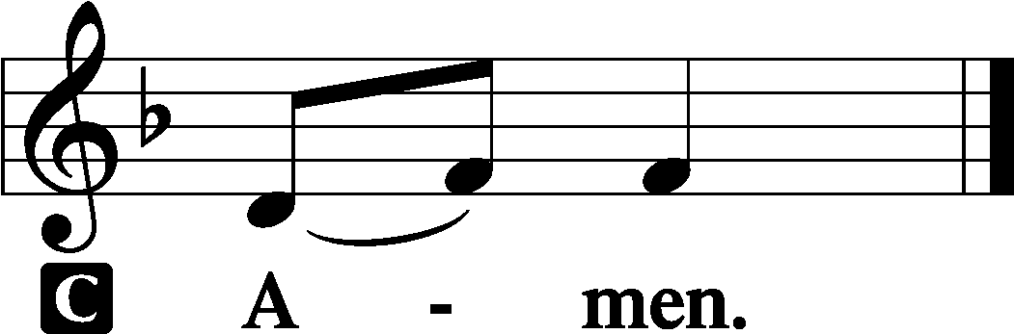

Luther's Morning Prayer
C I thank You, my heavenly Father, through Jesus Christ, Your dear Son, that You have kept me this night from all harm and danger; and I pray that You would keep me this day also from sin and every evil, that all my doings and life may please You. For into Your hands I commend myself, my body and soul, and all things. Let Your holy angel be with me, that the evil foe may have no power over me.
Amen.

Benediction Numbers 6:24–26 166
A final blessing from God this morning before we leave.

P The Lord bless you and keep you.
The Lord make His face shine on you and be gracious to you.
The Lord look upon you with favor and T give you peace.

Sit

387 Joy to the World LSB 387
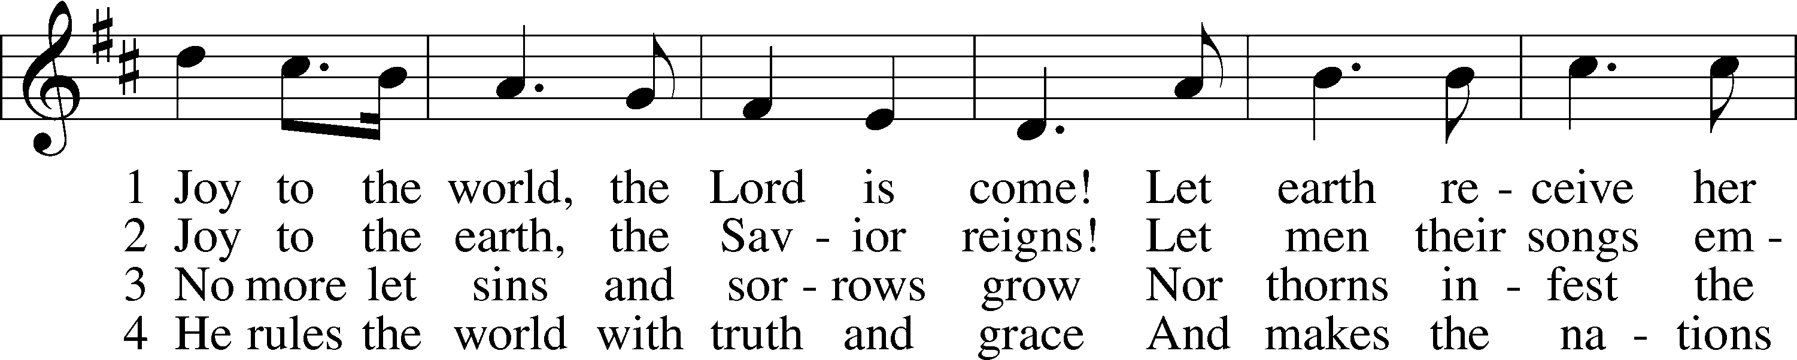
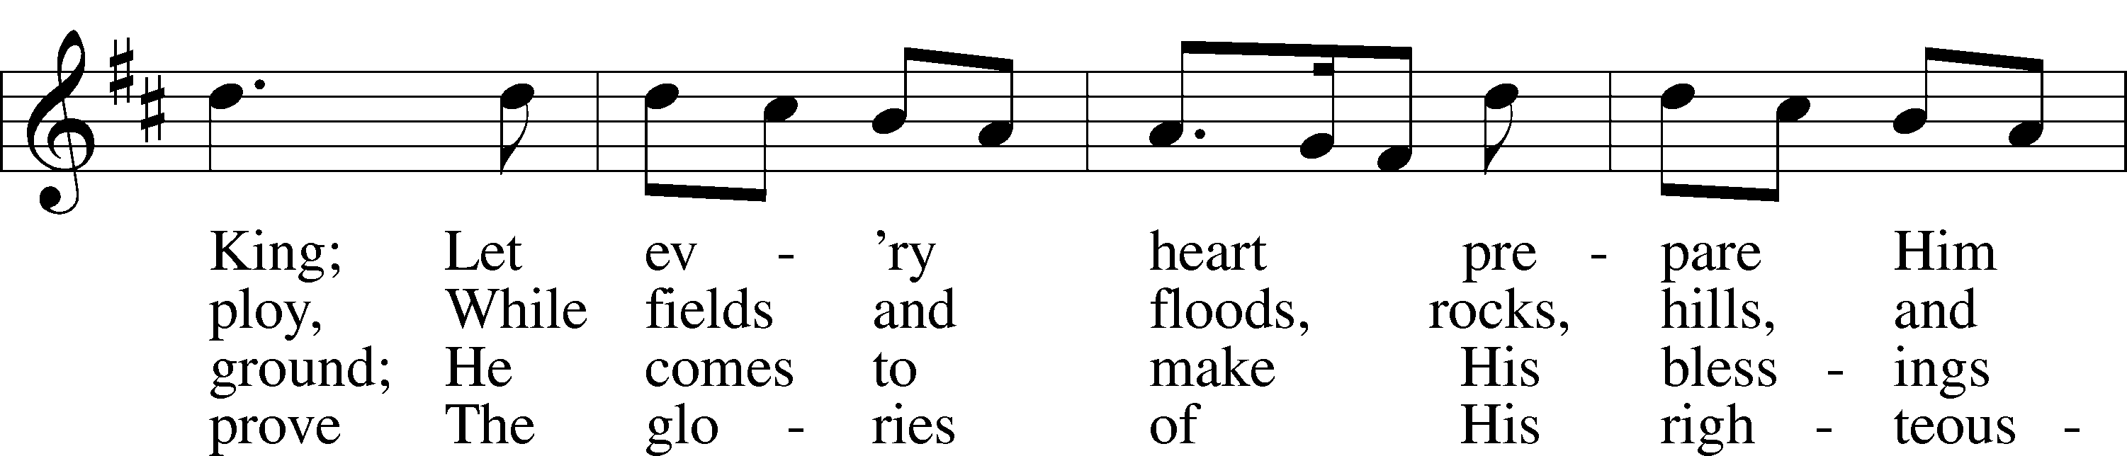
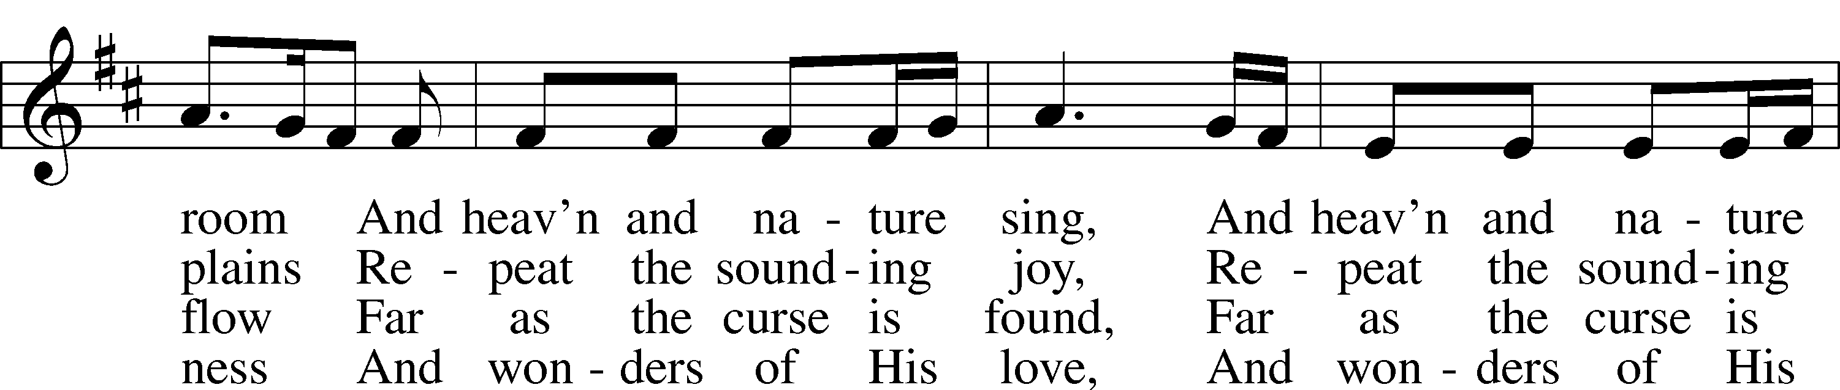
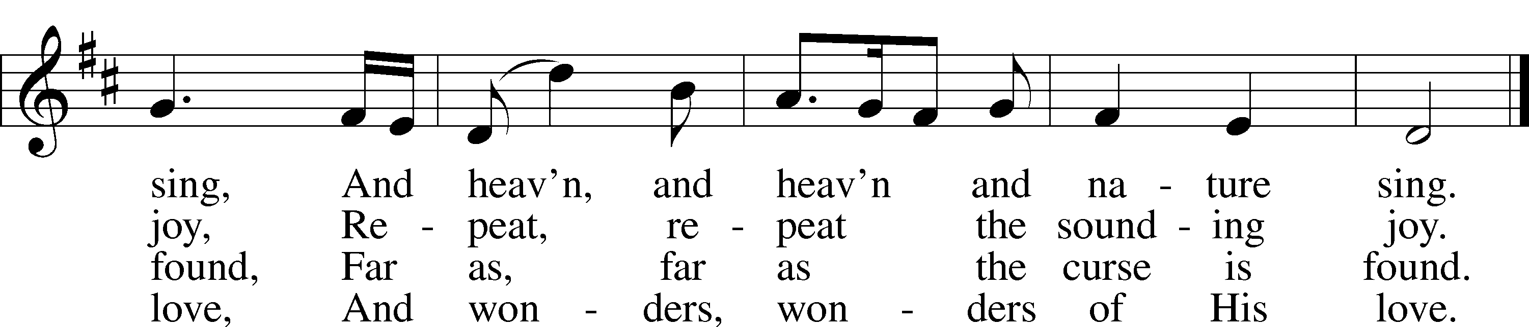
Text: Isaac Watts, 1674–1748
Tune: George Frideric Handel, 1685–1759, adapt.
Text and tune: Public domain

Acknowledgments
Unless otherwise indicated, Scripture quotations are from the ESV® Bible (The Holy Bible, English Standard Version®), copyright © 2001 by Crossway, a publishing ministry of Good News Publishers. Used by permission. All rights reserved.
Created by Lutheran Service Builder © 2023 Concordia Publishing House.

Poinsettias

Phil & Jolene Balch – in memory of Glen & Mildren Balch, Herb & Enola Meyerhoff
John Bylsma – in memory of Elaine Robson
Patrick & Norlinda Campbell – in memory of Zachary, Villamor, Nestor, Nolan
Judy Crites – in honor of Our Family
Eddie & Connie Dawson – in memory of Edward Sr. & Ann R. Dawson
Lynne Dryer & Chase Ford – in memory of Lura Lee Dryer
John Hart
The Holmer Family – in memory of Terry Holmer
Wayne Kellner & Family – in memory of Barbara Kellner
Matt & Mel Lang – in memory of Loved Ones Gone Before Us
Walt & Kendra Malone – in memory of
Walt & Wilma Brandes, DeWitt Malone, Geraldine Ross, Harvey Sutton
Allyson Null – in memory of Chuck & Willa Hauser
Robert Parker – in memory of Marjean Jo Parker
Kimberly Saxton Scruggs – in memory of Mr. & Mrs. W. H. Saxton
Scott & Andrea Van Genderen – in honor of Our Children & Grandchildren
John & Melissa Williamson – in memory of James & Teresa Dodd

